

**Science – States of Matter**

**Meaning**

**Vocabulary**

**Skills**

**Books**

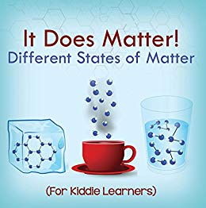

* To be able to draw diagrams to represent states of matter.
* To compare the properties of materials in different states of matter.
* To use a thermometer to measure temperature accurately.
* To explain how to keep it a fair test when researching.

The conversion of a gas to a liquid, forming as droplets on a cold surface.

**condensation**

The process of turning from a liquid into a gas when heated.

**evaporation**

A substance or matter that is in a state of free movement and will expand to fill a container.

**gas**

A substance that flows freely but has a constant volume.

**liquid**

**Knowledge**

To become liquefied when heated.

**melt**

🞄Materials and substances come in different states of matter; solids, liquids and gases.

🞄Each state of matter gives the material/ substance different properties.

🞄Materials can change states of matter when heated and cooled, however some materials cannot change state.

Very small (microscopic) pieces that make up a solid, liquid or a gas.

**particles**

A substance that is firm and stable in shape.

**solid**

To become hard or solid.

**solidify**

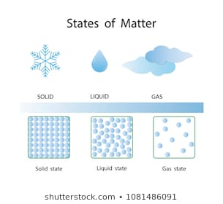

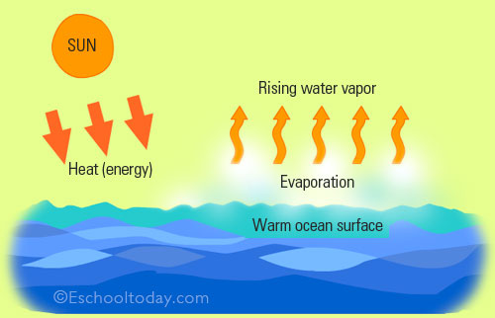

A form that matter can exist in. (Solid, liquid or gas)

**state**

The vapour (gas) that water turns into when heated.

**steam**

A measurement of how hot or cold something is.

**temperature**

**thermometer**

An instrument for measuring temperature.

**Key Skills in Science**

**What I will know and be able to do at the end of the topic.**

**What I should be able to do and know now.**

* I can make systematic and careful observations.
* I can set up some simple practical enquiries, including comparative tests.
* I am beginning to collect data in a variety of ways, including labelled diagrams, bar charts and tables.
* I am beginning to talk about and identify differences and similarities in the properties of materials.
* I am beginning to identify simple changes related to simple scientific phenomena.
* I am beginning to discuss criteria for grouping and sorting and can classify using a simple key.

**Knowledge:**

* To know that we get solids, liquids and gases.
* To know that solids are hard.
* To know that liquids are runny.
* To know that we cannot see gases in the air.
* To know that when water heats up it disappears/ dries up.
* To know that when ice/ snow gets hot it turns to water.

**Skills:**

🞄Draw a solid object and a liquid in a container.

🞄Draw a table to collect results for an experiment.

🞄Explain in small steps how a process happens.

**Knowledge:**

**Can you name the 3 states of matter? Give 2 examples of each one.**

**Can you explain the process of evaporation?**

When a liquid _________ it turns into a ______.

**Can you explain the process of condensation?**

When a gas _________ it turns into a ______ on a _________ surface.

**Can you explain a test to find out the temperature that water turns into a gas? How would you make it fair?**

**Can you explain the water cycle? D**raw a diagram to show it.

Can you link this to your knowledge of countries around the world?

**Skills:**

Draw a diagram showing the formation of the particles in a solid, liquid and a gas.

Create a table using a ruler for collecting data from my research.

Explain how to make it a fair test when carrying out an experiment and carry this out in practice.

**What I will be learning**

* To compare and group materials together according to whether they are solids or liquids.
* To identify and explore the properties of gases.
* To observe that materials change state when they are heated or cooled.
* To research the temperature in degrees Celsius (°C) at which materials change state.
* To understand the process of evaporation.
* To understand the process of condensation.
* To identify the part played by evaporation and condensation in the water cycle and associate the rate of evaporation with temperature.