

**Geography – Where we are and what we do**

**Vocabulary**

**Skills**

**Books**

* Make a simple sketch map.
* Take photographs of my local area.
* Name countries and cities in the UK.
* Locate countries and cities in the UK on a map.
* Point out human and physical geographical features.

Farming, this can be the farming of animals or the farming of crops.

**agricultural**

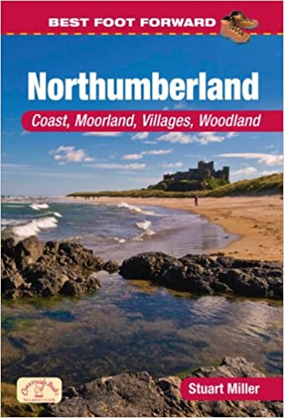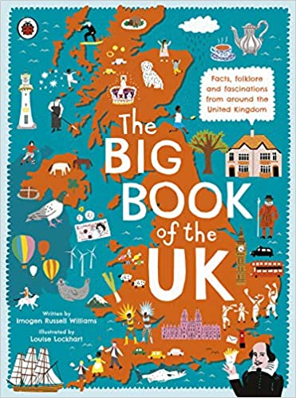

To do with businesses, shops and making money.

**commercial**

Geography dealing with how human activity affects or is influenced by the earth's surface.

**human features**

Places or areas very close to where you are.

**local**

**Knowledge**

What an area of land is used for, for example; housing, farms, shops.

**land use**

Discover and find the exact place or position of something.

**locate**

**By the end of this topic you will have increased your knowledge of our local area and have expanded it to the wider world and be able to:**

* Describe different types of settlement and land use.
* Name and locate countries and cities in the UK.
* Make a simple sketch map of the human and physical features in your local area.
* Take photographs of your local area to help you make a map.

An image or picture taken using a camera.

**photograph**

Geography dealing with things that occur naturally on earth. e.g. Weather, hills, rivers.

**physical features**

Areas of land with homes that people live in.

**residential**

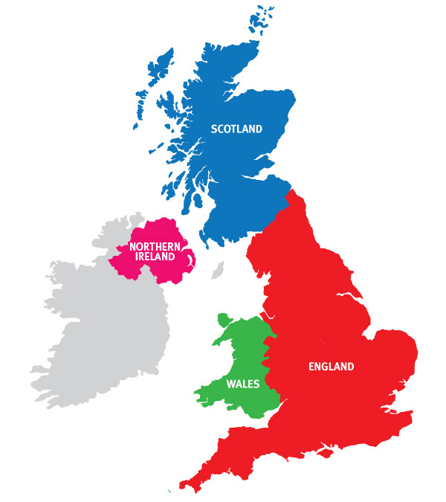

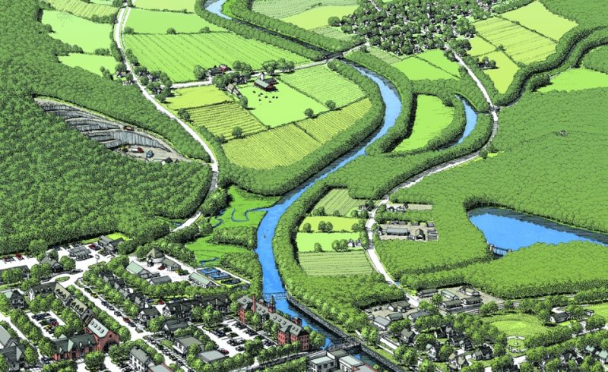

A place where people have moved to and have built up and established a community.

**settlement**

A roughly drawn map that shows basic details.

**sketch map**

The United Kingdom, made up of England, Scotland, Northern Ireland and Wales.

**UK**

**What I should be able to do and know now.**

**What I will know and be able to do at the end of the topic.**

**Key skills in Geography**

**Knowledge:**

* Can you describe our location within the UK?
* What does land use mean? Can you name some types of land use?
* What is agricultural land use?
* What is residential land use?
* Why is it important to take photos of human and physical features when creating a map?
* Can you name some physical and human features in your local area?

**Skills:**

* Attempt to make a sketch map of an area studied.
* Use standard symbols on maps.
* Give and follow directions using 4 points on a compass.
* Use photographs to create a map.
* To describe and understand key aspects of physical geography including; climate zones, rivers, coasts, mountains, earthquakes, volcanoes and tsunamis.
* To name and locate countries and cities in the UK, geographical features and some topographical features (hills, mountains, coasts, rivers).
* To use simple symbols and the key when reading maps.

**Knowledge:**

* Houses and shops are built on land.
* Towns are made of lots of houses and buildings.
* Countryside often surrounds villages and towns.
* Farms need lots of fields and space.
* People have moved to live in certain areas and build homes there.

**Skills:**

* Name some local towns and villages.
* Use a camera to take a photograph.
* Draw a map including some local features.
* Name features of a town.

**What I will be learning**

**As well as increasing your knowledge of our local you will learn to:**

* Describe different types of settlement and land use.
* Name and locate countries and cities in the UK.
* Make a simple sketch map of the human and physical features in your local area.
* Take photographs of your local area to help you make a map.