Maths Key Skills Stage 2: Skill Check 6

Name: ___________________________________ Date: _______________ Class/Group: _______________________________

A: Place Value, Add and Subtract |  | B: Multiply, Divide and Fractions |  |  | C: Measure and Geometry
1. What is the missing number?  0 2 4 6 10 12 | 2:1 | 11. 35 ÷ 5 = |  | 2:11 | 21. Estimate the weight  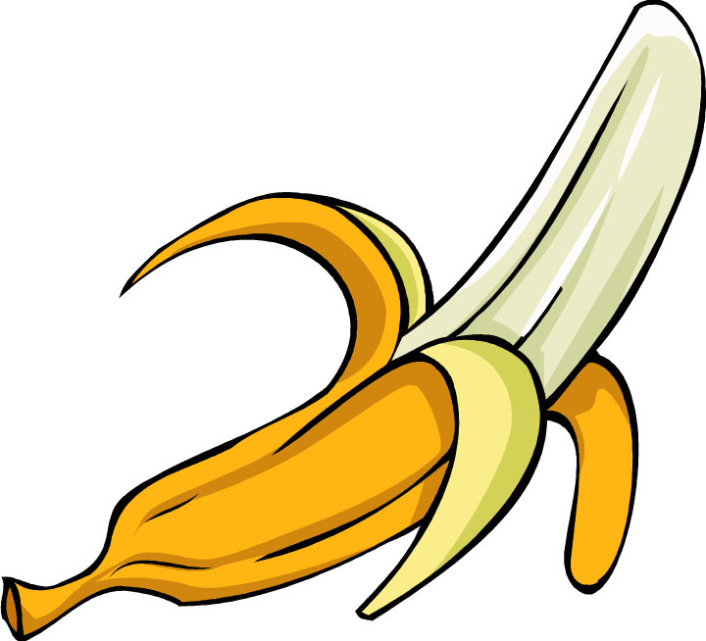  of a banana. Write a, b or c.  a. about 15g  b. about 150g  c. about 15kg |  | 2:17
2. What is the value of the 4 in this number? 49 | 2:2 | 12. Which are the odd numbers?  3 6 9 12 |  | 2:11 |  |  | 2:17
3. What number is labelled?  15  20 | 2:3 | 13. What symbol is missing?  4 6 = 24 |  | 2:12 | 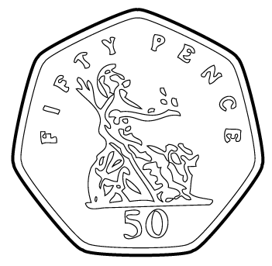  22. How many ten pence  (10p) coins are the  same value as a  fifty pence (50p) coin? |  | 2:19
4. Which numbers are > 15?  12 14 16 18 | 2:4 | 14. What symbol is missing?  30 ÷ 6 5 |  | 2:12 |  |  | 2:19
5. Write this number in numerals.  fifty three | 2:5 | 15. Is this true? Write ‘yes’ or ‘no’.  10 ÷ 5 = 5 ÷ 10 |  | 2:13 | 23. Katie has sixty pence (60p).  She spends forty-five pence (45p).  How much money does she have left? |  | 2:20
6. There are 30 children in a class. 12 are girls. How many are boys? | 2:6 | 16. 4 children share 32 sweets.  How many sweets does each child get? |  | 2:14 |  |  | 2:20
7. 20 - 7 = | 2:7 | 17. 4 teams enter a 7-a-side contest. How many players are in the contest? |  | 2:14 | 24. Which is longest? Write a, b, or c.  a. an hour  b. 80 minutes  c. quarter of an hour |  | 2:21
8. 58 - 10 = | 2:8 | 18. Write the fraction one half in numerals. |  | 2:15 |  |  | 2:21
9. Is this true? Write ‘yes’ or ‘no’.  17 + 18 = 18 + 17 | 2:9 | 19. How many quarters are in 2 whole ones?  1  2 |  | 2:15 | 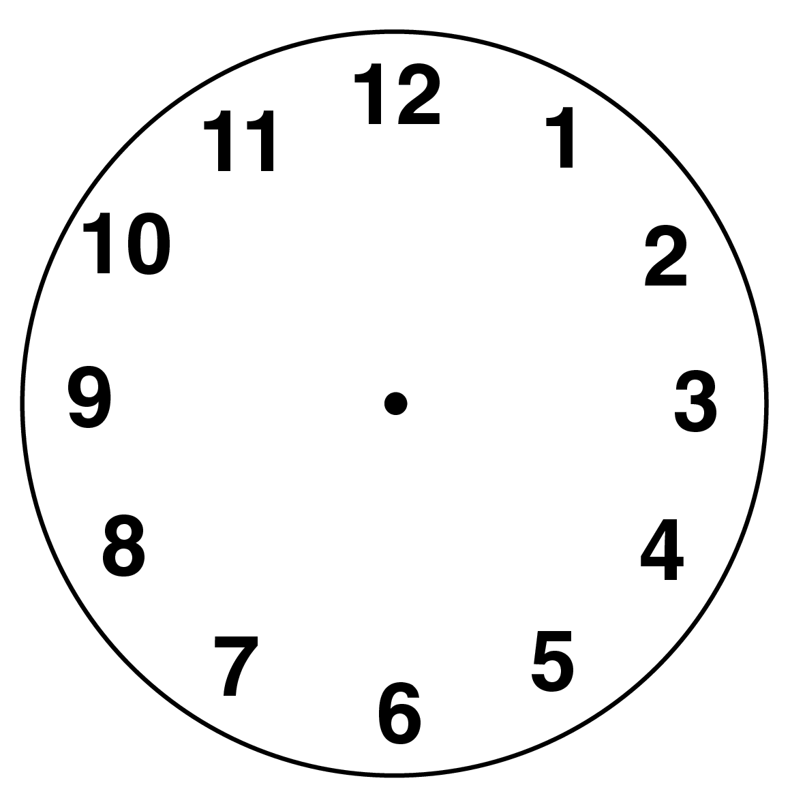  25. Draw the hands  to show  Quarter to four. |  | 2:22
10. Use 65 + 18 = 83 to help find:  83 - 18 = | 2:10 | 20. What is of 14 ? |  | 2:16 |  |  | 2:22
Total (A) |  | Total (B) |  |  | Total (C)
Test Total (A+B+C) |  | R (0-9) | Y (10-19) |  |  | G (20-25)

