Music – Year 1 – spring 1 and 2 – Into the Groove
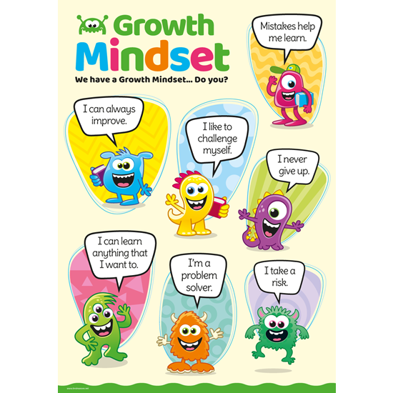
Music Genres & Knowledge

How pulse, rhythm and pitch work together by mixing styles. The learning is focused around one song: Into the Groove by Joanna Mangon and is arranged into different styles:

Blues - How Blue Can You Get - B.B. King
Baroque - Let The Bright Seraphim by George Frederick Handel
Latin - Livin’ La Vida Loca - Ricky Martin
Bhangra - Jai Ho - J.R. Rahman
Folk - Lord Of The Dance - Ronan Hardiman
Funk - Diggin’ On James Brown - Tower of Power

● Do you like the song? ● What can you hear? ● What is the style of this music?
● How is the song put together? ● What is the structure/form/shape of the song?
Growth Mindset Strategies
Skills

Listen to a variety of musical styles.
Perform – Into the Groove
Learn to play [glockenspiel] together.
Play instrumental parts in the song.
Improvise using voices and instruments.
Start to use correct musical language.

Vocabulary | Meaning
beat | To make a regular movement or sound.
composition | A piece of music that someone has written.
conductor | Someone who directs a performance of musicians or a piece of music.
dynamics | Changes in loudness in a piece of music
ensemble | A group of musicians who regularly play together.
instrument | An object, such as a piano, guitar, or drum, that is played to produce musical sounds.
improvisation | A performance that a musician has not practised or planned.
melody | A tune, often forming part of a larger piece of music.
pitch | To express or set something at a particular level.
pulse | A steady beat.
rhythm | A strong pattern of sounds or musical notes that is used in music and dancing.
tempo | The speed at which a piece of music is played.
vocal | Relating to or produced by the voice in singing.

