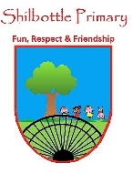
Science - Year 1 – spring 2 - Materials
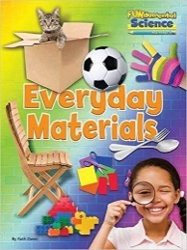
00
Knowledge
Objects are things that you can touch or see.
Objects are made from materials.
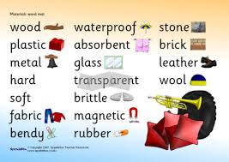

Skills
Ask and enquire.
Sort and classify.
Observe closely using simple equipment.
Perform simple tests.
Identify and classify.
Gather and record data.
Talk about your learning
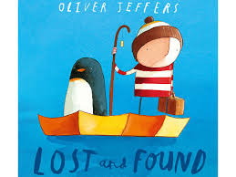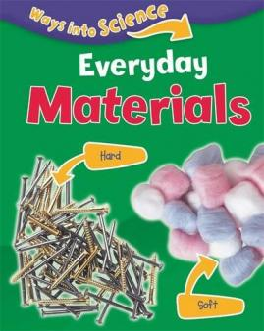
Books

Vocabulary | Meaning
absorbent | A material that soaks up liquid easily.
bendy | An object that bends easily into a curved shape.
dull | A colour or light that is not bright.
elastic | A rubber material that stretches when  you pull it and returns to its original size and shape when you let it go.
manmade | Things that are created by people.
natural | Things that exist in nature and are not  made by people.
opaque | If an object or substance is opaque,  you cannot see through it.
rough | Uneven and not smooth.
shiny | Things that are bright and reflect light.
smooth | No roughness, lumps or holes.
stiff | Firm or does not bend easily.
stretchy | Slightly elastic.
transparent | If an object is transparent, you can see  through it.
waterproof | Does not let water pass through
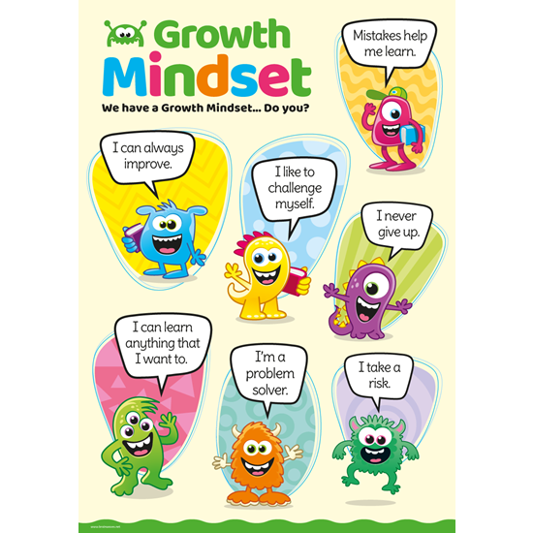
What I will know and be able to do at the end of the topic.
Growth Mindset Strategies

What I should be able to do and know now.
Knowledge
What is a material? A material is something an object is made from. This includes metal, fabric, plastic, stone and wood.
Can you identify which material a common object is made from? I can identify an object made from wood, plastic, metal, stone and glass.
Can you describe a material by its properties? – I can use the words rough, smooth, hard, soft, shiny, dull, stretchy, opaque, transparent to describe objects.
Why do some materials suit certain objects better than others? –
Why are houses made out of brick? – They are hard, rigid and tough.
Why are clothes made out of fabric? – It is flexible and stretchy.
Why are tables made of wood? – It is hard and sturdy.
What is the best material for an umbrella? – A fabric that is waterproof is the best material for an umbrella so it does not let the rain in.
Skills – I can predict and test the best materials for a particular purpose
Knowledge
Objects feel and look different based on the material they are made from.
We use different materials when painting and making art.
Skills
I can listen attentively in a range of situations.

I can answer ‘how’ and ‘why’ questions about my experiences and in response to stories or events.

I can talk about the features of my own immediate environment and how environments might vary from one another.

What I will be learning

- How to sort materials according to what they are made of.
- Identifying objects that are made from a particular material.
- Grouping materials according to their properties.
- How to carry out an experiment to test the suitability of materials for a particular purpose.

