Maths Key Skills Stage 4: Skill Check 1

Name: ___________________________________ Date: _______________ Class/Group: _______________________________

A: Place Value, Add and Subtract |  | B: Multiply, Divide and Fractions |  |  | C: Measure and Geometry
1. What is the missing number?  18 36 45 54 | 4:1 | 11. 42 ÷ 6 = |  | 4:9 | 21. How many metres (m) are in  3.5 kilometres (km)? |  | 4:19
2. What is the missing number?  49 56 63 77 | 4:1 | 12. Two factors of 28 add up to 9. What are they? |  | 4:10 |  |  | 4:19
3. What is 1,000 more than 150? | 4:2 | 13. 234 x 5 = |  | 4:11 | 22. The sides of a rectangle are 2m and 6m.  What is the perimeter  of the rectangle? |  | 4:20
4. Round this number to the nearest 10: 1,543 | 4:2 | 14. In a class of 18 there are 2 girls for every 1 boy. How many girls are there? |  | 4:12 |  |  | 4:20
5. What is 3 – 5? | 4:3 | 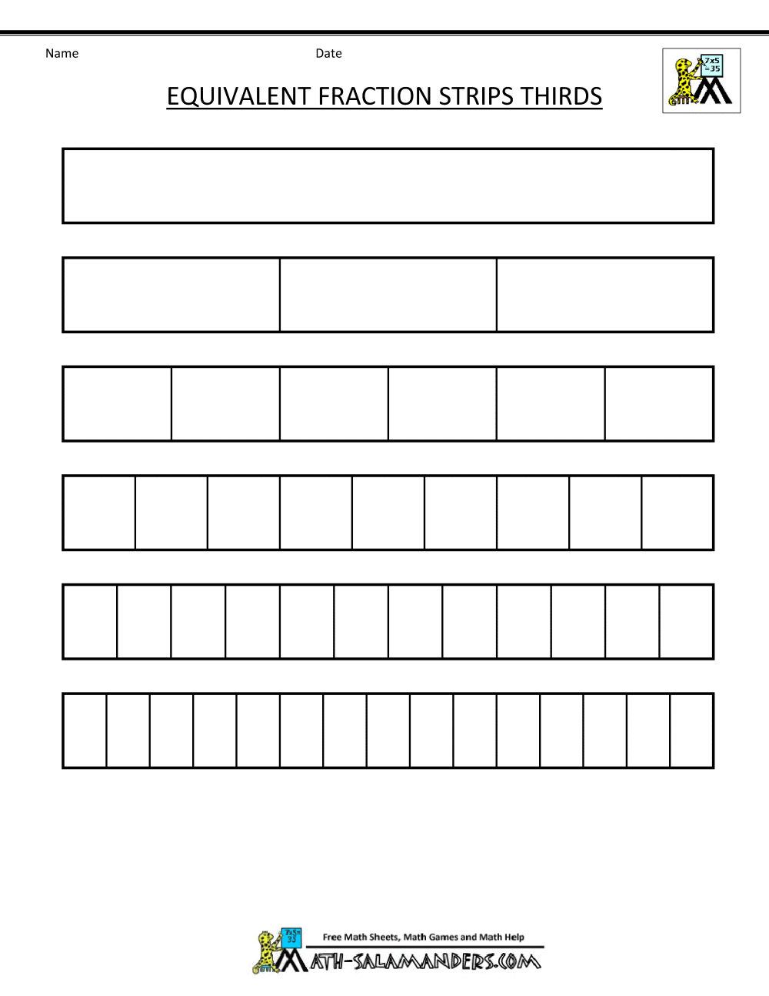  15.  1  3  ?  15  = |  | 4:13 | 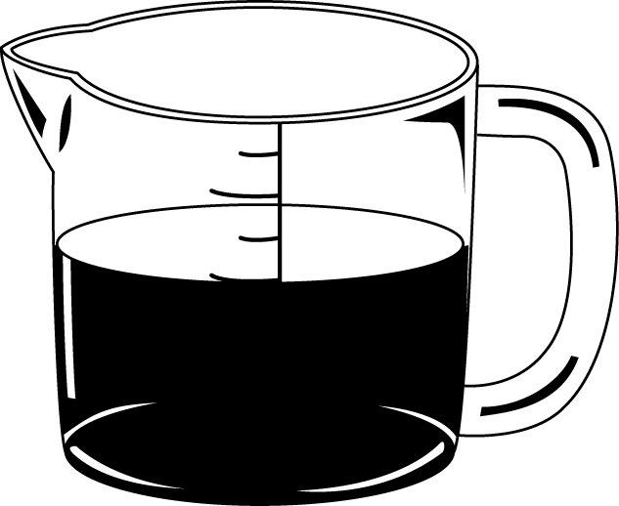  23. About how much is in this 1 litre jug? Write a, b or c.  a. about 250ml  b. about 550ml  c. about 750ml |  | 4:21
6. What is the value of the 2 in this number? 2,789 | 4:4 | 16. What is the missing number?  1.72 1.73 1.74 1.76  3  13  6  13 |  | 4:14 |  |  | 4:21
7. Write the number 22 in Roman numerals. | 4:5 | 17.  1  4  + |  | 4:15 | 24. How would 2 pm be shown on a 24 hour digital clock?  : |  | 4:22
8. 4,528 - 216 = | 4:6 | 18. Write as a decimal number. |  | 4:16 |  |  | 4:22
9. Write the sum to check 239 + 154 = 393: 393 - = | 4:7 | 19. 23 ÷ 100 = |  | 4:17 | 25. What is the special  name for this type  of triangle? |  | 4:23
10. I have £1. I spend 34p then 45p. How much do I have left? | 4:8 | 20. Round 3.4 to the nearest whole number. |  | 4:18 |  |  | 4:23
Total (A) |  | Total (B) |  |  | Total (C)
Test Total (A+B+C) |  | R (0-9) | Y (10-19) |  |  | G (20-25)

