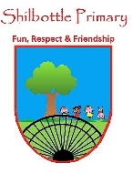

**Art – Year 6 – Spring 1 – Street Art**

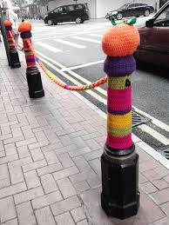

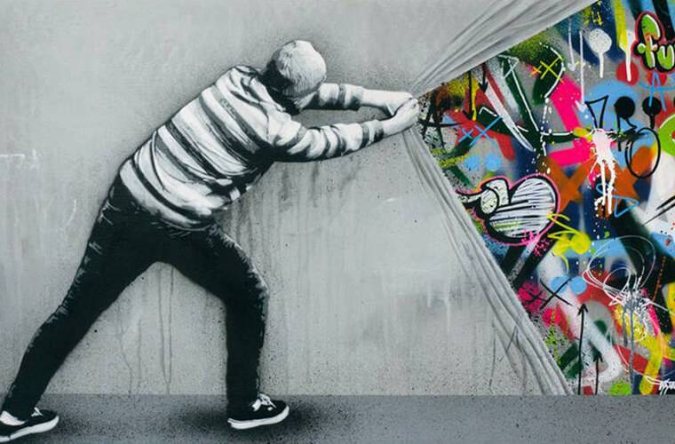

**Knowledge**

The history of **graffiti**: New York ‘**taggers**’ sprayed their ‘**throwies**’ on the sides of subway trains before moving to the streets of New York City. This was **vandalism**. City authorities decided to designate spaces where **graffiti** was allowed to discourage it elsewhere. The spaces became popular with tourists. Today, street artists look at using unusual methods and materials such as plastic bricks to repair cracks in walls or ‘**Guerrilla crochet**’ where artists knit crochet decorations around everyday objects in the street.

**Skills**

Use sketch books to review and revisit ideas.

Improve mastery of art and design techniques, including drawing, painting and sculpture.

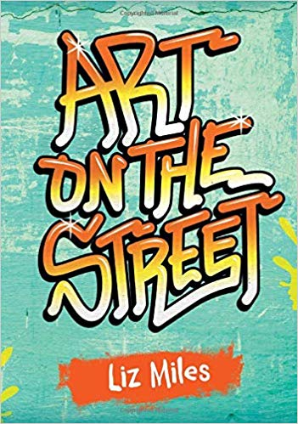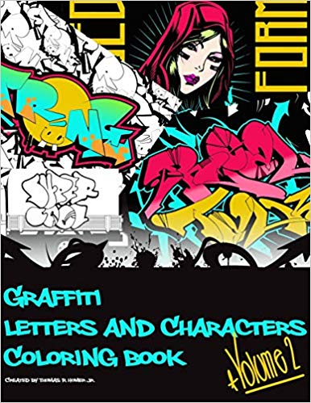

**Books**

|  |  |
| --- | --- |
| Vocabulary | Meaning |
| **annotate** | Add notes to a text or diagram giving explanation or comment. |
| **antisocial** | Contrary to the laws and customs of society, in a way that causes annoyance and disapproval from others. |
| **Banksy** | An anonymous England-based street artist. |
| **graffiti** | Writings or drawings scribbled, scratched, or sprayed illicitly on a wall or other surface in a public place. |
| **Guerrilla crochet** | Sometimes known as ‘Yarn Bombing’. A type of graffiti that employs colourful displays of knitted or crotcheted yarn |
| **polarise** | Cause to divide into two sharply contrasting sets of opinions. |
| **political** | Relating to the government or public affairs of a country. |
| **satirical** | Criticising people or ideas in a humorous way, especially in order to make a political point. |
| **tag** | The most basic writing of an artist’s name. A personalised signature. |
| **throwie** | A piece of graffiti produced relatively quickly. |
| **vandalism** | Action involving deliberate destruction of or damage to public or private property. |

**Concept Links**

**What I will know and be able to do at the end of the topic.**

**What I should be able to do and know now.**

https://lh6.googleusercontent.com/KIJNmnllcmNugCGeE23ABLdV038CshfwDnBVzw-7sIFHOm10UeInCmGRoP0ZwiDgvt5mIByf9x9eFYi7lzEYXonEfKzz5FdqehufwxH2VhKS06fKgcMWcLQvVmTlL_Hfryit5N58 https://lh5.googleusercontent.com/xvjOGcg3svNDV9O0oWcbkzZVdJqiJITEIj6lPeswkl3lDHX-KJGOSxSUnfCvUndhUjBkIPeHczqYFWUiIwjY-65Q4m0YL98T2HMDyMrX9Nj5pz0YCskRKktzH4MvIpzfLnYx92-t

Creating a sketchbook Drawing and Painting

https://lh6.googleusercontent.com/DYDz6qHpXV31po7IkjnI0tkc4MnsfEJpYS3LBp_AMXc2OCzei5IaBl_V0VlNJIjMf5iTBl3y3FnX3kDIDzdjMZS0qXnrO7y2fSf7z0hu6HvBSnrx2Kx-3xya47SrCVvu0gb2P7QN https://lh5.googleusercontent.com/NTez087FozgPWfSR3h5gtIacyKQPT3eS9IyGtBjYet7T_IofeaM7a2Dmwgol_lmGOkwjEiKuIS8HXFUWlRT-cROaSkkDMKN0IZZQuZjCRAphPG9wg2AILfMVEnw9CM41tiojKrAp

Using materials Using Art techniques

**Knowledge**

Street art polarises opinion because …

Street art polarises opinion, but …

Street art polarises opinion, so …

Street art can improve public spaces because …

Street art can improve public spaces, but …

Street art can improve public spaces, so …

Street artists use satire to improve a wrongdoing because …

Street artists use satire to improve a wrongdoing, but …

Street artists use satire to improve a wrong doing, so …

**Skills**

Using a sketchbook to revise and improve ideas is important because …

Using a sketchbook to revise and improve ideas is important, but …

Using a sketchbook to revise and improve ideas is important, so …

**Knowledge**

I can explain what I can see in different sections of a picture.

I understand how to identify similarities and differences in art.

I am able to talk about my art work.

I am able to choose the right equipment and tidy up my equipment during my art work.

**Skills**

I know how to draw with a range of equipment.

I can show my observational skills by drawing what I can see.

Be able to identify key features in a picture.

**What I will be learning**

1. Through sketching, to develop ideas and techniques for art work comprising stylised graffiti lettering.
2. Through sketching, develop ideas for improving a public space with street art.
3. To express ideas through a satirical work of art designed for public places.
4. To develop techniques for creating street art using stencils.
5. To create street art using stencils.

