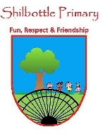
P.S.H.E. – Celebrating difference
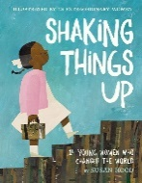
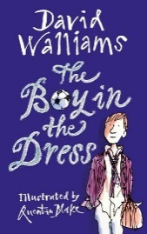
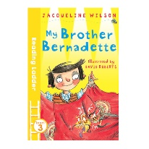
Knowledge

During this topic, the children will learn about and celebrate differences amongst us and others around the world.
Challenge your own preconceptions, as well as those of others and to think about the negative effects of both stereotyping and discrimination on others.
Children will learn how to identify stereotypes and challenge stereotypical thinking looking also at indirect and direct bullying.
Understand the meaning of the words stereotype, discrimination, indirect and direct bullying, culture and conflict.
Discover what makes up their own identity.

Skills
Identify similarities and differences between one another.
To understand and emphasise with others.
Develop an understanding of types of bullying and how they happen.
Talk about and explain your learning.

Books

Vocabulary | Meaning
bullying | Bullying is done on purpose, it’s not an accident. If someone hurts you during a game by accident that is not bullying, but if every time you played a game they hurt you, or your feelings that would be bullying.
conflict | When 2 individuals or sides do not agree, it can lead to an argument or tension.
culture | The ideas, customs, and social behaviour of a particular people or society.
developing world | - Areas that are seeking to become more advanced economically and socially.
differences | Variety between things/ people, not everyone is the same.
direct bullying | Behaviour that hurts, harms, or humiliates and is overt and obvious to anyone witnessing it
discrimination | The unjust or prejudicial treatment of different categories of people, especially on the grounds of race, age, sex, or disability.
indirect bullying | Behaviour that hurts, harms, or humiliates, which is often covert, subtle, and not always immediately acknowledged as bullying.
race | A race is a categorization of humans based on shared physical or social qualities into groups.
racism | The belief that different races possess distinct characteristics, abilities, or qualities, especially so as to distinguish them as inferior or superior to one another.
rumours | A story or report that is circulated that has not been verified true.
similarity | Something which is the same or very close in likeness.

Key skills in PHSE
What I will know and be able to do at the end of the topic.
What I should be able to do and know now.

Knowledge

Explain what the word ‘culture’ means? Can you give an example?

What is the difference between direct bullying and indirect bullying? Use examples to help explain.

If someone is racist. What does this mean?

What does the word prejudice mean?

Compare your culture with the culture of someone else. What are the similarities? What are the differences?

Skills
Listen to other peoples’ points of view and opinions.

Make comparisons between my own and other’s beliefs.

Recognise racist, stereotypical and prejudice behaviours.

- Making decisions and choices.
- Managing pressure and stress.
- Managing risk and personal safety.
- Active listening.
- Analysing and evaluating situations.
- Communicating ideas and views to others.
- Self-reflection Managing risk and personal safety.
- Setting challenging goals for self.

Knowledge
To know that it is wrong to tease or bully someone.
What is right and wrong.
How their actions or words may make others feel.
To understand that people are different and can have different challenges to them.
Recognise what makes us different and similar,
To know that sometimes people pick on others for what they look like.
Skills
Recognise what is fair / unfair in their actions.
Recognise what is right / wrong in their actions.
Recognise kind / unkind actions in themselves and other children.
Understand tolerance.

What I will be learning

- To understand that cultural differences sometimes cause conflict.
- To understand what racism is.
- To understand that name-calling and rumour-spreading can be bullying behaviours.
- To know the difference between indirect and direct bullying.
- To compare my life with people who are in the developing world.
- To describe and understand a different culture to my own.

