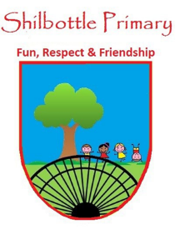
Year 5 Spelling List – Summer 2
Dear Parents/Carers,
Below is a copy of the spellings which will be tested this half term. The spellings will be a mix of a general spelling rule each week as well as some statutory UKS2 spellings.
Spelling homework should be handed in by Thursday each week. The children are expected to copy out the 10 spelling words and then write a sentence for each word which shows their understanding of the word meanings. Please note - This may not be enough to learn the spellings completely, it is expected that the children will carry out further practice at home of the spellings, in preparation for the spelling test on Friday.

Week 1  Test date: 9/06/2023 | Week 2  Test date: 16/06/2023 |  | Week 3  Test date: 23/06/2023
Spelling rule  Words ending in –ant, -ance, -ancy  substance  distance  assistance  observance  instance  hesitance  Year 5 and 6 spellings  appreciate  competition  identity  occur | Spelling rule  Words ending in shus spelt -cious  gracious  malicious  atrocious  ferocious  suspicious  spacious  Year 5 and 6 spellings  communicate  thorough  nuisance  definite |  | Spelling rule  Words ending in shus spelt -tious  fictitious  cautious  ambitious  infectious  superstitious  scrumptious  Year 5 and 6 spellings  leisure  frequently  explanation  available
Week 4  Test date: 30/06/2023 | Week 5  Test date: 7/07/2023 | Week 6  Test date: 14/07/2023 | Week 7  Test date: 21/07/2023
Spelling rule  Words ending in shul spelt –cial or -tial  partial  confidential  initial  presidential  torrential  influential  Year 5 and 6 spellings  Controversy  Individual  Exaggerate  especially | Spelling rule  Words from the term  suspicious  leisure  instance  influential  cautious  malicious  observance  torrential  identity  distance | Spelling rule  Words from the year  whistle  rhythm  considerable  obedient  suspicious  instance  assistance  torrential  ambitious  partial | No test this week as last day before summer.

