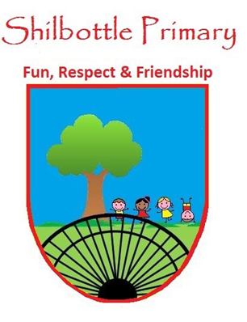
Year 2 Spelling List – Autumn 2
Dear parents/carers,
Below is a copy of the spellings which will be tested this half term. There will be a general spelling rule each week with 3 high frequency words at the end. These words will no longer be placed into books on a weekly basis and therefore this list should be kept in a safe place. You may also find it useful to take a photo on a smartphone to keep a record of the words which will enable you to support your child’s learning beyond the home. A copy of these words will also be available from the school website should you need to replace them. Many thanks for your continued support.
Week 1  Test date 5th November | Week 2  Test date 12th November | Week 3  Test date 19th November
- shy  - sky  - try  - cry  - reply  - terrify  - multiply  - butterfly  - why  - rely  Spelling rule: igh sound spelt with a y | - stopping  - shopping  - slipping  - chatting  - nodding  - beginning  - dropping  - running  - skipping  - gripping  Spelling rule: adding the suffix ing when the word ends in a short vowel sound and a consonant | - making  - baking  - smiling  - sliding  - shining  - shading  - tickling  - chuckling  - writing  - racing  Spelling rule: adding the suffix ing when the word ends in e
Week 4  Test date 26th November | Week 6  Test date 3rd December | Week 7  Test date 10th December
- join  - jacket  - gentle  - giant  - large  - fringe  - charge  - badge  - bridge  - hedge  Spelling rule: the j sound spelt with a j, g, ge, dge | - want  - wash  - was  - watch  - wand  - squat  - quarrel  - quantity  - squash  - quality  Spelling rule: the o sound spelt with an a after qu and w | - painted  - hunted  - jumped  - popped  - hugged  - shopped  - hummed  - skipped  - slipped  - clapped  Spelling rule: adding the suffix ed
The last test on 24th October will be a combination of all the words

