

**RE – Why is the Bible important to Christians?**

**Vocabulary**

**Skills**

**Books**

* To be able to retell a story from the Bible accurately.
* To explain the importance of the Bible to Christians.
* To describe the features/ set up of the Bible.

To accept that something is true, even without proof.

**believe**

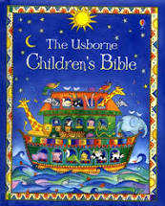

The Christian book made up of the Old and New testaments.

**Bible**

People who believe in the religion of Christianity.

**Christians**

A building used for Christians to come and worship.

**church**

**Knowledge**

To Christians, the creator and ruler of the universe.

**God**

The name of a man who Christians believe was the son of God.

**Jesus**

**By the end of this topic you will learn:**

* About how the Bible is structured; the Old testament and the New testament and what each involves.
* Learn some of the stories from the Bible and understand the meanings of them.
* Why the Bible is an important book for Christians in their daily lives and worship of God.

The second part of the Bible. It tells about the life and teachings of Jesus and his earliest followers.

**New testament**

The first part of the Bible, made up of 39 books.

**Old testament**

A short, well-known saying that states advice.

**proverb**

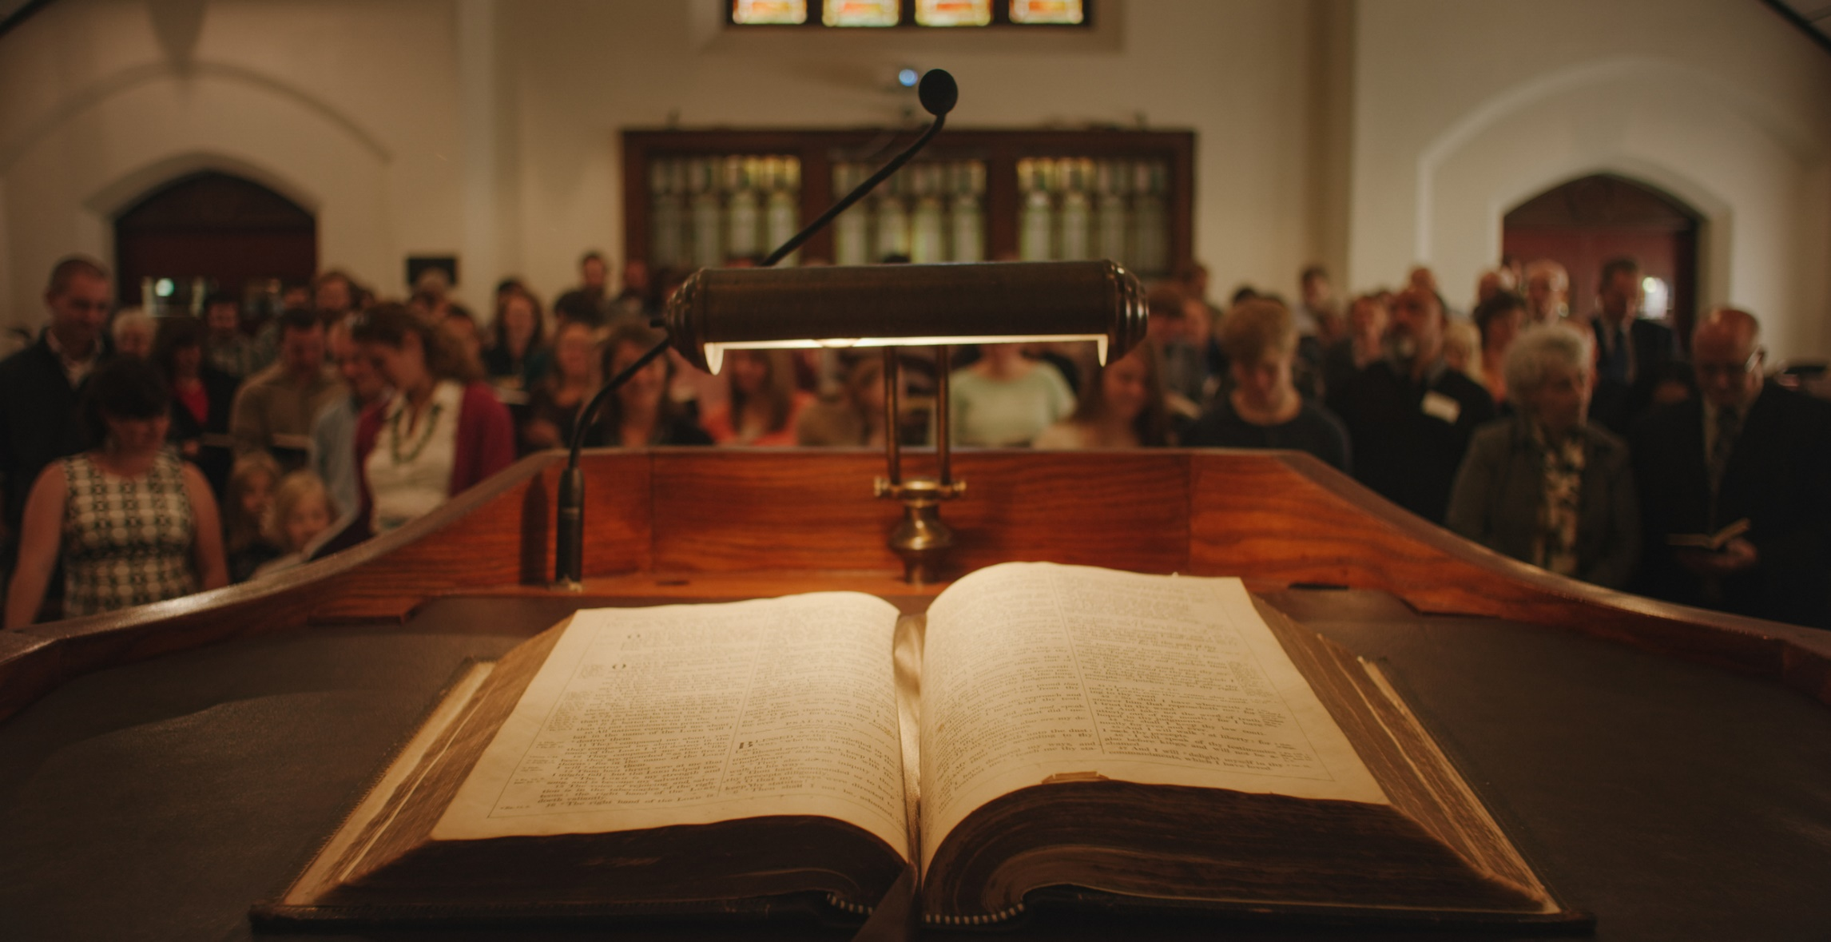

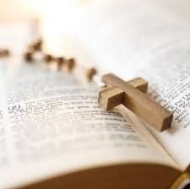

An account of events that have happened. It can be real or made up.

**story**

Swapping words from one language to another.

**translations**

The act of addressing and adoring an important person.

**worship**

**What I should be able to do and know now.**

**What I will know and be able to do at the end of the topic.**

**Key skills in RE**

**Knowledge:**

* The book that contains all of the Stories about Jesus is the B_______.
* The bible is made up of 2 parts;
* the O___ T_________ and the N____ T_________.
* The Bible contains different types of writing. Can you name 3 types?
* Explain why the Bible is important to Christians? Give 2 reasons.

**Skills:**

* Identify the impact the Bible has on Christians’ lives.
* Describe some of the features of the Bible.
* Retell some stories form the Bible.
* Interpret the meaning behind the Stories of Jesus’ teachings.
* Begin to identify the impact religion has on believers’ lives.
* Recognise and name some features of religious life and practice.
* Describe some of the beliefs and features of a religion, recognising similarities and differences.
* Ask important questions about religion and beliefs.
* Show awareness of other peoples’ views.

**Knowledge:**

* To know that Jesus is important to Christians.
* The Bible is the book that Christians use.
* The Bible is a book about Jesus.
* Bibles are found in Churches.
* Churches are where Christians go to think about God and Jesus.

**Skills:**

* Retell a story in order of what happened.
* Name characters from a story.
* Draw a picture to illustrate a story.

**What I will be learning**

* To identify and describe ways in which the Bible is important for Christians.
* To find out how Christians use the Bible at home and at church.
* To find out about the different kinds of writing in the Bible and why each is important.
* To learn about what makes a book special to different people.
* To find out how different genres of writing in the Bible show different aspects of God.
* To investigate the Old and New Testaments of the Bible