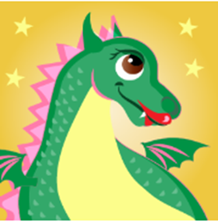
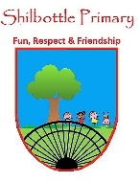
Music – Year 3 – Spring 1 – The Dragon Song
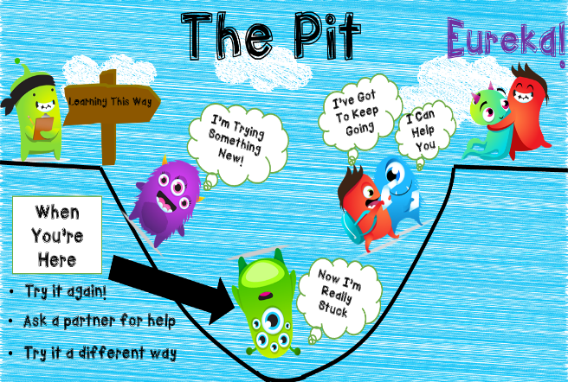  Growth Mindset Strategies  Music Genres & Knowledge  To learn and build upon your knowledge and understanding of pulse and rhythm to learn to sing, play, improvise and compose.  Traditional Folk Melodies  ● The Dragon Song by Joanna Mangona and Pete Readman  ● Birdsong - Chinese Folk Music  ● Vaishnava Java - A Hindu Song  ● A Turkish Traditional Tune  ● Aitutaki Drum Dance from Polynesia  ● Zebaidir Song from Sudan  ● Do you like the song? ● What can you hear? ● What is the style of this music?  ● How is the song put together? ● What is the structure/form/shape of the song?  Skills  Listen and appraise different songs.  Identify different instruments within songs.  Find the pulse, beat and rhythm. Use correct musical language.  Play instruments with notation.  Compose and evaluate their songs.  Vocabulary | Meaning
composition | A piece of music that someone has written.
conductor | Someone who directs a performance of musicians or a piece of music.
dynamics | Changes in loudness in a piece of music
ensemble | A group of musicians who regularly play together.
instrument | An object, such as a piano, guitar, or drum, that is played to produce musical sounds.
improvisation | A performance that a musician has not practised or planned.
melody | A tune, often forming part of a larger piece of music.
notation | A system of written symbols used to represent musical notes.
pitch | To express or set something at a particular level.
pulse | A steady beat.
rhythm | A strong pattern of sounds or musical notes that is used in music and dancing.
tempo | The speed at which a piece of music is played.
vocal | Relating to or produced by the voice in singing.

