Maths Key Skills Stage 3: Skill Check 8

Name: ___________________________________ Date: _______________ Class/Group: _______________________________

A: Place Value, Add and Subtract |  | B: Multiply, Divide and Fractions |  |  | C: Measure and Geometry
1. What is the missing number?  0 50 150 200 250 | 3:1 | 11. 72 ÷ 8 = |  | 3:10 |   23. One cup holds 330 millilitres of liquid. How much do 3 cups hold? |  | 3:19
2. What is the 3 worth in this number?  513 | 3:2 | 12. 12 x 8 = |  | 3:10 |  |  | 3:19
3. Write this number in words.  720 | 3:3 | 13. 34 x 4 = |  | 3:11 | 22. Tom bought 4 cans of pop that were 60p each. How much did they cost in total? Give your answer in pounds and pence. |  | 3:21
4. Estimate the labelled number?  0  100  50 | 3:4 | 14. I buy 6 packs of balloons. I have 30 balloons. How many are in each pack? |  | 3:12 |  |  | 3:21
5. Write a number that is smaller than 648 using the same three digits. | 3:5 | 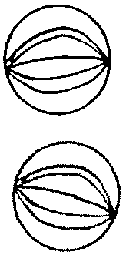  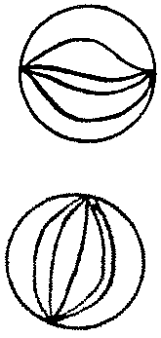  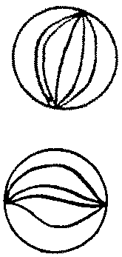  16. What fraction  is circled? |  | 3:13 | 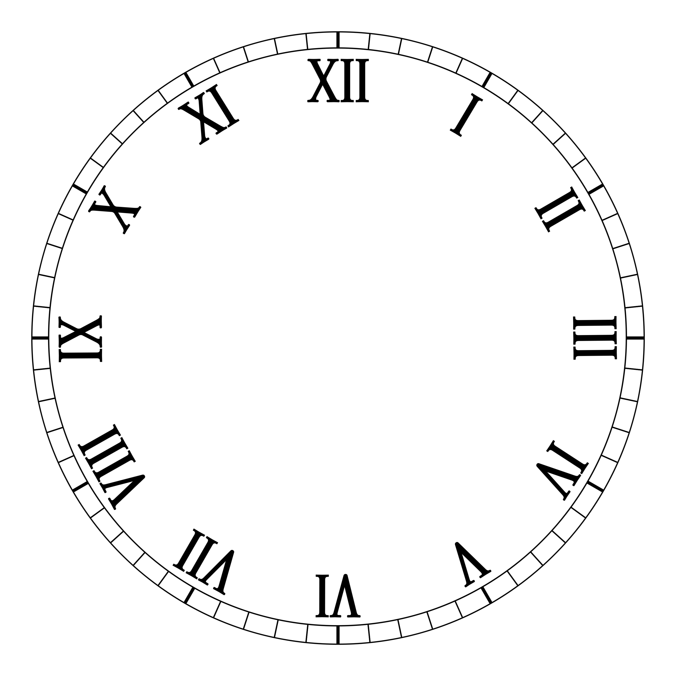  23. Draw hands on  the clock to show  Twenty five minutes  to four. |  | 3:22
6. 392 + 10 = | 3:6 | 16. What fraction  is shaded?  1  3 |  | 3:14 |  |  | 3:22
7. 528 - 64 = | 3:7 | 17. What is of 18? |  | 3:15 | 24. How many right angles make half a turn? |  | 3:27
8. Circle the best estimate to 79 + 101  170 180 190 200 | 3:8 | 18. This shape is in tenths.  2  5  Shade in . |  | 3:16 |  |  | 3:27
9. Use 18 + 34 = 52 to help solve:  520 – 180 = | 3:9 | 19. Add the  3  9  5  9  +  fractions. |  | 3:17 | 25. Circle the vertical line. |  | 3:28
10. What is the missing number?  148 - = 89 | 3:9 | 20. Write the  1  3  1  6  1  7  1  2  smallest fraction. |  | 3:18 |  |  | 3:28
Total (A) |  | Total (B) |  |  | Total (C)
Test Total (A+B+C) |  | R (0-9) | Y (10-19) |  |  | G (20-25)

