Maths Key Skills Stage 3: Skill Check 6

Name: ___________________________________ Date: _______________ Class/Group: _______________________________

A: Place Value, Add and Subtract |  | B: Multiply, Divide and Fractions |  |  | C: Measure and Problem Solving
1. What is the missing number?  0 4 8 16 | 3:1 | 11. 28 ÷ 4 = |  | 3:10 | 23. Alfie is 1m 12cm tall.  Zac is 91cm tall.  How much taller is Alfie than Zac? |  | 3:19
2. What is the 6 worth in this number?  361 | 3:2 | 12. 8 x 6 = |  | 3:10 |  |  | 3:19
3. Write this number in numerals.  four hundred and sixty two | 3:3 | 13. Use 9 x 6 = 54 to solve:  9 x 12 = |  | 3:11 | 22. What is the perimeter of this rectangle?  6cm  9cm |  | 3:20
4. What number is labelled?  0  40  20 | 3:4 | 14. What is the missing number?  4 x = 50 - 22 |  | 3:12 |  |  | 3:20
5. Make the largest number possible using the digits 6 4 8. | 3:5 | 15. What is the missing number?  0.7 0.8 0.9 1.0  4  10 |  | 3:13 |   23. Cans of pop are  60p each.  I have £2.  How many cans of  pop can I buy? |  | 3:21
6. 603 - 10 = | 3:6 | 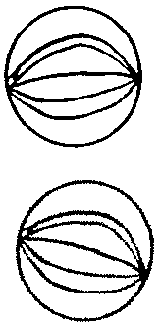  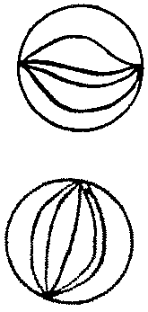  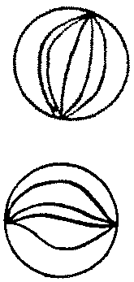  16. Circle  of the marbles.  1  4 |  | 3:14 |  |  | 3:21
7. 723 - 312 = | 3:7 | 17. What is of 12? |  | 3:15 | 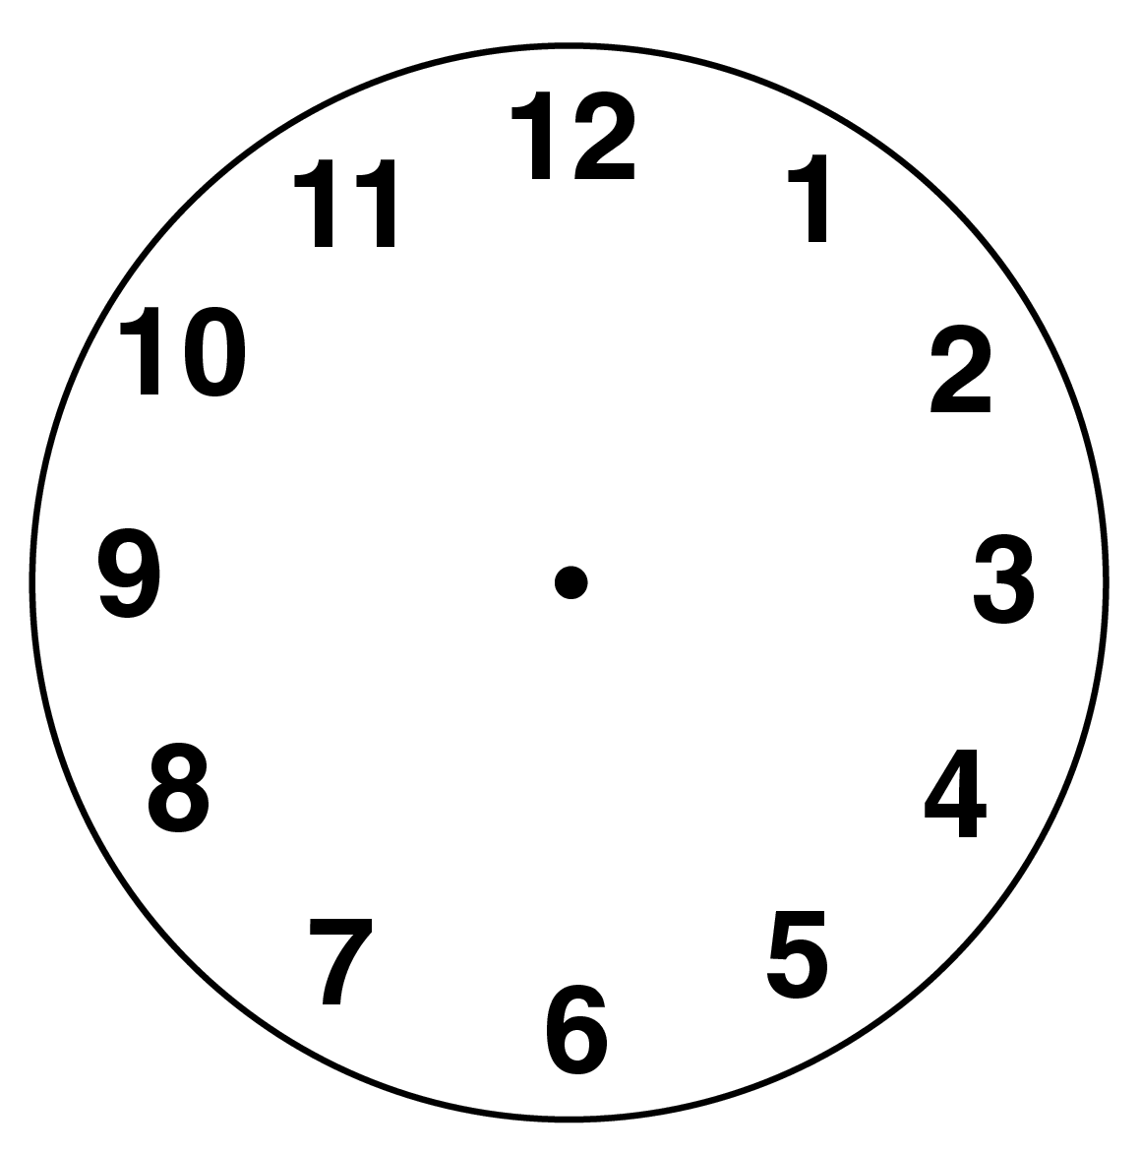  24. Draw the hands  to show  twenty five minutes  past eight. |  | 3:22
8. Circle the best estimate to 48 + 89:  110 120 130 140 | 3:8 | 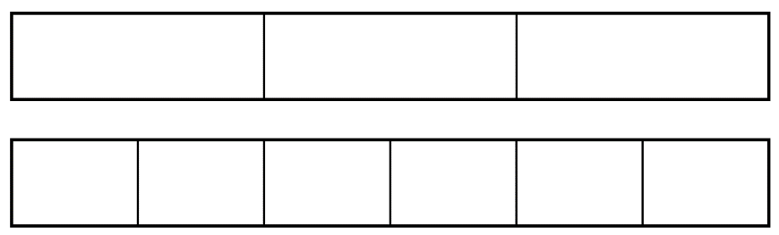  18.  1  3  ?  6  = |  | 3:16 |  |  | 3:22
9. One orange costs twenty pence. How much will five oranges cost? | 3:9 | 19. Add the  2  9  5  9  +  fractions. |  | 3:17 | 25. How many minutes are equal to 180 seconds? |  | 3:24
10. What is the missing number?  - 23 = 9 | 3:9 | 20. Write the  1  5  1  6  1  4  1  2  smallest fraction. |  | 3:18 |  |  | 3:24
Total (A) |  | Total (B) |  |  | Total (C)
Test Total (A+B+C) |  | R (0-9) | Y (10-19) |  |  | G (20-25)

