Maths Key Skills Stage 3: Skill Check 7

Name: ___________________________________ Date: _______________ Class/Group: _______________________________

A: Place Value, Add and Subtract |  | B: Multiply, Divide and Fractions |  |  | C: Measure, Geometry and Statistics
1. What is the missing number?  0 8 16 32 | 3:1 | 11. 21 ÷ 3 = |  | 3:10 | 23. About how long does it take to have a shower?  a. 10 seconds  b. 1 minute  c. 10 minutes |  | 3:23
2. What is the 5 worth in this number?  536 | 3:2 | 12. 7 x 4 = |  | 3:10 |  |  | 3:23
3. Put these in order, smallest first.  635 563 536 365 | 3:3 | 13. Use 9 x 5 = 45 to solve:  450 ÷ 9 = |  | 3:11 | 22. Which of these is a description of a square based pyramid?  a. I have 5 faces and 5 vertices.  b. I have 8 edges and 6 vertices.  c. I have 6 faces and 8 edges. |  | 3:25
4. Draw an arrow to label 20.  0  100 | 3:4 | 14. Eggs come in boxes of 6. I need 16 eggs. How many boxes should I buy? |  | 3:12 |  |  | 3:25
5. Circle all the multiples of 50.  25 100 75 125 150 | 3:5 | 15. If you split a shape into tenths, how many equal parts do you have?  2  5 |  | 3:13 | 23. Label two obtuse angles using the letter ‘O’. |  | 3:26
6. 139 - 100 = | 3:6 | 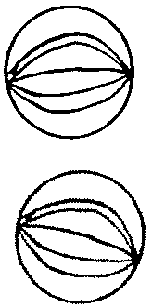  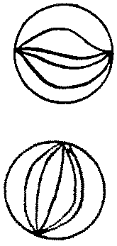  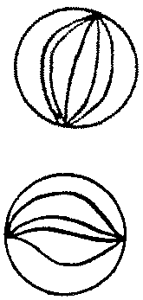  16. Circle  of the marbles. |  | 3:14 |  |  | 3:26
7. 325 + 274 = | 3:7 | 17. What fraction is labelled?  0  1 |  | 3:15 | 24. Favourite drinks of teachers:  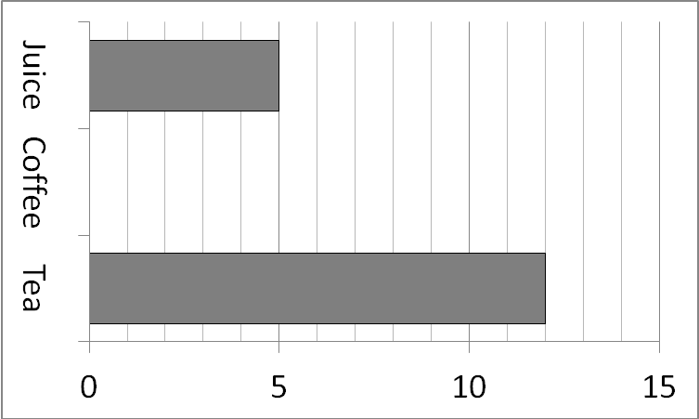  13 people said coffee. Show this.  25. How many more people said ‘Tea’ than said ‘Juice’? |  | 3:29  3:30
8. Write the sum to check 68 - 29 = 39.  Check: 29 + = | 3:8 | 18.  6  8  ?  4  = |  | 3:16 |  |  | 3:29  3:30
9. To a no. I add 32 then subtract 17. I now have 40. What did I start with? | 3:9 | 19. Subtract the  4  5  3  5  -  fractions. |  | 3:17 |  |  | 3:29  3:30
10. What is the missing number?  178 + = 236 | 3:9 | 20. Write the  5  9  1  9  7  9  3  9  largest fraction. |  | 3:18 |  |  | 3:29  3:30
Total (A) |  | Total (B) |  |  | Total (C)
Test Total (A+B+C) |  | R (0-9) | Y (10-19) |  |  | G (20-25)

