Music – Year 5 – spring – Make you feel my love [Adele]
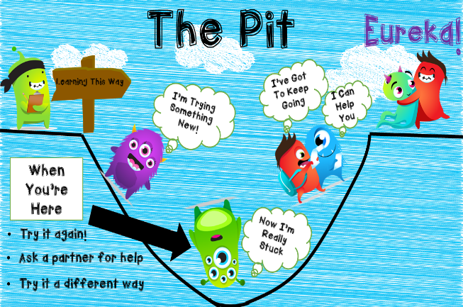

Music Genres & Knowledge

How pulse, rhythm and pitch work together by mixing styles. Year 5 will learn to sing, play, improvise and compose with this song. They will also listen and appraise other classic rock songs.
Pop
I`ll stand by you (Girls aloud)
Little things (One direction)
Secret love song (Little mix)

● Do you like the song? ● What can you hear? ● What is the style of this music?
● How is the song put together? ● What is the structure/form/shape of the song?
Growth Mindset Strategies
Skills

Sing in unison with clear diction, controlled pitch and sense of phrase.
Compose an instrumental
Play an instrument and perform parts in a range of solo and ensemble contexts with increasing accuracy and expression.
Add in different pulses during the improvisation parts of the performance.

Vocabulary | Meaning
composition | A piece of music that someone has written.
conductor | Someone who directs a performance of musicians or a piece of music.
dynamics | Changes in loudness in a piece of music
ensemble | A group of musicians who regularly play together.
improvisation | A performance that a musician has not practised or planned.
pitch | To express or set something at a particular level.
pulse | A steady beat.
rhythm | A strong pattern of sounds or musical notes that is used in music and dancing.
tempo | The speed at which a piece of music is played.
texture | The character of a piece of music
timbre | A quality of sound that makes voices or musical instruments sound different from each other.
stave | The five lines and four spaces between them on which musical notes are written
vocal | Relating to or produced by the voice in singing.

