Maths Key Skills Stage 2: Skill Check 3

Name: ___________________________________ Date: _______________ Class/Group: _______________________________

A: Place Value, Add and Subtract |  | B: Multiply, Divide and Fractions |  |  | C: Measure and Geometry
1. What is the missing number?  0 5 10 15 20 | 2:1 | 11. 4 x 10 = |  | 2:11 | 21. What units would you use to measure the mass of a pencil?  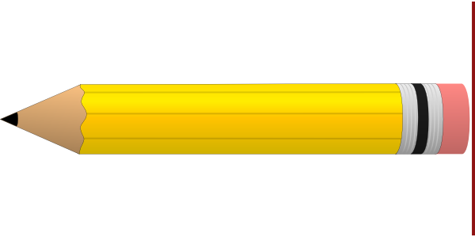  a. centimetres  b. grams  c. millimetres |  | 2:17
2. What is the value of the 6 in this number? 56 | 2:2 | 12. 18 ÷ 2 = |  | 2:11 |  |  | 2:17
3. Estimate the number labelled.  0  20  10 | 2:3 | 13. What symbol is missing?  45 ÷ 5 9 |  | 2:12 | 22. How many faces does a cube have?  a. 6  b. 8  c. 12 |  | 2:24
4. Use <, > or = to make this correct:  28 13 | 2:4 | 14. What symbol is missing?  7 3 = 21 |  | 2:12 |  |  | 2:24
5. Write this number in numerals.  eighty four | 2:5 | 15. Tick (✓) if true:  3 x 4 = 4 x 3 20 ÷ 2 = 2 ÷ 20 |  | 2:13 | 23. Name the shaded face on this cylinder. |  | 2:25
6. There are 20 sweets in a bag. Tom eats 13 of them. How many are left? | 2:6 | 16. £12 is shared between 3 people. How much does each person get? |  | 2:14 |  |  | 2:25
7. 7 + = 20 | 2:7 | 17. 6 cars each have 2 people in them. How many people are in the cars? |  | 2:14 | 24. Tick (✓) the shape that does not contain a right-angle. |  | 2:26
8. 52 - 18 = | 2:8 | 18. Circle two thirds  of the strawberries.  3  4 |  | 2:15 |  |  | 2:26
9. Is this true? Write ‘yes’ or ‘no’.  15 - 6 = 6 - 15 | 2:9 | 19. Shade in  1  3  of the shape. |  | 2:15 | 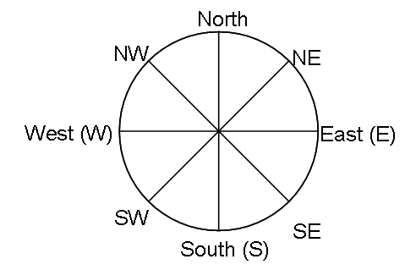  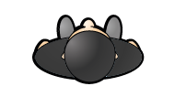  25. Ben is facing South.  What direction will  he be facing after  turning through 2  right angles? |  | 2:28
10. Use 49 + 24 = 73 to help find:  73 - 49 = | 2:10 | 20. What is of 12 ? |  | 2:16 |  |  | 2:28
Total (A) |  | Total (B) |  |  | Total (C)
Test Total (A+B+C) |  | R (0-9) | Y (10-19) |  |  | G (20-25)

