PSHE – Y5 – Spring 1 – When things go wrong
Knowledge
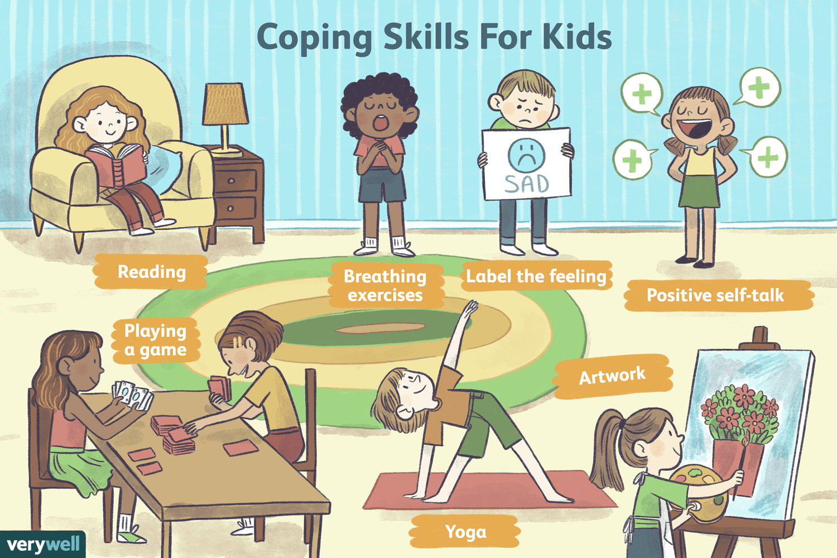
Skills
I can keep safe online.
I can identify behaviors which are unacceptable in relationships.

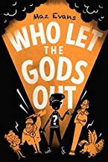
Books

Vocabulary | Meaning
astonished | Greatly surprised or impressed; amazed.
brave | Ready to face and endure danger or pain; showing courage.
calm | Not showing or feeling nervousness, anger, or other strong emotions.
cold | Of or at a low or relatively low temperature, especially when compared with the human body.
cross | Annoyed
confused | Unable to think clearly
embarrassed | Feeling or showing embarrassment.
nervous | Easily agitated or alarmed.
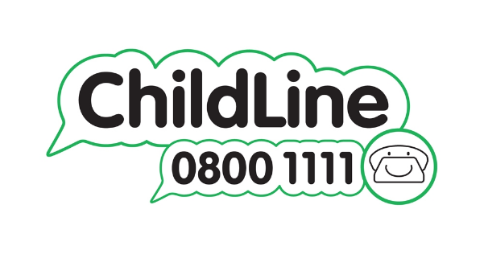

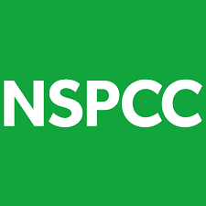
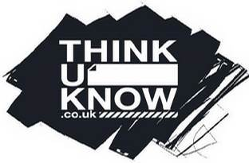

Growth Mindset Strategies
What I will know and be able to do at the end of the topic.
What I should be able to do and know now.

Understand the difference between a FIXED
mindset and a GROWTH mindset.
Be Curious; Be courageous.
Challenge yourself. Ask, ‘What could I do
differently next time?’
Give everything your best effort and
persevere.
Practice; Practice; Practice.

Knowledge

Nobody in a relationship should have to experience physical or emotional abuse because …
Nobody in a relationship should have to experience physical or emotional abuse but …
Nobody in a relationship should have to experience physical or emotional abuse so …

I know who to speak to if things are going wrong and I feel sad because …
I know who to speak to if things are going wrong and I feel sad so …

Skills
I have strategies about how I can stay safe online.

I have a clear understanding of what a healthy relationship should be.
Knowledge

Skills

What I will be learning

People can be influenced by what they see online.
Everything that you see online is not trustworthy.
To know who and where to report an incident if you feel unsafe online.
What a healthy relationship should consist of.

