Maths Key Skills Stage 2: Skill Check 1

Name: ___________________________________ Date: _______________ Class/Group: _______________________________

A: Place Value, Add and Subtract |  | B: Multiply, Divide and Fractions |  |  | C: Measure and Geometry
1. What is the missing number?  0 2 4 6 8 10 | 2:1 | 11. 25 ÷ 5 = |  | 2:11 | 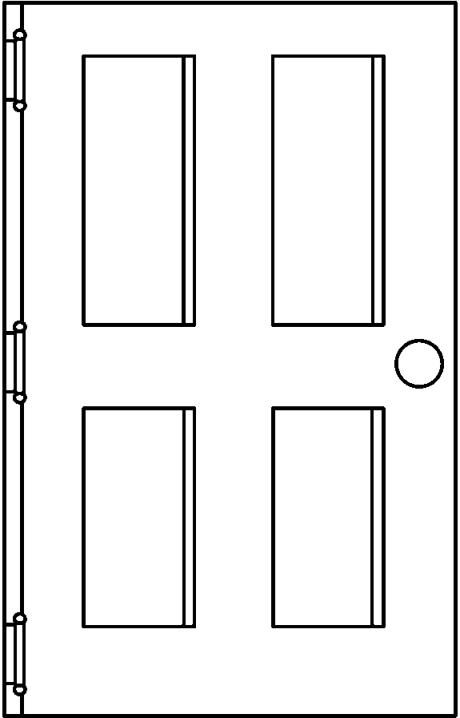21. Estimate the height  of a door. Write a, b or c.  a. about 2m  b. about 20cm  c. about 200mm |  | 2:17
2. What is the value of the 8 in this number? 83 | 2:2 | 12. Which are the odd numbers?  5 10 15 20 |  | 2:11
3. What number is labelled?  20  15 | 2:3 | 13. What symbol is missing?  3 4 = 12 |  | 2:12 | 22. How many five pence  (5p) coins are the  same value as a  fifty pence (50p) coin? |  | 2:19
4. Which numbers are < 15?  12 14 16 18 | 2:4 | 14. What symbol is missing?  40 4 = 10 |  | 2:12
5. Write this number in numerals.  sixty five | 2:5 | 15. Is this true? Write ‘yes’ or ‘no’.  8 ÷ 2 = 2 ÷ 8 |  | 2:13 | 23. Katie has one pound (£1).  She spends twenty-ﬁve pence (25p).  How much money does she have left? |  | 2:20
6. There are 30 children in a class. 15 are girls. How many are boys? | 2:6 | 16. 5 children share 15 sweets.  How many sweets does each child get? |  | 2:14
7. 20 - 16 = | 2:7 | 17. 6 teams enter a 5-a-side contest. How many players are in the contest? |  | 2:14 | 24. Which is longest? Write a, b, or c.  a. half an hour  b. 40 minutes  c. quarter of an hour |  | 2:21
8. 34 + 10 = | 2:8 | 18. Write the fraction one quarter in numerals. |  | 2:15
9. Is this true? Write ‘yes’ or ‘no’.  19 + 8 = 8 + 19 | 2:9 | 19. How many thirds are in 1 whole?  1  2 |  | 2:15 | 25. Ben arrives at the park at ten o’clock. He leaves at eleven o’clock.  How many minutes does he spend at the park? |  | 2:22
10. Use 31 + 23 = 54 to help find:  54 - 31 = | 2:10 | 20. What is of 8 ? |  | 2:16
Total (A) |  | Total (B) |  |  | Total (C)
Test Total (A+B+C) |  | R (0-9) | Y (10-19) |  |  | G (20-25)

