PSHE – Y5 – Spring 2 – Dealing with feelings
Knowledge
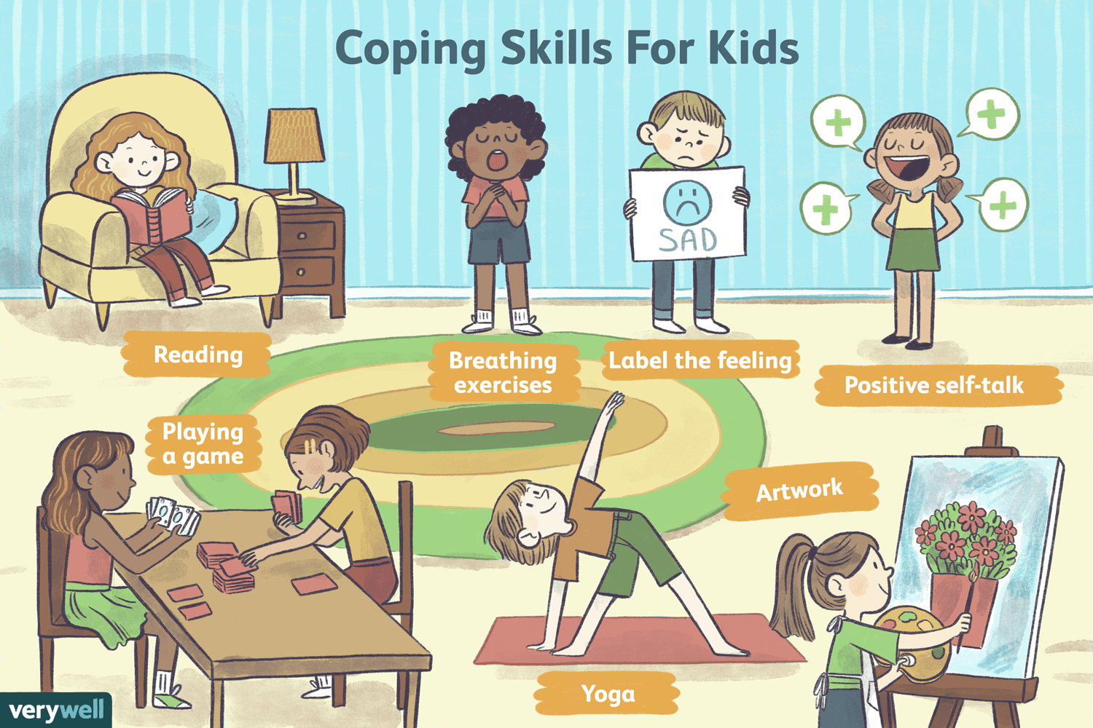
Skills
I can identify the feelings that I am experiencing.
I understand how changes in my life can lead to changes in my mood.

Books

Vocabulary | Meaning
content | In a state of peaceful happiness.
delighted | Feeling or showing great pleasure.
down | In or into a weaker or worse position, mood, or condition.
dumbfounded | Greatly astonish or amaze.
elated | Make (someone) ecstatically happy.
fearful | Feeling or showing fear or anxiety.
grumpy | Bad-tempered and irritable.
relaxed | Free from tension and anxiety.
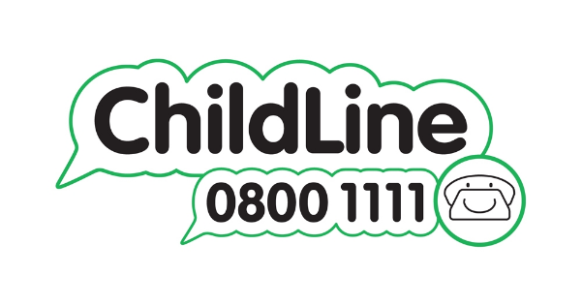

Growth Mindset Strategies
What I will know and be able to do at the end of the topic.
What I should be able to do and know now.

Understand the difference between a FIXED
mindset and a GROWTH mindset.
Be Curious; Be courageous.
Challenge yourself. Ask, ‘What could I do
differently next time?’
Give everything your best effort and
persevere.
Practice; Practice; Practice.

Knowledge
Being able to talk about my feeling and how they impact on me is important because …

Being able to talk about my feeling and how they impact on me is important but …

Being able to talk about my feeling and how they impact on me is important so …

Skills:
I can identify the feelings that I am experiencing.
I understand how changes in my life can lead to changes in my mood
Knowledge

Skills

What I will be learning

To name and describe a wide range and
intensity of emotions and feelings
To understand how the same feeling can be expressed differently
To recognise how emotions can be expressed appropriately in different situations.
To identify situations when someone may feel
conflicting emotions due to change.

