Maths Key Skills Stage 1: Skill Check 10

Name: ___________________________________ Date: _______________ Class/Group: _______________________________

A: Number and Place Value |  | B: Fractions and Measure |  |  | C: Measure and Geometry
1. What is the missing number?  13 14 15 16 | 1:1 | 11. Shade one half of this shape. |  | 1:11 | 16. I go swimming _______ I put on my swimming costume.  a. before  b. after |  | 1:16
2. What is the missing number?  10 15 20 25 | 1:2
3. What number is one less than 99? | 1:3 | 12. Draw two lines to split the shape into quarters. |  | 1:12 | 17. If Monday is the 1st day of the week, what day is the 7th day of the week?  a. Friday b. Saturday c. Sunday |  | 1:17
4. Pat has 12 sweets. Sam has 15.  Who has the least? | 1:4
5. Write this number in words:  20 | 1:5 |   13. Which is lightest?  A B |  | 1:13 | 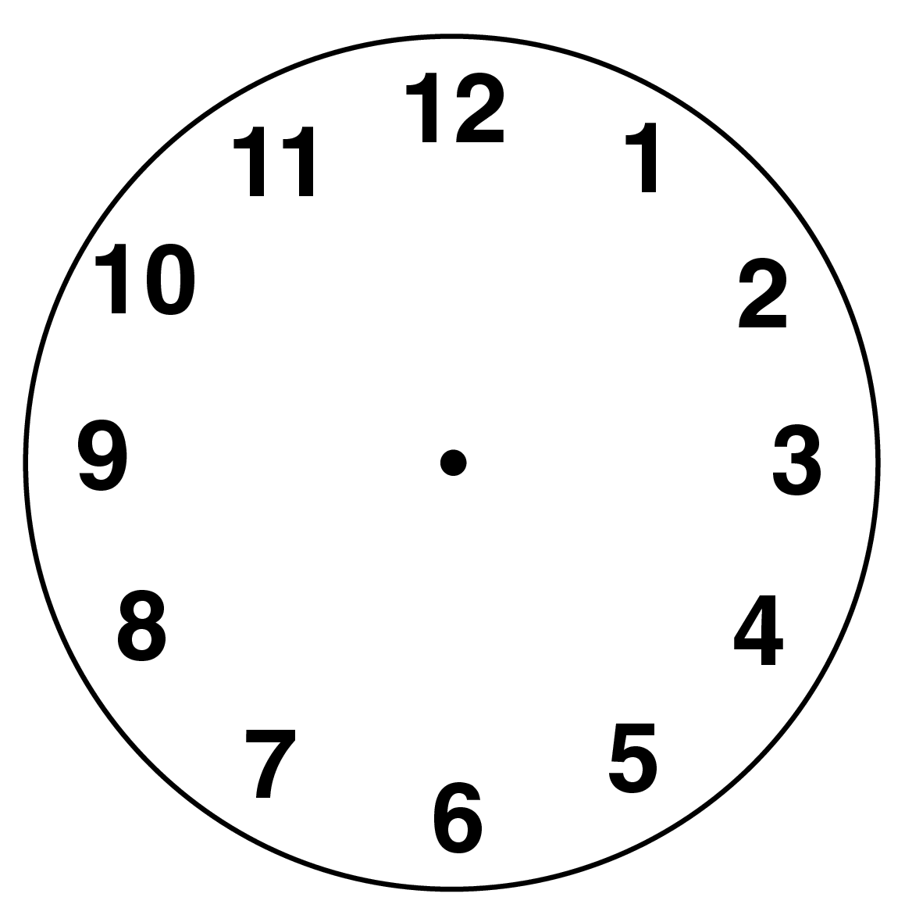  18. What time does  this clock show? |  | 1:18
6. What symbol is missing?  9 6 = 3 | 1:6
7. What is the missing number?  19 + = 20 | 1:7 | 14. How heavy is the apple?    0  10  20  30  40  50  grams |  | 1:14 |   19. Draw a triangle on the grid. |  | 1:19
8. 17 - 4 = | 1:8
9. What is the missing number?  16 = 3 + 8 | 1:9 | 15. How much altogether?  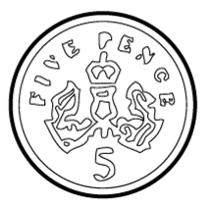  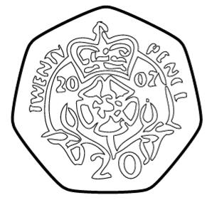  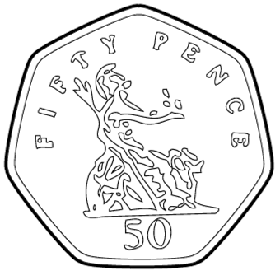 |  | 1:15 | 20. The arrow points:  a. left  b. down  c. right |  | 1:20
10. There are 10 sweets in a bags. How many sweets do I get in 2 bags? | 1:10
Total (A) |  | Total (B) |  |  | Total (C)
Test Total (A+B+C) |  | R (0-7) | Y (8-15) |  |  | G (16-20)

