

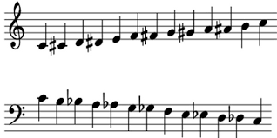

**Music – Year 1 – spring 1 and 2 – Round and Round**



Music Genres & Knowledge

How pulse, rhythm and pitch work together by mixing styles. The learning is focused around different songs based on different styles.

Round and Round by Joanna Mangona - Bossa Nova Latin style

Livin’ La Vida Loca - Ricky Martin – Latin style

The Imperial March, Darth Vader’s Theme (March of the Empire) - John Williams – Classical/ Film music style

It Had Better Be Tonight - Michael Bublé – Latin influenced big band jazz

Why Don’t You – Gramophonedzie - House, funk and swing style

Oye Como Va – Santana- Latin/Jazz/Rock fusion style

● Do you like the song? ● What can you hear? ● What is the style of this music?

● How is the song put together? ● What is the structure/form/shape of the song?

Growth Mindset Strategies

Skills

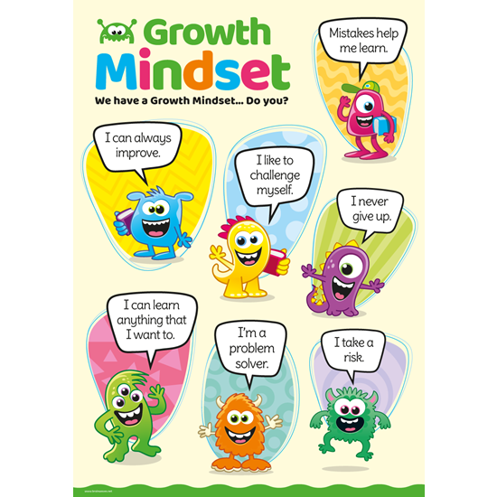

Listen to a variety of musical styles.

Perform – Into the Groove

Learn to play [glockenspiel] together.

Play instrumental parts in the song.

Improvise using voices and instruments.

Start to use correct musical language.

|  |  |
| --- | --- |
| Vocabulary | Meaning |
| **beat** | To make a regular movement or sound. |
| **composition** | A [piece](https://dictionary.cambridge.org/dictionary/english/piece) of [music](https://dictionary.cambridge.org/dictionary/english/music) that someone has written. |
| **conductor** | Someone who directs a performance of musicians or a piece of music. |
| **dynamics** | [Changes](https://dictionary.cambridge.org/dictionary/english/change) in [loudness](https://dictionary.cambridge.org/dictionary/english/loud) in a [piece](https://dictionary.cambridge.org/dictionary/english/piece) of [music](https://dictionary.cambridge.org/dictionary/english/music) |
| **ensemble** | A [group](https://dictionary.cambridge.org/dictionary/english/group) of [musicians](https://dictionary.cambridge.org/dictionary/english/musician) who [regularly](https://dictionary.cambridge.org/dictionary/english/regularly) [play](https://dictionary.cambridge.org/dictionary/english/play) together. |
| **instrument** | An [object](https://dictionary.cambridge.org/dictionary/english/object), such as a [piano](https://dictionary.cambridge.org/dictionary/english/piano), [guitar](https://dictionary.cambridge.org/dictionary/english/guitar), or [drum](https://dictionary.cambridge.org/dictionary/english/drum), that is [played](https://dictionary.cambridge.org/dictionary/english/play) to [produce](https://dictionary.cambridge.org/dictionary/english/produce) [musical](https://dictionary.cambridge.org/dictionary/english/musical) [sounds](https://dictionary.cambridge.org/dictionary/english/sound). |
| **improvisation** | A [performance](https://dictionary.cambridge.org/dictionary/english/performance) that a [musician](https://dictionary.cambridge.org/dictionary/english/musician) has not practised or planned. |
| **melody** | A [tune](https://dictionary.cambridge.org/dictionary/english/tune), often [forming](https://dictionary.cambridge.org/dictionary/english/form) [part](https://dictionary.cambridge.org/dictionary/english/part) of a larger piece of music. |
| **pitch** | To [express](https://dictionary.cambridge.org/dictionary/english/express) or set something at a [particular](https://dictionary.cambridge.org/dictionary/english/particular) [level](https://dictionary.cambridge.org/dictionary/english/level). |
| **pulse** | A steady beat. |
| **rhythm** | A [strong](https://dictionary.cambridge.org/dictionary/english/strong) [pattern](https://dictionary.cambridge.org/dictionary/english/pattern) of [sounds](https://dictionary.cambridge.org/dictionary/english/sound) or [musical](https://dictionary.cambridge.org/dictionary/english/musical) [notes](https://dictionary.cambridge.org/dictionary/english/note) that is used in [music](https://dictionary.cambridge.org/dictionary/english/music) and [dancing](https://dictionary.cambridge.org/dictionary/english/dance). |
| **tempo** | The [speed](https://dictionary.cambridge.org/dictionary/english/speed) at which a [piece](https://dictionary.cambridge.org/dictionary/english/piece) of [music](https://dictionary.cambridge.org/dictionary/english/music) is [played](https://dictionary.cambridge.org/dictionary/english/play). |
| **vocal** | [Relating](https://dictionary.cambridge.org/dictionary/english/relate) to or [produced](https://dictionary.cambridge.org/dictionary/english/produce) by the [voice](https://dictionary.cambridge.org/dictionary/english/voice) in [singing](https://dictionary.cambridge.org/dictionary/english/singing). |