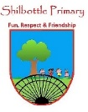

**Art - Investigating patterns**

**Vocabulary**

**Skills**

**Books**

* To be able to design a piece of artwork in the style of an artist.
* To select materials, appropriate for the task I am completing.
* To use coloured pencils to create colour gradients.
* To compare artists work/ styles for what is similar and what is different.

To take in turns and follow one another.

**alternate**

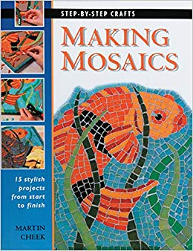

The material that holds the tiles on a mosaic, like a glue.

**cement**

A decorative pattern.

**design**

A colour going from light to dark in shade.

**gradient**

**Knowledge**

Lines going across from side to side, like the horizon line.

**horizontal**

An art style that involves sticking lots of small tiles to form a picture.

**mosaic**

**By the end of this topic you will learn:**

* To know that a pattern is made up of many repeating parts.
* How to build a pattern and create a piece of artwork in the style of an artist
* About some artists from around the world that are famous for their work on patterns.
* How to construct a mosaic style pattern like those the Romans created.

The part of the pattern that gets repeated.

**motif**

When a design has lines, shapes, colours that are repeated.

**pattern**

Dishes, Vases and objects made from baked clay.

**pottery**

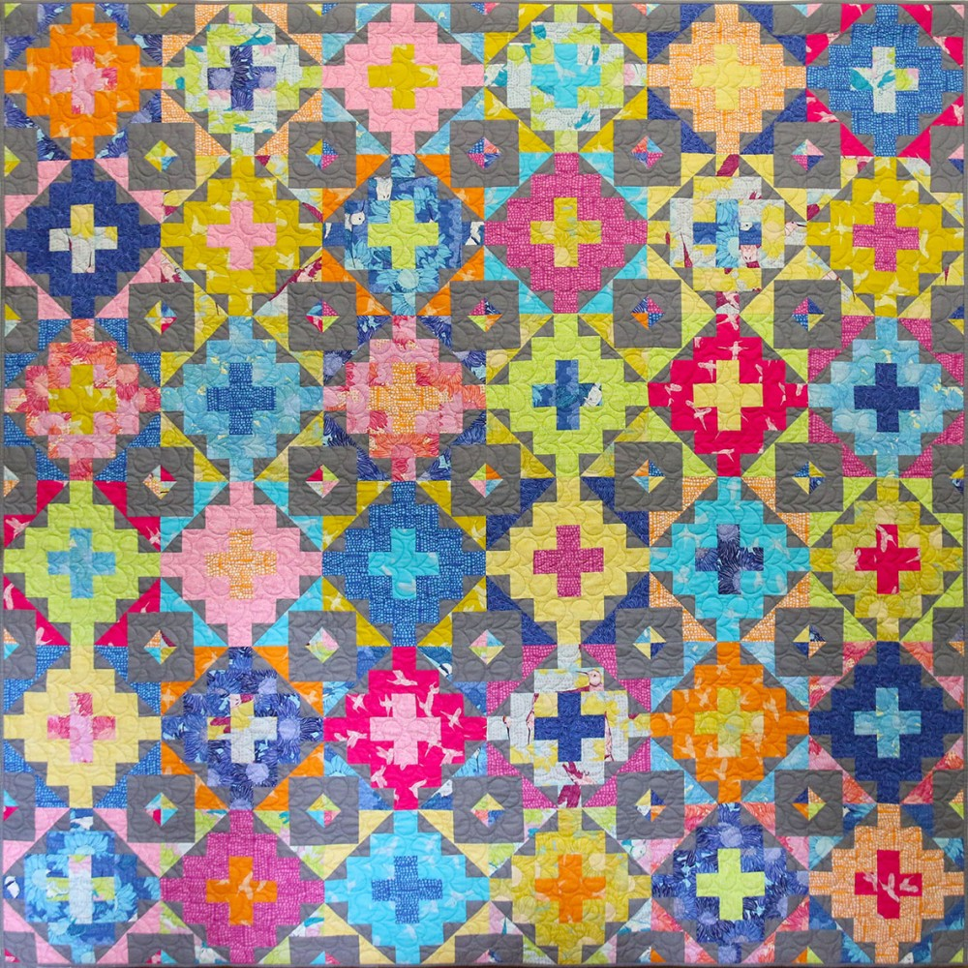

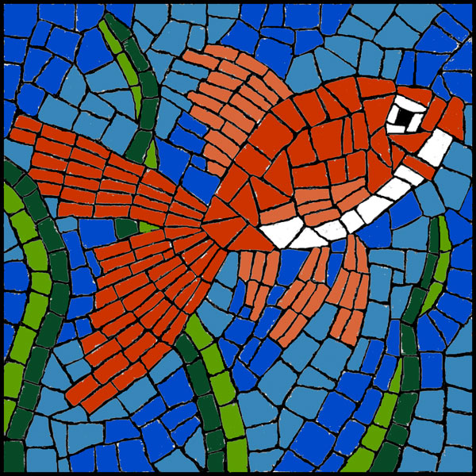

The dark shape and outline of a figure.

**silhouette**

Small pieces of baked clay, used to make a mosaic.

**tiles**

Lines going straight up and down.

**vertical**

**What I should be able to do and know now.**

**What I will know and be able to do at the end of the topic.**

**Key skills in Art**

**Knowledge:**

* What is a pattern?

A pattern is a ________ that is made up of a __________ section called a _________.

* Can you name some artwork styles that use pattern around the world? Can you describe what the style of artwork involves/ looks like?

In Australia…..

The ancient Greeks created…..

This style of artwork involves…..

* Can you name a famous pattern artist?

What was their work like?

What were the patterns they created used for?

**Skills:**

* Recognise the motif in a pattern to use it to build a bigger section of the pattern.
* Create artwork in the style of the aboriginal art, using a stick to create dots.
* Choose my colours to match those of an artist’s work.
* Create a mosaic style piece, by cutting the tiles to the correct size and shape to fit my design.
* Develop ideas from starting points throughout the curriculum.
* Replicate some of the techniques used by notable artists and designers.
* Create original pieces that are influenced by the study of others.
* Include texture that conveys feelings, expression or movement.
* Use cutting techniques to create shapes and edges.

**Knowledge:**

* To know that a pattern is made of colours, shapes and lines.
* If I press harder with a pencil, the colour will get darker.
* A pattern is usually colourful and includes at least 2 colours.
* Artwork styles are different, in different countries around the world.

**Skills:**

* Use a pencil to colour in.
* Create a pattern by alternating colours.
* Draw shapes and lines using a ruler.
* Stick shapes onto a picture to build the design.

**What I will be learning**

1. That a pattern is made up of a part that is repeated – the motif.
2. Patterns are used in furniture like wallpaper, pottery and curtains.
3. The names of some famous artists and their pattern work.
4. Pattern style artwork from various parts of the world, such as the Greek Mosaic and the Aboriginal artwork from Australia.