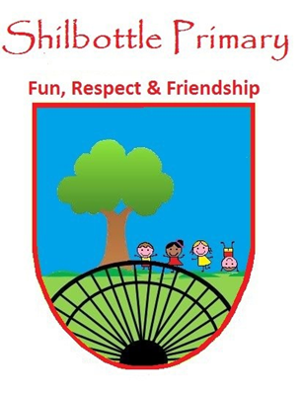
Year 3 Spelling List – Autumn 2

Spelling lists for this term are given below. Each week children will have 6 spellings following a spelling rule and 4 spellings from the expected to know lower KS2 words. Children will be tested on these spellings on a Friday in class.
Spelling Homework: To be completed in Homework book. Children are to write out the words in a list and then write a sentence using each word (10 sentences in total).

Week 1  Test date 5/11/21 | Week 2  Test date 12/11/21 |  | Week 3  Test date 19/11/21 | Week 4  Test date 26/11/21 | Week 5  Test date 3/12/21
Spelling rule  Words ending in -ture  nature  creature  future  picture  departure  adventure  Lower KS2 spellings  continue  decide  describe  different | Spelling rule  Homophones  where wear  no know  write right  meat meet  bear bare  break brake  Lower KS2 spellings  difficult  disappear  early  Earth |  | Spelling rule  Adding –ation to verbs to form nouns  information  plantation  sensation  temptation  preparation  explanation  Lower KS2 spellings  eight  eighth  enough  exercise | Spelling rule  Words with the ‘c’ sound spelt ‘ch’  character  chemist  stomach  orchestra  ache  scheme  Lower KS2 spellings  experience  experiment  extreme  famous | Spelling rule  Words with the ‘sh’ sound spelt ‘ch’  parachute  chalet  machine  chef  charade  brochure  Lower KS2 spellings  favourite  February  forward  fruit
Week 6  Test date 10/12/21 |  | Week 7  Test Date 17/12/21 |  | Helping your child to practice can be done by testing them throughout the week or by using a range of activities such as pyramid spellings, rainbow writing, forwards and backwards writing.  A set of cards using these activities will be sent home at the start of the year.
Spelling rule  The short ‘i’ sound spelt ‘y’  mystery  cygnet  Egypt  cymbals  pyramid  syllable  Lower KS2 spellings  grammar  group  guard  guide |  | Spelling rule  Words from the term  where  stomach  information  machine  pyramid  ache  Lower KS2 spellings  exercise  favourite  group  difficult

