Maths Key Skills Stage 1: Skill Check 11

Name: ___________________________________ Date: _______________ Class/Group: _______________________________

A: Number and Place Value |  | B: Fractions and Measure |  |  | C: Measure and Geometry
1. What is the missing number?  72 73 74 76 | 1:1 | 11. Colour in ½ of the counters. |  | 1:11 | 16. If tomorrow is Monday, then Sunday… a. was yesterday  b. is today  c. is tomorrow. |  | 1:16
2. What is the missing number?  2 4 6 8 | 1:2
3. What number is one more than 38? | 1:3 | 12. Colour in ¼ of the shape. |  | 1:12 | 17. What month comes before April?  a. February  b. May  c. March |  | 1:17
4. What number is labelled?  5  10 | 1:4
5. Write this number in words:  18 | 1:5 | 13. Which tower is half  the height of tower Y?  Y A B C |  | 1:13 | 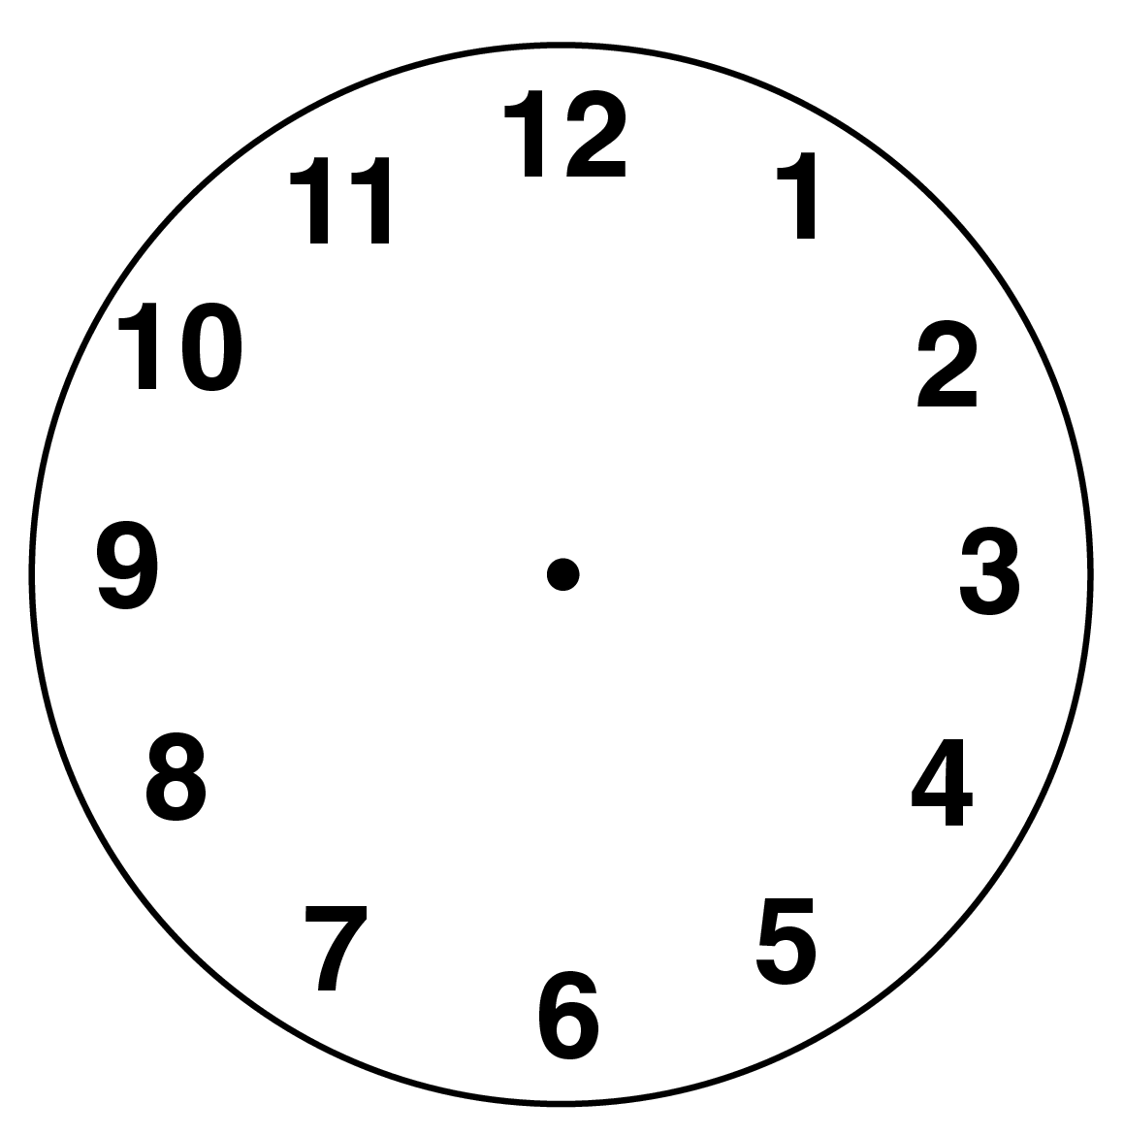  18. What time does  this clock show? |  | 1:18
6. What symbol is missing?  7 4 = 11 | 1:6
7. What is the missing number?  15 + = 20 | 1:7 | 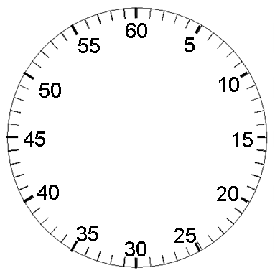  14. A boy timed himself  running a race. How  many seconds did he  take to finish? |  | 1:14 | 19. What is this shape?  a. cuboid  b. pyramid  c. sphere |  | 1:19
8. 18 - 9 = | 1:8
9. There are 15 people on a bus. 9 get off. How many people are there now? | 1:9 | 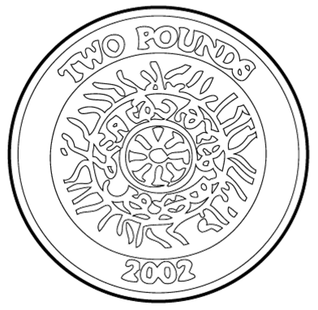  15. How much altogether?  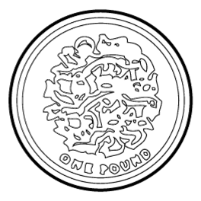 |  | 1:15 | 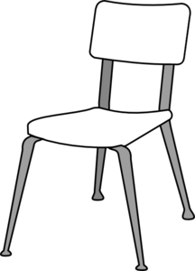  20. The teddy bear is:  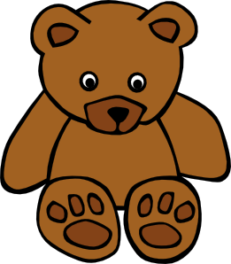  a. on the chair.  b. behind the chair.  c. next to the chair. |  | 1:20
10. 12 pens are shared by 4 children. How many pens do they get each? | 1:10
Total (A) |  | Total (B) |  |  | Total (C)
Test Total (A+B+C) |  | R (0-7) | Y (8-15) |  |  | G (16-20)

