Maths Key Skills Stage 1: Skill Check 15

Name: ___________________________________ Date: _______________ Class/Group: _______________________________

A: Number and Place Value |  | B: Fractions and Measure |  |  | C: Measure and Geometry
1. What is the total score on the dice?  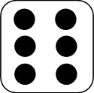  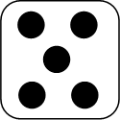  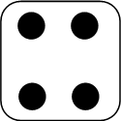 | 1:1 | 11. Circle ½ of the sweets.  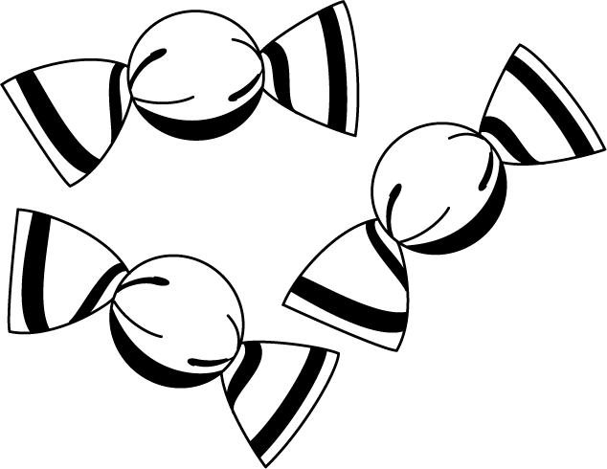 |  | 1:11 | 16. I go to school in the:  a. afternoon.  b. evening.  c. morning. |  | 1:16
2. What is the missing number?  10 30 40 50 | 1:2
3. What number is one less than 46? | 1:3 | 12. Finish shading in a quarter of this shape. |  | 1:12 | 17. There are twelve months in a…  a. year.  b. week.  c. day. |  | 1:17
4. Circle the right phrase:  9 is less than/equal to/more than 3x4 | 1:4
5. Write this number in numerals:  eleven | 1:5 | 13. Which cup has less than ‘Y’?  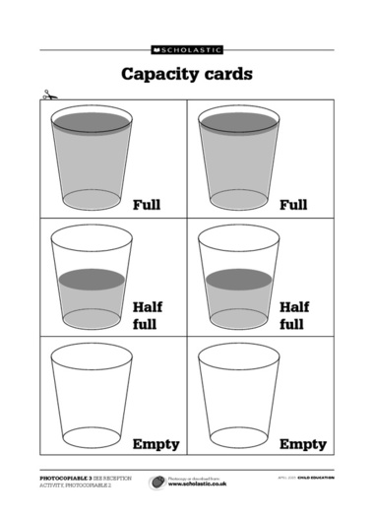  Y A B |  | 1:13 | 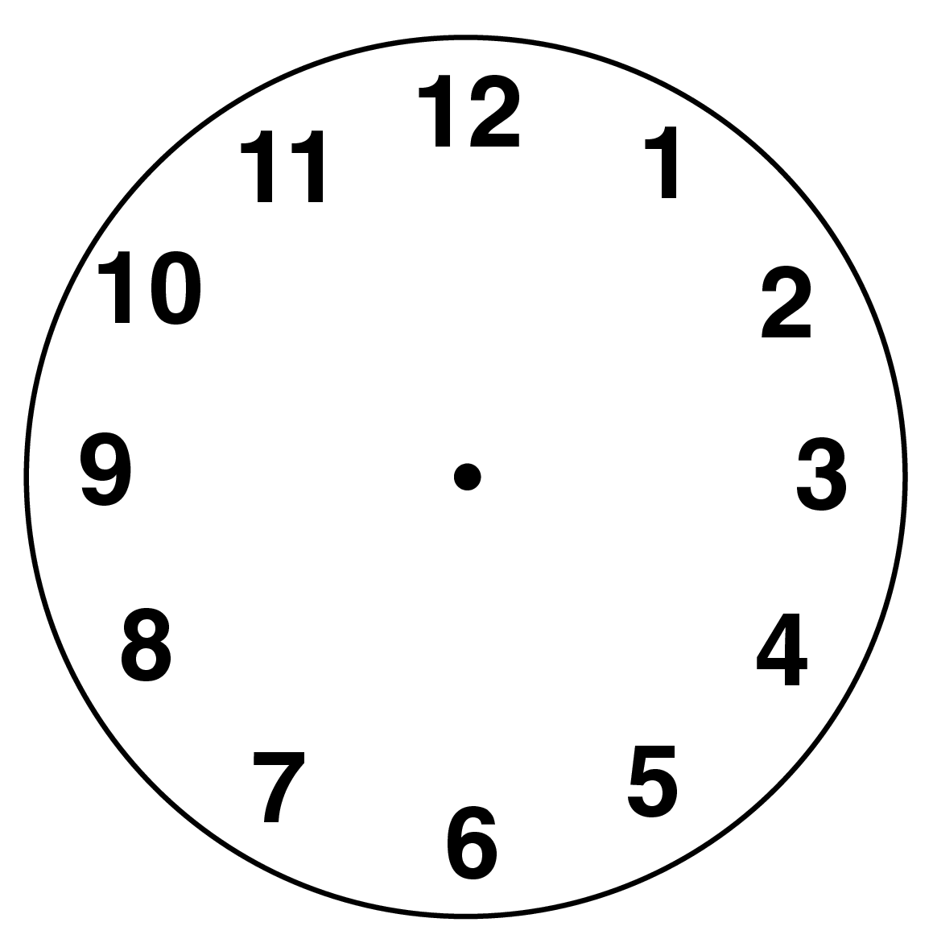  18. What time does  this clock show? |  | 1:18
6. What symbol is missing?  6 1 = 7 | 1:6
7. What is the missing number?  20 - = 4 | 1:7 | 14. A man times himself running a marathon. Which number represents the seconds?  04:38:28 |  | 1:14 |   19. Complete the rectangle. |  | 1:19
8. 9 + 16 = | 1:8
9. Jo has 15 sweets. After eating some she has 8 left. How many did she eat? | 1:9 | 15. How much altogether?  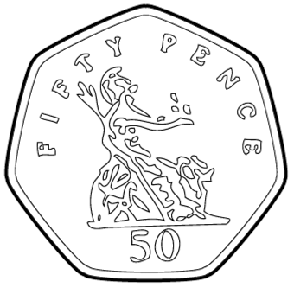  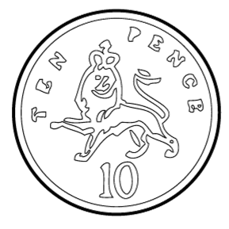 |  | 1:15 | 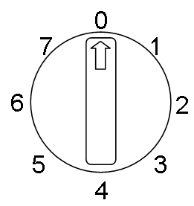  20. What number will the  dial be pointing to  after a quarter turn  anticlockwise? |  | 1:20
10. Eggs come in boxes of 6. If I buy 3 boxes, how many eggs do I have? | 1:10
Total (A) |  | Total (B) |  |  | Total (C)
Test Total (A+B+C) |  | R (0-7) | Y (8-15) |  |  | G (16-20)

