Maths Key Skills Stage 2: Skill Check 5

Name: ___________________________________ Date: _______________ Class/Group: _______________________________

A: Place Value, Add and Subtract |  | B: Multiply, Divide and Fractions |  |  | C: Measure and Geometry
1. What is the missing number?  87 77 67 57 47 | 2:1 | 11. 90 ÷ 10 = |  | 2:11 | 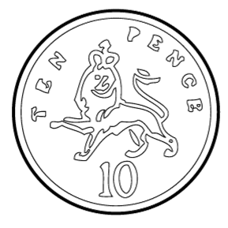  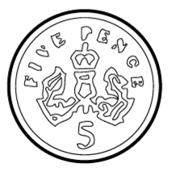  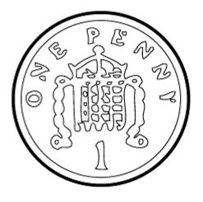  21. Tim has twenty pence (20p). Tick the coins that have the same value. |  | 2:19
2. What is the value of the 9 in this number? 92 | 2:2 | 12. Which are the even numbers?  2 17 16 23 |  | 2:11 |  |  | 2:19
3. Draw an arrow to label 8.  5  10 | 2:3 | 13. What symbol is missing?  35 = 5 7 |  | 2:12 | 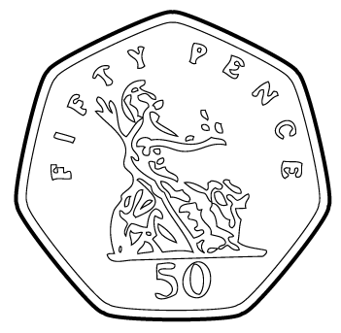  22. Sam has fifty pence  (50p). He buys an apple  for thirty pence (30p).  How much change  does Sam get? |  | 2:20
4. Use <, > or = to make this correct:  2 x 4 5 + 3 | 2:4 | 14. What symbol is missing?  4 = 32 8 |  | 2:12 |  |  | 2:20
5. Write this number in numerals.  thirty nine | 2:5 | 15. Tick (✓) if true:  8 ÷ 4 = 4 ÷ 8 9 x 7 = 7 x 9 |  | 2:13 | 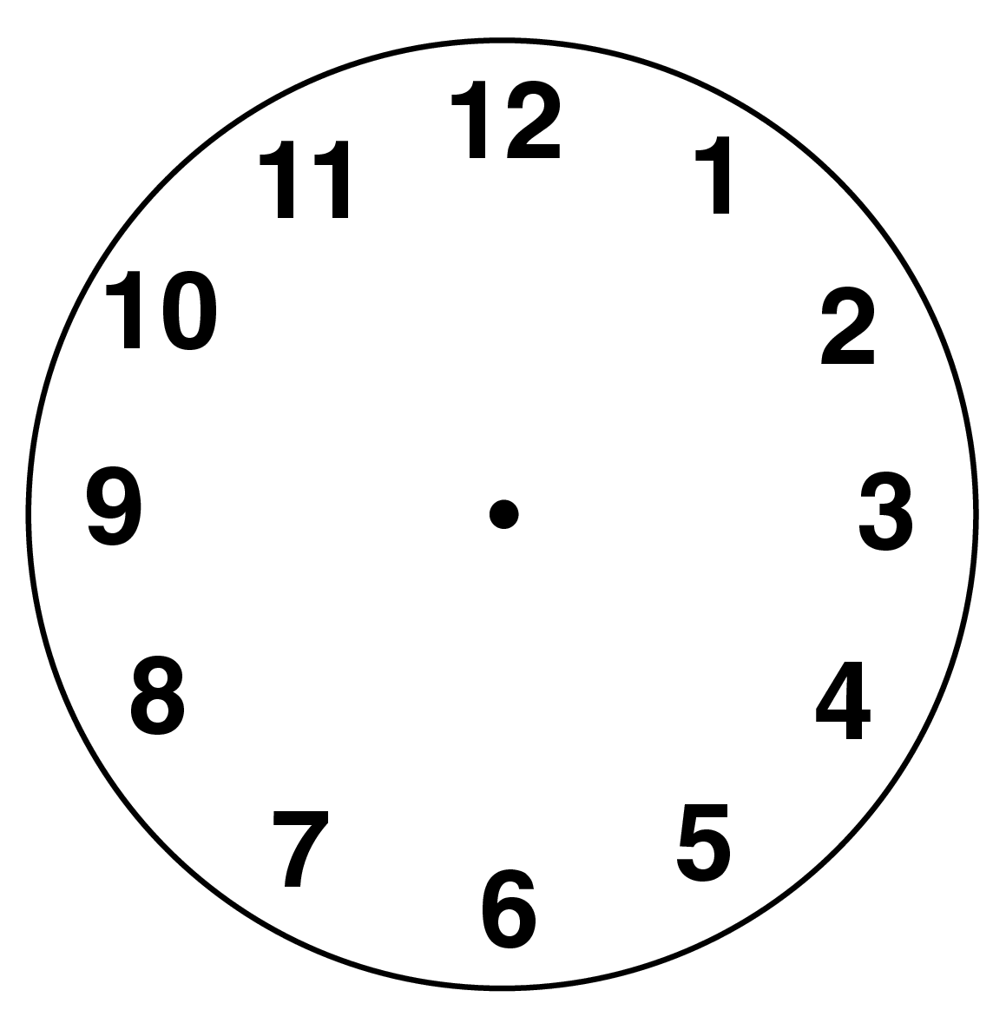  23. What time does  this clock show? |  | 2:22
6. There are 29 people on a train. 16 get off. How many people now? | 2:6 | 16. 4 boys share 20 chocolates. How many chocolates does each boy get? |  | 2:14 |  |  | 2:22
7. 20 - = 14 | 2:7 | 17. 4 bags each contain 6 apples. How many apples are there in total? |  | 2:14 | 24. Favourite ice-cream flavours of some pupils are shown below.  Vanilla Chocolate Mint  How many pupils chose chocolate?  25. How many pupils were asked in total? |  | 2:29  2:30
  3
  2
  1
8. 67 - 10 = | 2:8 | 18. What fraction  is shaded? |  | 2:15 |  |  | 2:29  2:30
9. Is this true? Write ‘yes’ or ‘no’.  27 + 7 = 7 + 27 | 2:9 | 19. How many quarters are in 1 whole? |  | 2:15 |  |  | 2:29  2:30
10. Use 92 = 23 + 69 to help find:  92 - 69 = | 2:10 | 20. Complete the  2  1  2  =  equivalent fractions. |  | 2:16 |  |  | 2:29  2:30
Total (A) |  | Total (B) |  |  | Total (C)
Test Total (A+B+C) |  | R (0-9) | Y (10-19) |  |  | G (20-25)

