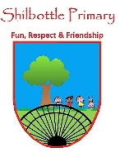

**PSHE - Year 1 – spring 2 – People who help us**

00

**Skills**

Develop awareness of safety.

Make links to other areas of learning.

Make choices and decisions.

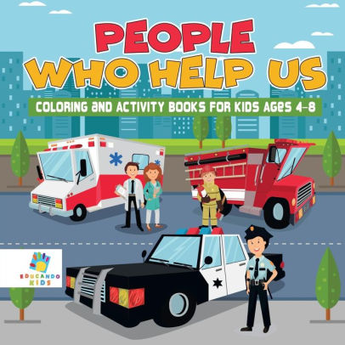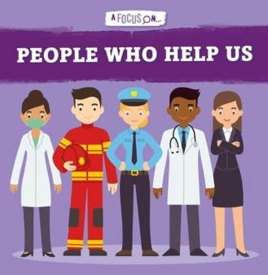

**Books**

**Knowledge**

To recognise familiar roles in school and community and identify how they help us.

To understand that there are people in the wider community who help.

To understand the role of police in the community.

To understand that policemen can be recognised by their uniform.

To learn who to ask for help or know what to do if you become lost or separated.

To identify how good decisions can keep us safe.

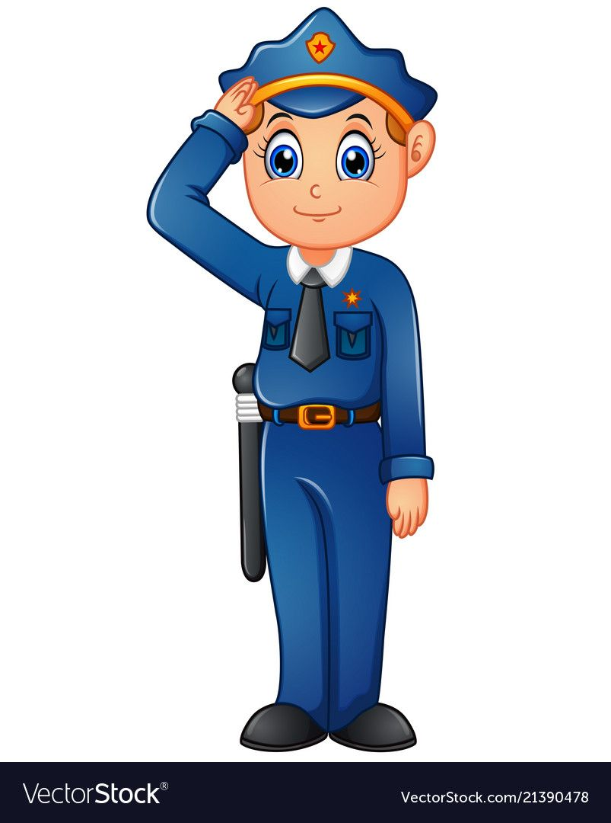

|  |  |
| --- | --- |
| Vocabulary | Meaning |
| community | A group of people living in the same place. |
| familiar | Not the same as each other. |
| separate | To move apart from something or someone. |
| uniform | Clothing worn by people who belong to the same group or organisation. |

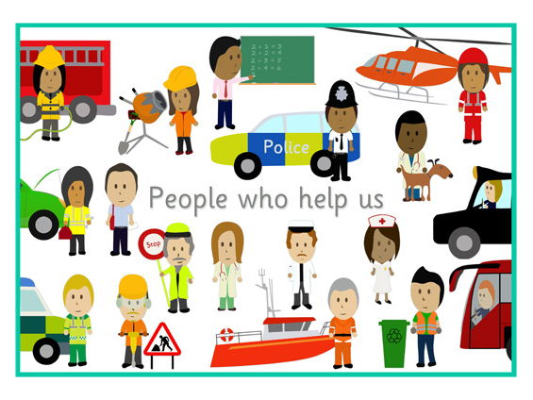

**What I will know and be able to do at the end of the topic.**

**Growth Mindset Strategies**

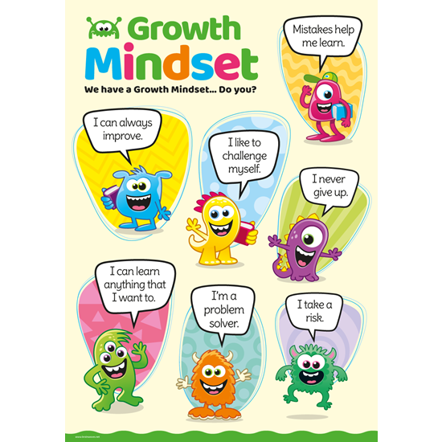

**What I should be able to do and know now.**

**Knowledge**

**Who are the people who help us in school?** Teachers, teaching assistants, dinner staff, office staff, caretaker.

**Which people can help us in the wider community?**  The main people who can help us are the police. Also there are firemen, paramedics, doctors, vets who help us.

**How can we recognise who can help us?**  A lot of people who can help us will wear a uniform, such as a policeman or a lifeguard.

**What should you do if you get lost or separated from your parents?** If we get lost in a shop, we should look for a member of staff in a shop uniform. We should never wander off or talk to strange people.

**Knowledge**

I know that my family and adults in school keep me safe.

**Skills**

I can show sensitivity to others’ needs and feelings, and form positive relationships with adults and other children.

I can talk about how I and others show feelings, talk about my own and others’ behaviour and its consequences, and know that some behaviour is unacceptable.

I work as part of a group or class, and understand and follow the rules

I adjust my behaviour to different situations, and take changes of routine in my stride.

I can say when I or do not need help.

**What I will be learning**

1. How adults in school can help them.
2. I can identify adults who are safe to ask for help.
3. I understand the role of police in helping us.
4. I can recognise the police by their uniform.
5. I know what to do if I am lost or separated from my parents.
6. I know how I can help myself to stay safe.