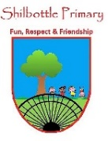
History– Autumn 1st - Year 1 and 2 - Houses
Vocabulary  Skills  Ask questions to find out information.  Develop an awareness of the past.  Place events in chronological order.  Ask and answer questions.  Use vocabulary related to the passing of time.  Know some of the ways we find out about the past.  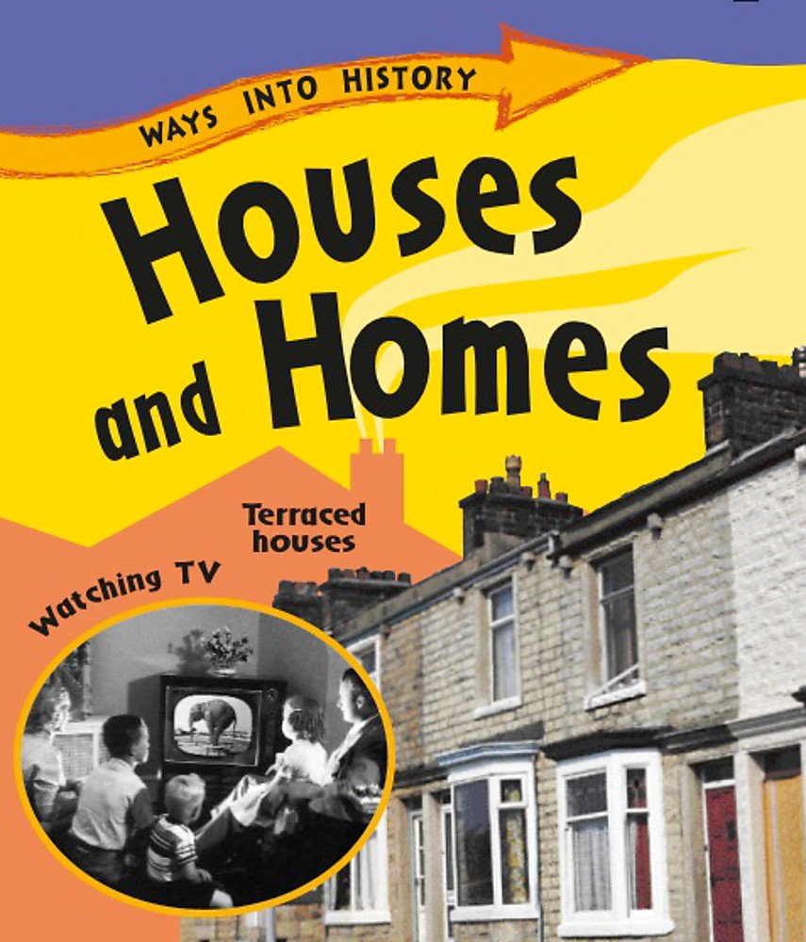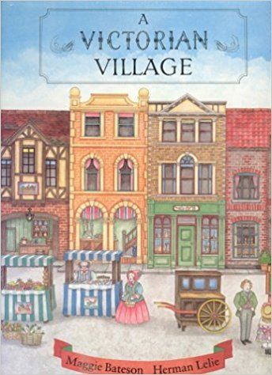  Books  Knowledge  To investigate and identify a variety of homes today.  To investigate similarities and differences between homes.  To explore homes built a long time ago and identify their features.  To find out what Victorian homes were like inside.  To identify and explore objects in a Victorian home.  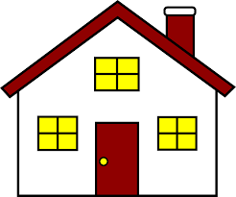 | Meaning
bungalow | A house that only has one storey.
cottage | A small house usually in the country.
detached | A separate house on its own.
Georgian | The period of time when King George was on the throne.
medieval | From the middle ages.
semi-detached | A house joined to another house on one side.
terraced | A row of houses joined together.
Tudor | The Tudors ruled England from 1485 to 1603.
Victorian | The period of time when Queen Victoria was on the throne (1837-1901)
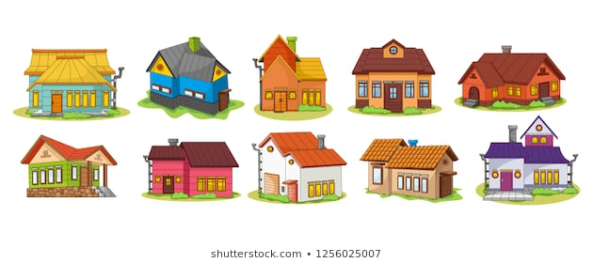

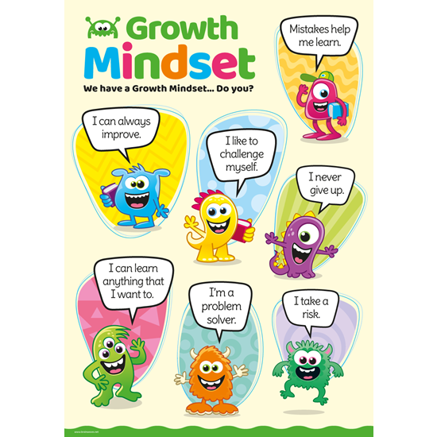
What I will know and be able to do at the end of the topic.
Growth Mindset Strategies

What I should be able to do and know now.
Knowledge
Can you name some different types of houses? Flat, bungalow, cottage, semi-detached, detached, terraced, mobile home, houseboat.
What things are the same between homes? They all have windows, doors and a roof.
What things are different between the houses? – Built form different materials, windows and doors made from different materials, chimneys.
Can you describe any features of houses built a long time ago? – Medieval houses – Castles, houses with stone walls and straw roofs. Tudor houses – Made with black wooden beams. Georgian houses – Made from brick with square shapes, straight lines and pillars. Victorian houses – Were often terraced with bay windows.
What do you think is the biggest difference between the inside of Victorian homes and modern homes? – Victorian homes had no electricity.
Skills –
Using your knowledge from science, what properties should the materials have that are used for a house? –

Knowledge
I can talk about past and present events in my life and in the lives of family members.

Skills
I can answer ‘how’ and ‘why’ questions about my experiences and in response to stories or events.
I can use past, present and future forms accurately when talking about events that have happened or are to happen in the future.

What I will be learning

- How to describe features common to all modern homes.
- How to identify key external features of homes.
- Can identify similarities and differences between modern houses and house built a long time ago.
- Can describe some of the features of Victorian houses.
- Can identify some differences between
objects found in modern homes and Victorian
homes and how this affected daily life for people in the past.

