Maths Key Skills Stage 3: Skill Check 3

Name: ___________________________________ Date: _______________ Class/Group: _______________________________

A: Place Value, Add and Subtract |  | B: Multiply, Divide and Fractions |  |  | C: Measure and Geometry
1. What is the missing number?  0 50 100 200 250 | 3:1 | 11. 40 ÷ 8 = |  | 3:10 | 23. The cup holds 250 millilitres of liquid. The jug holds 1 litre of liquid.  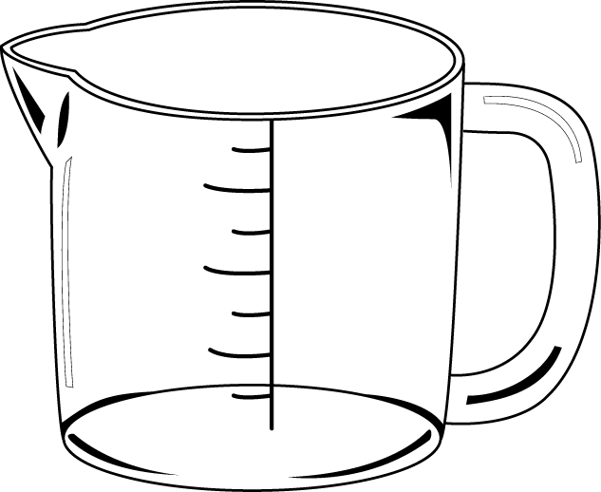  How many more  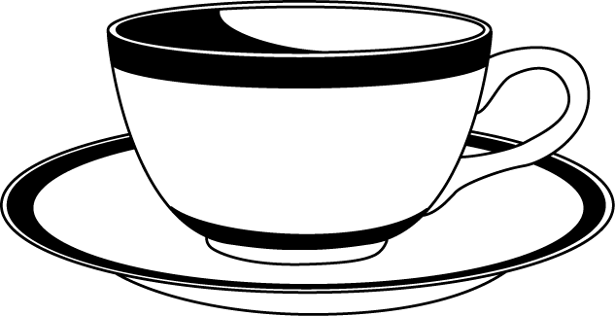  millilitres does the  jug hold? |  | 3:19
2. What is the 7 worth in this number?  347 | 3:2 | 12. 9 x 8 = |  | 3:10 |  |  | 3:19
3. Write this number in words.  602 | 3:3 | 13. 18 x 3 = |  | 3:11 | 22. Tom bought 3 cans of pop that were 75p each. How much did they cost in total? Give your answer in pounds and pence. |  | 3:21
4. Estimate the labelled number?  0  100  50 | 3:4 | 14. I buy 5 packs of balloons. I have 45 balloons. How many are in each pack?  1  10 |  | 3:12 |  |  | 3:21
5. Write a number that is bigger than 793 using the same three digits. | 3:5 | 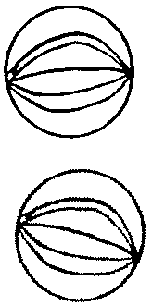  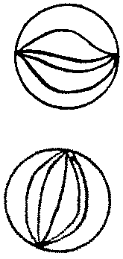  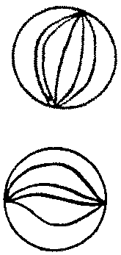  16. Circle  of the marbles. |  | 3:13 | 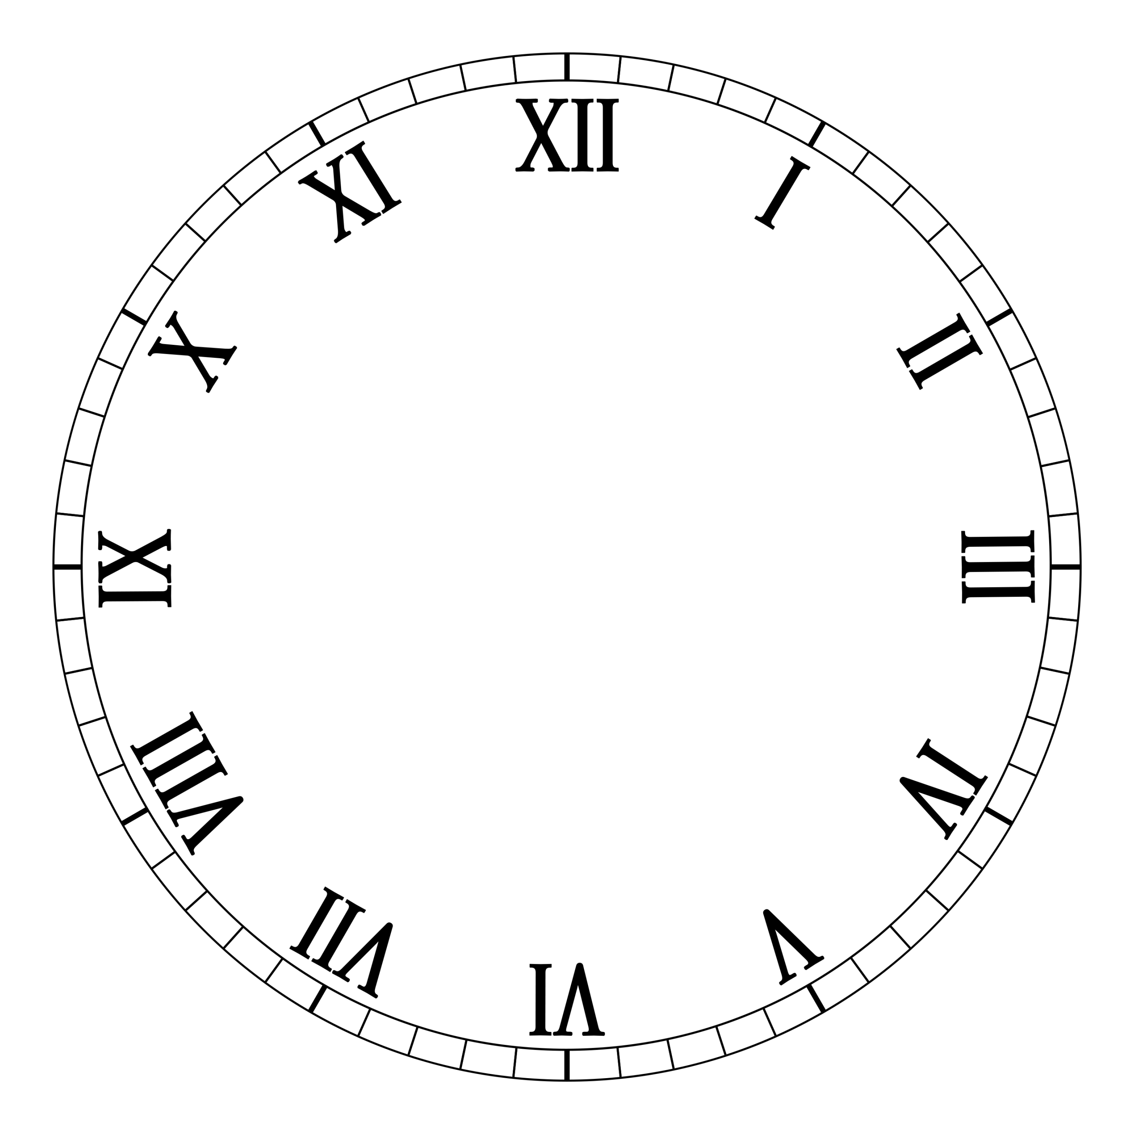  23. What time does  this clock show? |  | 3:22
6. 302 - 10 = | 3:6 | 16. What fraction  is shaded?  1  6 |  | 3:14 |  |  | 3:22
7. 752 - 93 = | 3:7 | 17. What is of 18? |  | 3:15 | 24. How many right angles make a complete turn? |  | 3:27
8. Circle the best estimate to 98 + 131  220 230 240 250 | 3:8 | 18. This shape is in tenths.  1  5  Shade in . |  | 3:16 |  |  | 3:27
9. Use 12 + 25 = 37 to help solve:  370 – 120 = | 3:9 | 19. Add the  2  7  3  7  +  fractions. |  | 3:17 | 25. Circle the horizontal line. |  | 3:28
10. What is the missing number?  182 - = 124 | 3:9 | 20. Write the  1  5  1  6  1  4  1  2  smallest fraction. |  | 3:18 |  |  | 3:28
Total (A) |  | Total (B) |  |  | Total (C)
Test Total (A+B+C) |  | R (0-9) | Y (10-19) |  |  | G (20-25)

