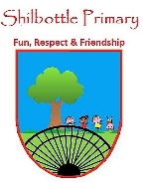
Science - Forces and Magnets
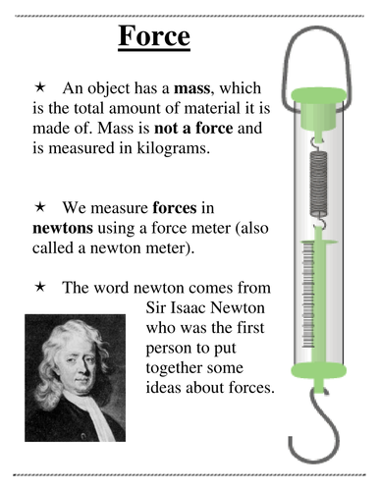
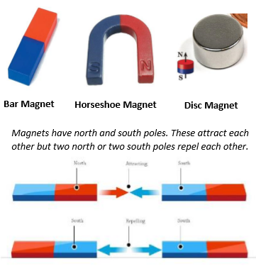
00
Knowledge

Skills
Identify forces as pushes and pulls.
Identify that friction is a force that slows objects down.
I can sort and classify materials.
I can investigate and explore outcomes.
Talk about your learning.
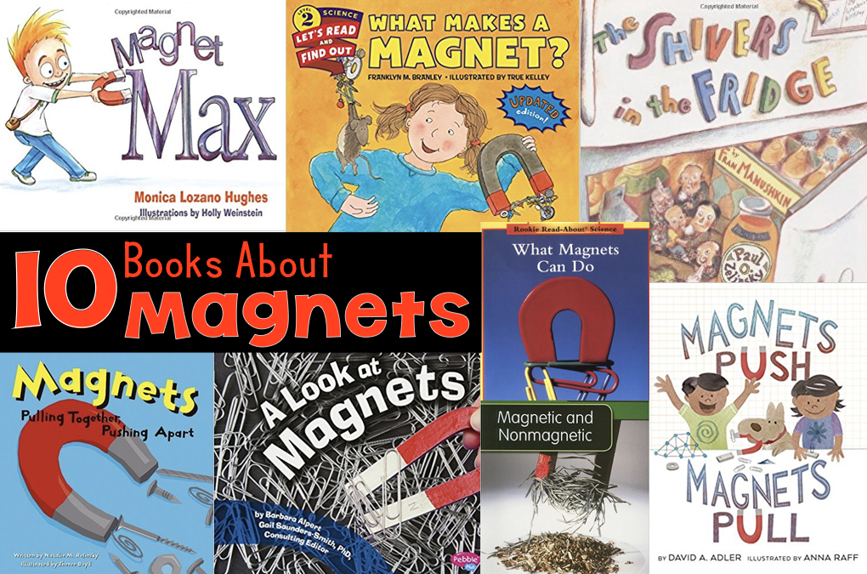
Books

Vocabulary | Meaning
acceleration | An increase in the rate or speed of something.
attract | To pull towards. Opposite of repel.
balanced force | Two forces of equal size acting in opposite directions.
contact force | A force that requires physical contact to occur e.g. kicking a ball.
force | A push or pull on an object which can cause it to move, change speed, direction or shape. Measured in Newtons (N).
friction | The resistance of motion when one object rubs against another.
gravity | The area around a large object when a weight can be felt.
mass | The amount of matter contained in an object. Measured in units such as g, kg.
magnet | A material or object that produces a magnetic field. It attracts or repels magnetic objects, including iron.
propel | The act of driving or pushing forward.
repel | To push away. Opposite of attract.
weight | The force due to gravity on objects.

• I can make systematic and careful observations.
• I can set up some simple practical enquiries, including comparative tests.
• I am beginning to collect data in a variety of ways, including labelled diagrams, bar charts and tables.
• I am beginning to talk about and identify differences and similarities in the properties of materials.
• I am beginning to identify simple changes related to simple scientific phenomena.
• I am beginning to discuss criteria for grouping and sorting and can classify using a simple key.
Key skills in Science
What I will know and be able to do at the end of the topic.
What I should be able to do and know now.
Knowledge
Identify the type of force required to carry out an action.

Explain that magnets produce an invisible pulling force.

Can you name 3 magnetic materials?

What are the different types of magnet?

I know that magnets will r____ or a_____ based on their poles.

Skills
What type of chart can I use to display my results?

I can explain my predictions and conclusions using key words or prompts.

Investigate the force of friction produced by different surfaces.

Investigate the strength of different magnets.

Knowledge
I know that some forces need contact between two objects.
I know that objects move at different speeds.
I know how non-fiction books can help my learning.
Skills
Identify that there are different types of forces acting on objects.
I am able to compare how objects move on different surfaces.
I can compare, sort and group materials.
I can use a magnet to identify whether the action is pull or push.

What I will be learning
How to describe magnets as having two poles.
How to identify different types of magnets.
How to identify whether a force is a repelling or an attracting force.
The differences between magnetic and non-magnetic materials.
How to create an investigation and display my results.

