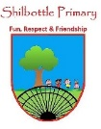

**DT– Regional food**

**Word Meaning**

**Skills**

**Books**

* To be able to create a product to fit some design criteria.
* To select appropriate ingredients to make a dish.
* To safely use equipment when preparing food.
* To analyse and evaluate existing dishes and those I have prepared myself.

The weather conditions in an area over a long period of time.

**climate**

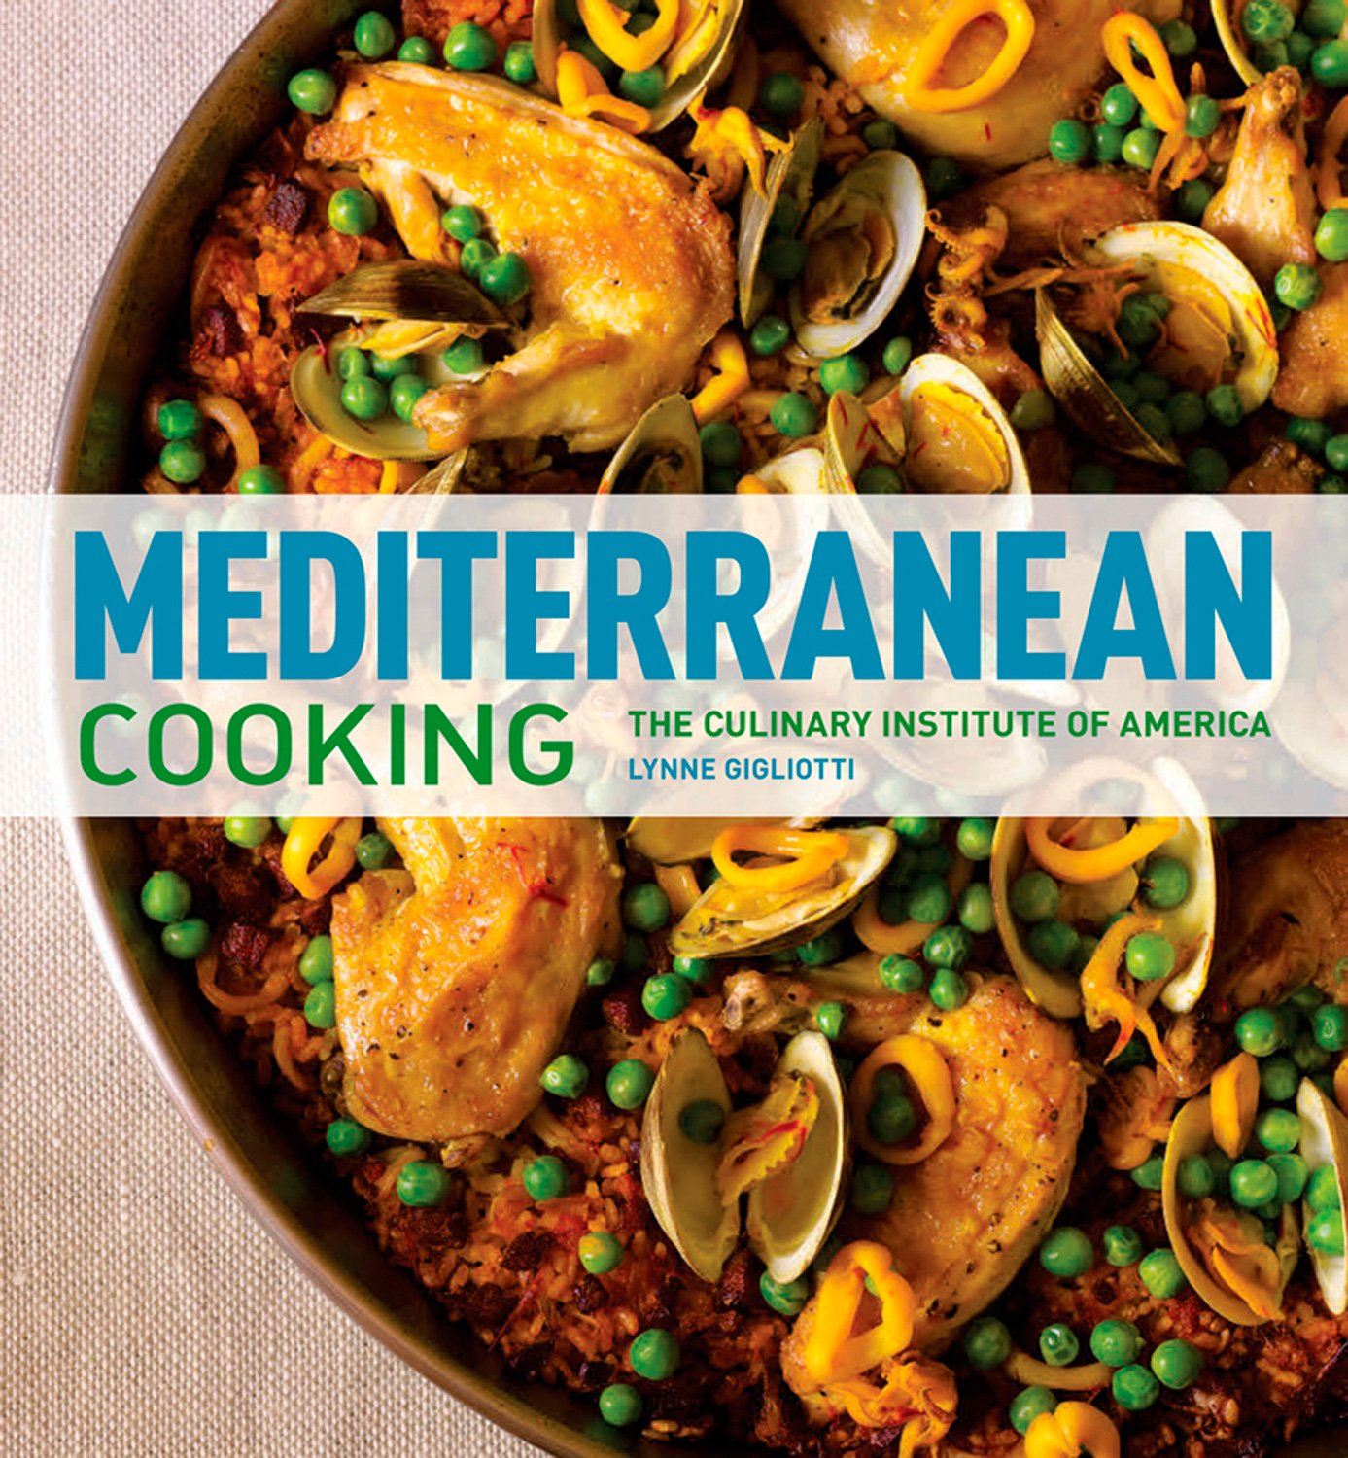 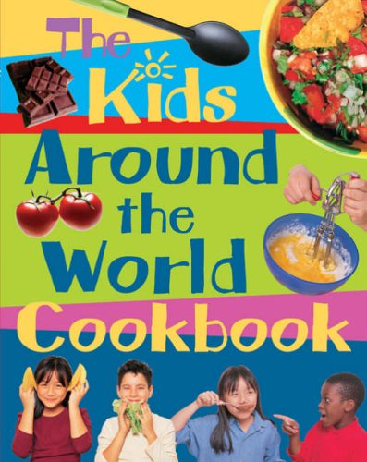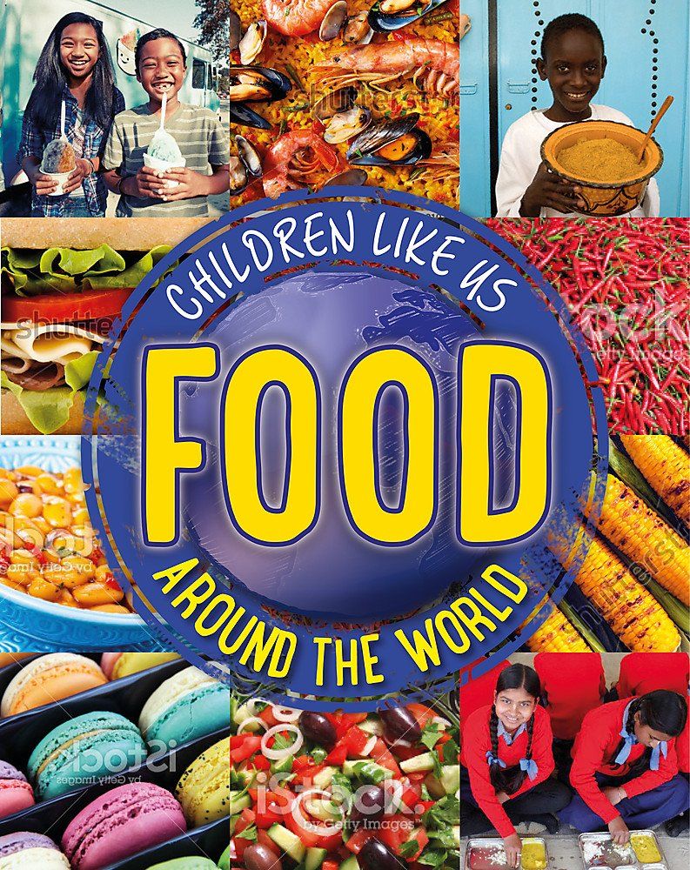

A style or method of cooking from a particular country or region.

**cuisine**

The ideas and ways of doing things for a particular group of people.

**culture**

The kinds of food that a person eats.

**diet**

**Knowledge**

The way in which something is shared out over an area.

**distribution**

Foods that are good for you are healthy.

**healthy**

**By the end of this topic you will learn:**

* All about the types of foods grown in different regions of the world including the Mediterranean region.
* The recipes that belong to different cultures and areas of the world.
* How to prepare regional dishes safely following a recipe.

The food items that are put together to make a particular dish.

**ingredients**

The area between Southern Europe and North Africa.

**Mediterranean**

A small, green, oval shaped fruit with a stone in the middle.

**olive**

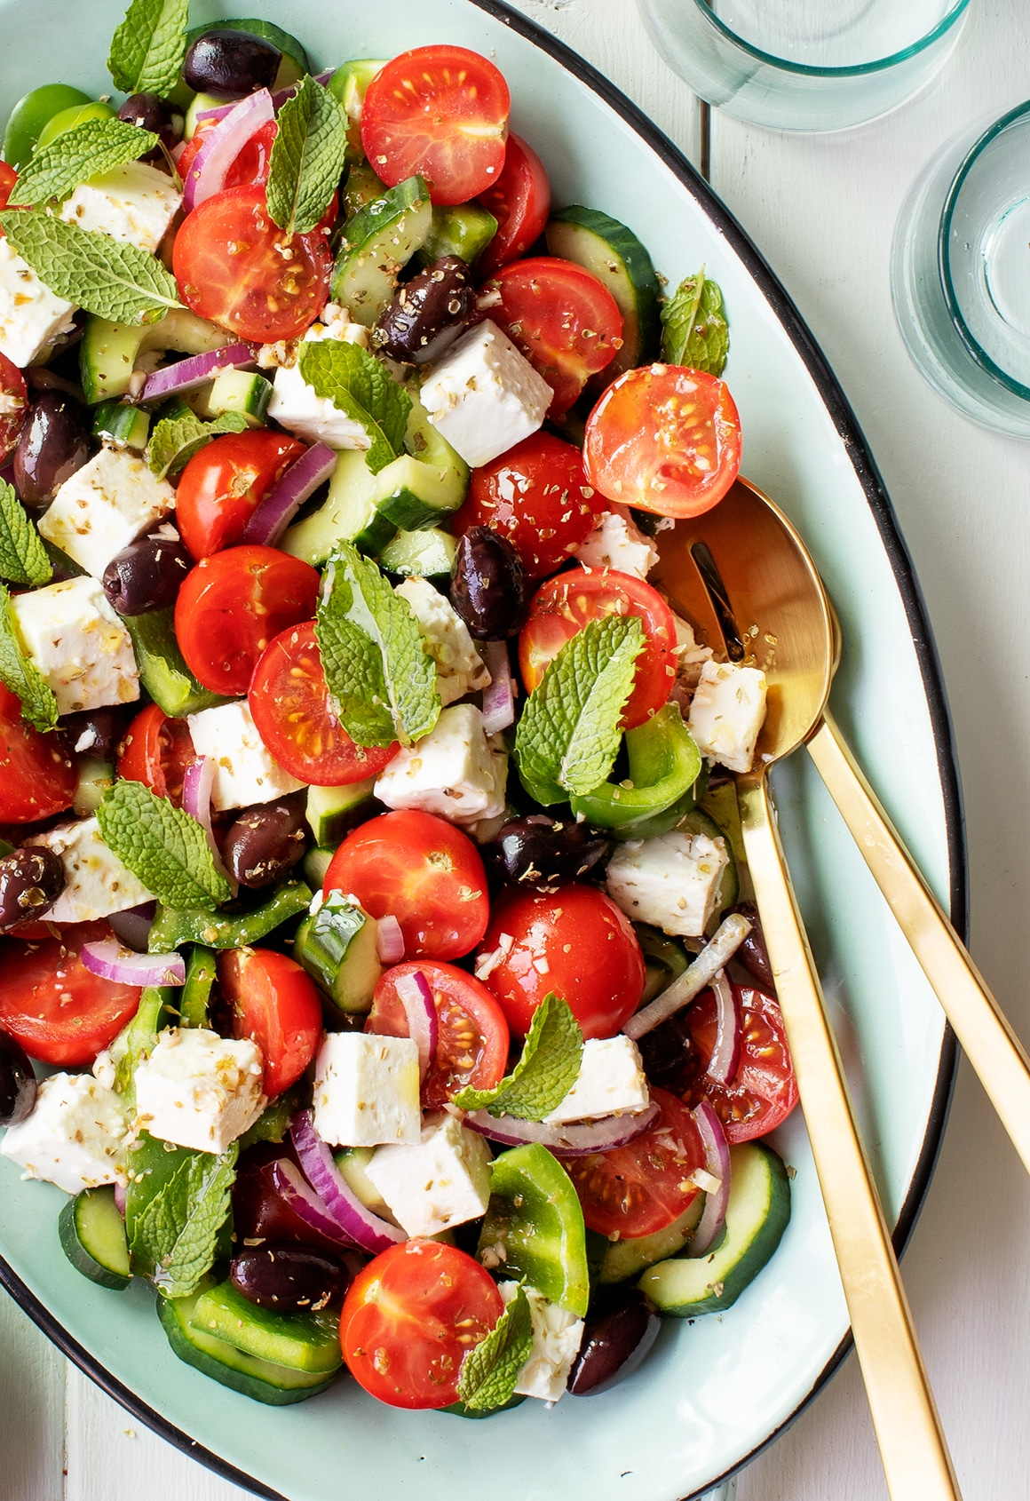

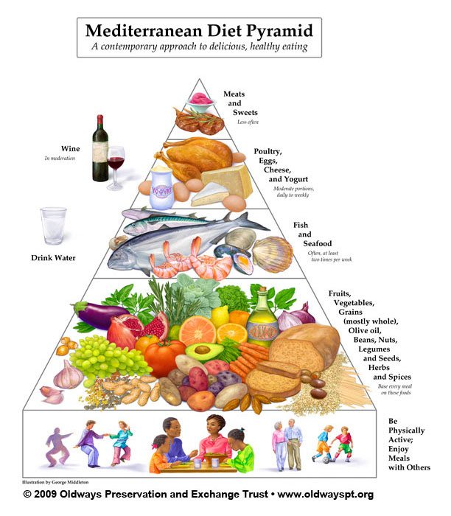

An oil made from olives, used for cooking and salad dressings.

**olive oil**

A set of instructions telling you how to prepare a particular dish.

**recipe**

Relating to a certain area of the world.

**regional**

**Key skills in DT**

**What I should be able to do and know now.**

**What I will know and be able to do at the end of the topic.**

* Understand and apply the principles of a healthy and varied diet.
* Cook a repertoire of predominantly savoury dishes so that they are able to feed themselves and others a healthy and varied diet.
* Become competent in a range of cooking techniques (for example, Selecting and preparing ingredients; using utensils and electrical equipment; applying heat in different ways; using awareness of taste, texture and smell to decide how to season dishes and combine ingredients; adapting and using their own recipes]).
* Understand the source, seasonality and characteristics of a broad range of ingredients.

**Knowledge:**

* Can you describe where the Mediterranean region is?
* What particular foods are associated with Mediterranean cuisine? Name 3.
* Explain how climate may impact on what can grow in a certain region? Give examples of the types of foods that grow there?
* List the ingredients that make a Greek salad.
* Write a recipe for preparing a regional dish..

**Skills:**

* Prepare food safely using food hygiene steps.
* Use equipment safely and correctly when preparing food.
* Follow a recipe accurately to create a dish.
* Measure out and weigh ingredients accurately.
* Design my own dish in the style of the Mediterranean cuisine.

**Knowledge:**

* Food is not the same in different parts of the world.
* People in different countries do different things to us.
* The weather is warmer in other parts of the world.
* A recipe tells you how to make something.
* Knives are sharp and should be used safely.

**Skills:**

* Use a spoon to stir.
* Use a knife to cut.
* Collect items from a list.
* Wear protective equipment when using an oven.
* Follow a set of instructions.

**What I will be learning**

* All about the Mediterranean region, the location and climate.
* Learn about the types of foods that grow in different regions of the world and the dishes that they make.
* How to safely prepare regional dishes.
* How to select suitable equipment for a job and use it correctly.