Maths Key Skills Stage 3: Skill Check 13

Name: ___________________________________ Date: _______________ Class/Group: _______________________________

A: Place Value, Add and Subtract |  | B: Multiply, Divide and Fractions |  |  | C: Measure and Geometry  1  2
1. What is the missing number?  0 50 100 150 250 | 3:1 | 11. 24 ÷ 8 = |  | 3:10 | 23. The jug holds 1 litres of liquid.  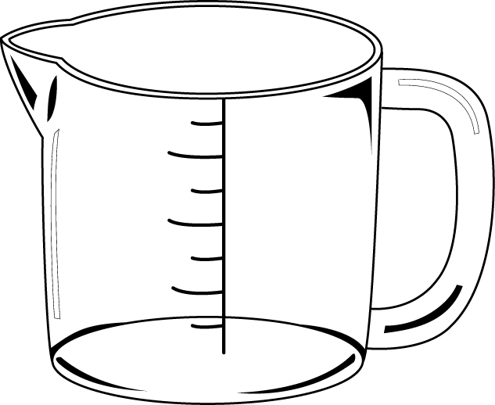  If the jug is half full,  how many millilitres  does it contain? |  | 3:19
2. What is the 4 worth in this number?  924 | 3:2 | 12. 6 x 8 = |  | 3:10 |  |  | 3:19
3. Write this number in words.  261 | 3:3 | 13. 13 x 4 = |  | 3:11 | 22. Tom bought 5 cans of pop that were 40p each. How much did they cost in total? |  | 3:21
4. Estimate the labelled number?  0  100  50 | 3:4 | 14. I buy 9 packs of balloons. I have 99 balloons. How many are in each pack?  3  10 |  | 3:12 |  |  | 3:21
5. Write a number that is bigger than 592 using the same three digits. | 3:5 | 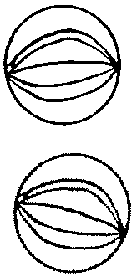  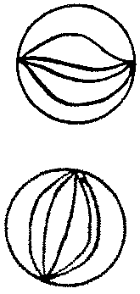  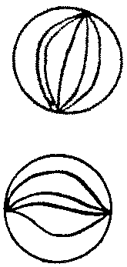  16. Circle  of the marbles. |  | 3:13 | 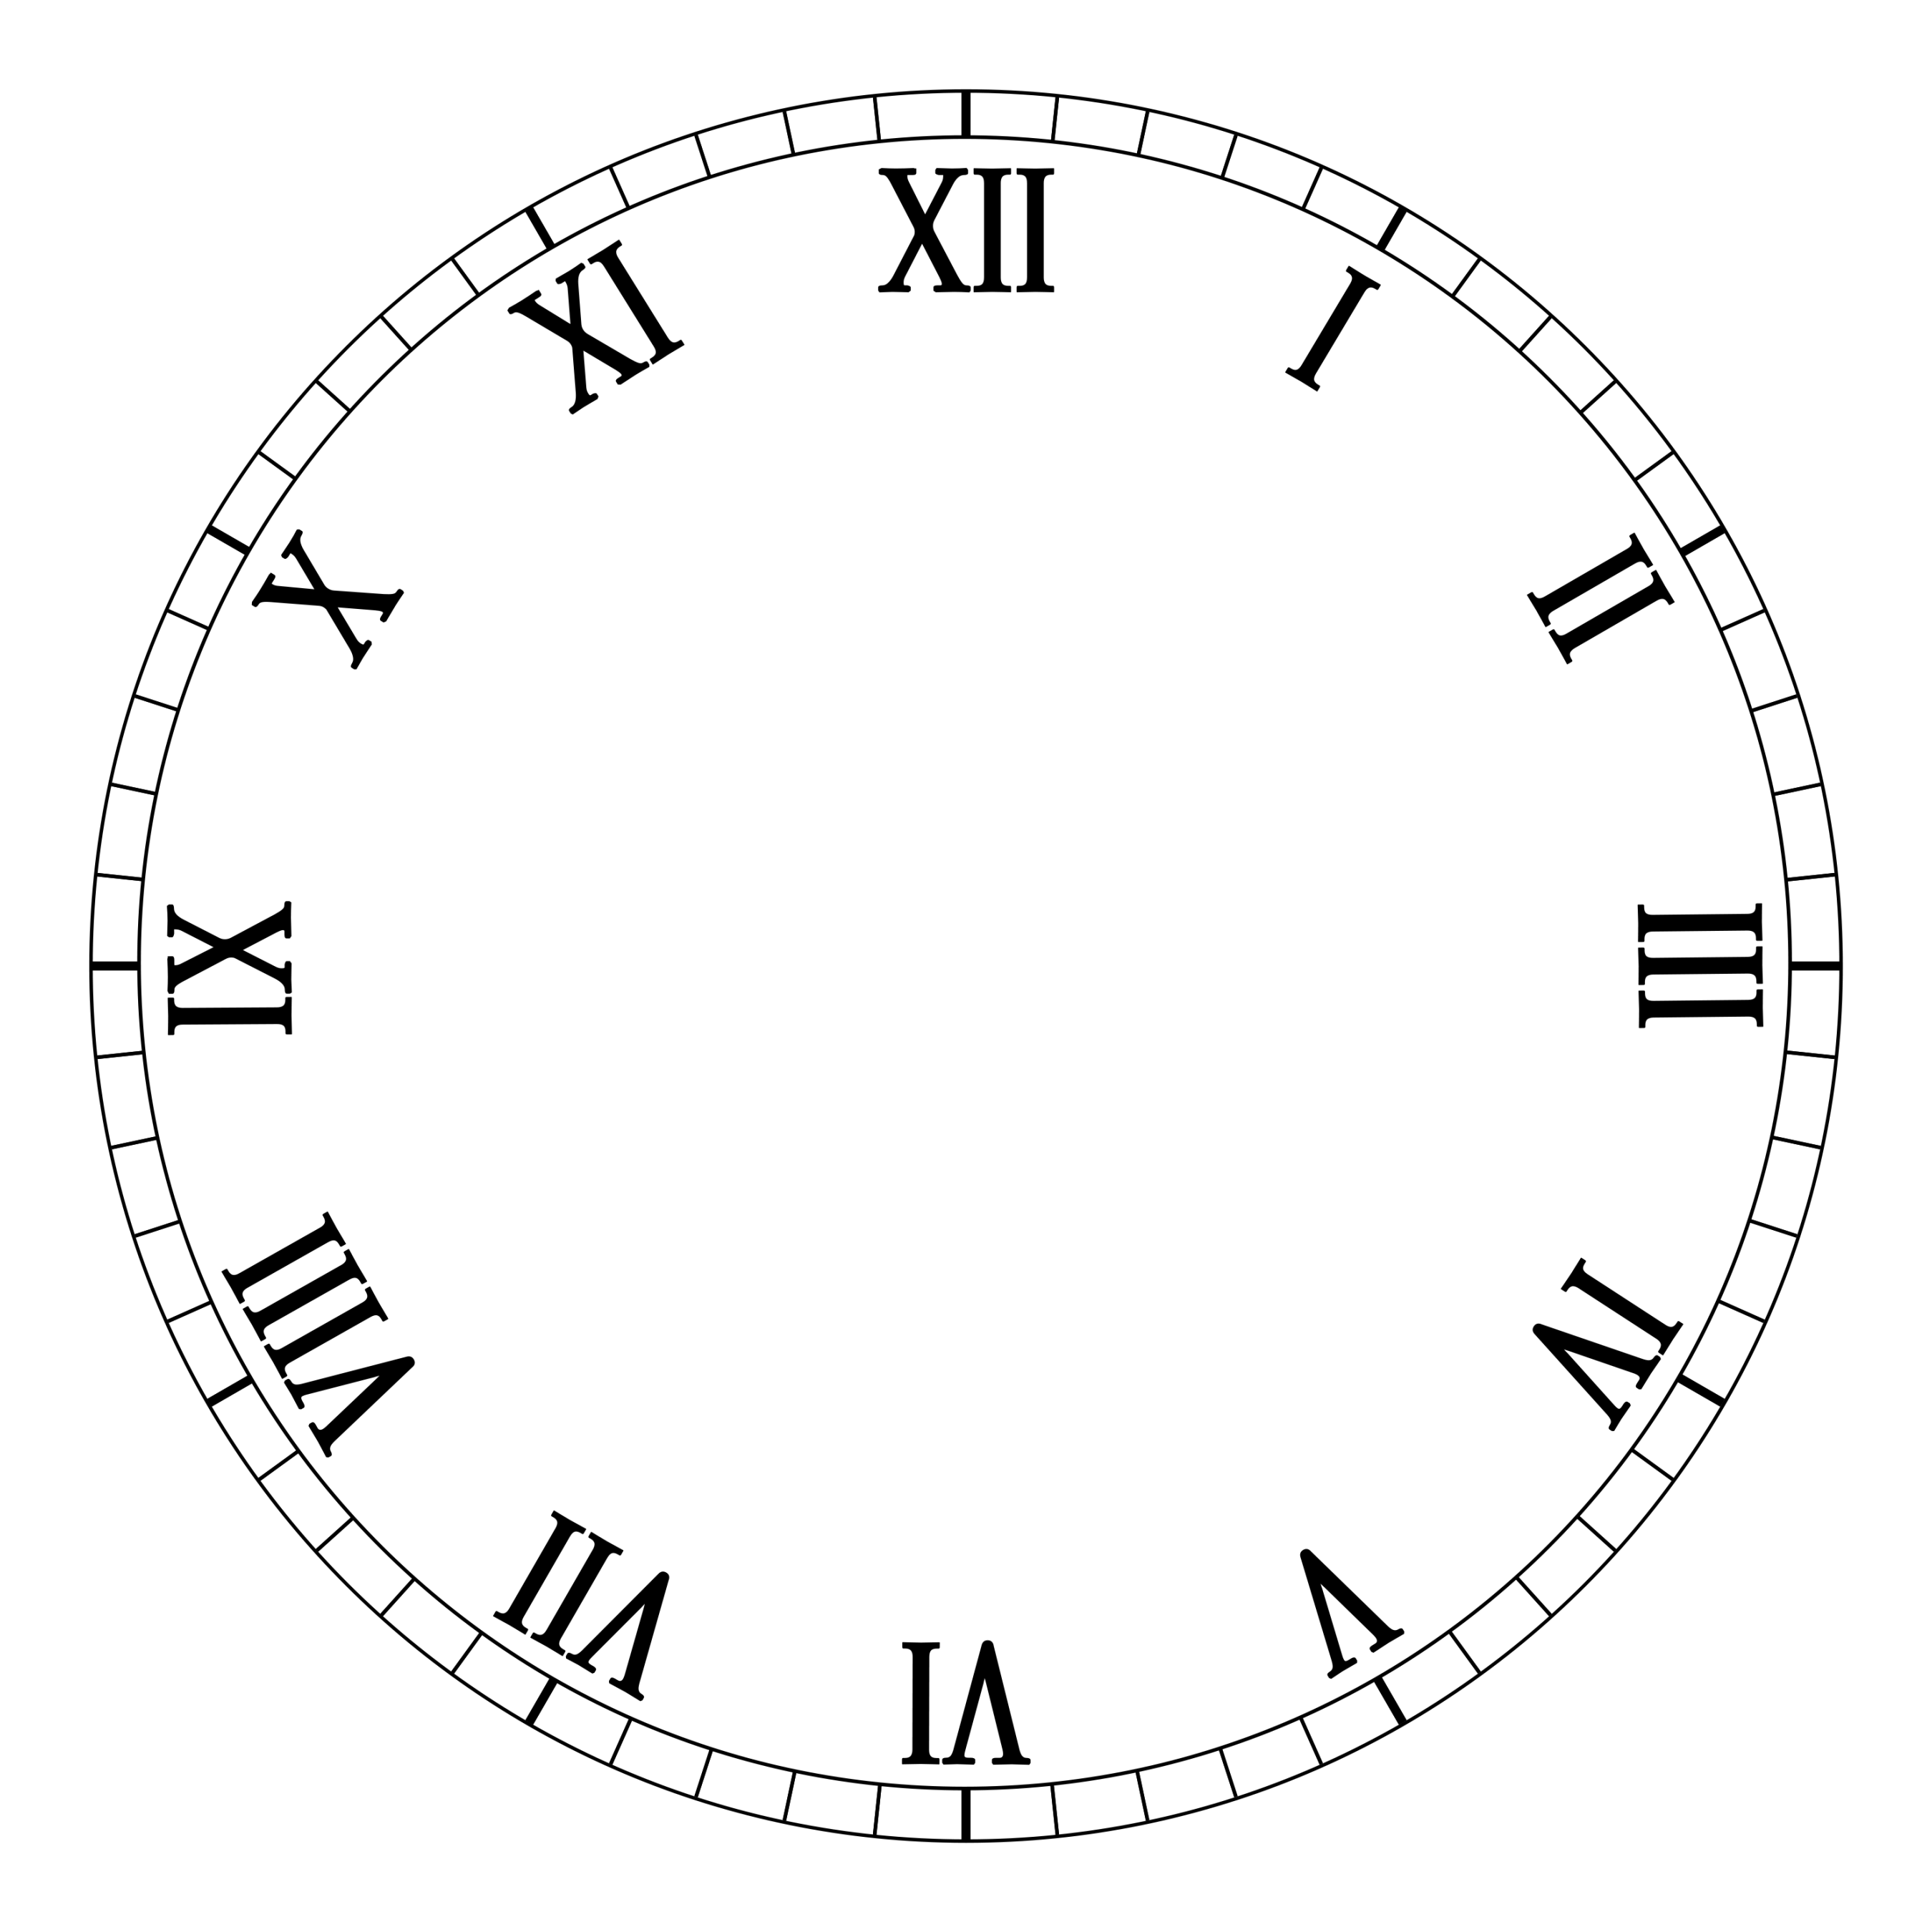  23. What time does  this clock show? |  | 3:22
6. 612 - 10 = | 3:6 | 16. What fraction  is shaded?  1  5 |  | 3:14 |  |  | 3:22
7. 326 - 78 = | 3:7 | 17. What is of 30? |  | 3:15 | 24. How many right angles make three quarters of a turn? |  | 3:27
8. Circle the best estimate to 52 + 179  220 230 240 250 | 3:8 | 18. This shape is in tenths.  3  5  Shade in . |  | 3:16 |  |  | 3:27
9. Use 46 + 27 = 73 to help solve:  730 – 270 = | 3:9 | 19. Add the  3  8  2  8  +  fractions. |  | 3:17 | 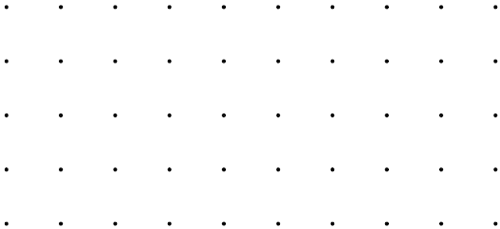  25. Draw a horizontal line on the grid. |  | 3:28
10. What is the missing number?  213 - = 149 | 3:9 | 20. Write the  1  9  1  7  1  4  1  6  smallest fraction. |  | 3:18 |  |  | 3:28
Total (A) |  | Total (B) |  |  | Total (C)
Test Total (A+B+C) |  | R (0-9) | Y (10-19) |  |  | G (20-25)

