Maths Key Skills Stage 3: Skill Check 5

Name: ___________________________________ Date: _______________ Class/Group: _______________________________

A: Place Value, Add and Subtract |  | B: Multiply, Divide and Fractions |  |  | C: Measure and Geometry
1. What is 10 more than this number?  67 | 3:1 | 11. 56 ÷ 8 = |  | 3:10 |   21. How much does  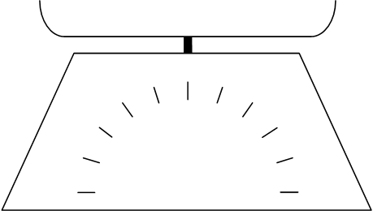  this strawberry  0  10  20  30  40  50  weigh?  grams |  | 3:19
2. What is the 5 worth in this number?  750 | 3:2 | 12. 12 x 4 = |  | 3:10 |  |  | 3:19
3. Write < or > to make this correct:  812 796 | 3:3 | 13. 17 x 4 = |  | 3:11 | 22. What is the  perimeter of this  equilateral  cm  0  2  4  6  8  10  triangle? |  | 3:20
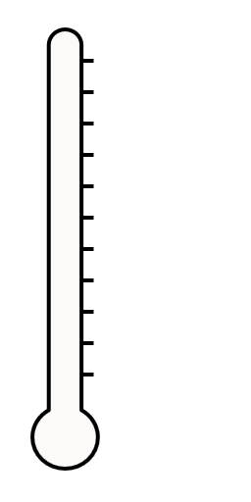  4. Show 18°C on the  20°C  thermometer.  0°C  10°C | 3:4 | 14. There are 3 girls for every 2 boys. If there are 12 girls, how many boys? |  | 3:12 |  |  | 3:20
5. Make the smallest number possible using the digits 2 7 and 5. | 3:5 | 15. What is one tenth of 8?  1  7 |  | 3:13 | 23. Ian turns through    a quarter turn. How  many degrees has  he turned through? |  | 3:26
6. 459 + 1 = | 3:6 | 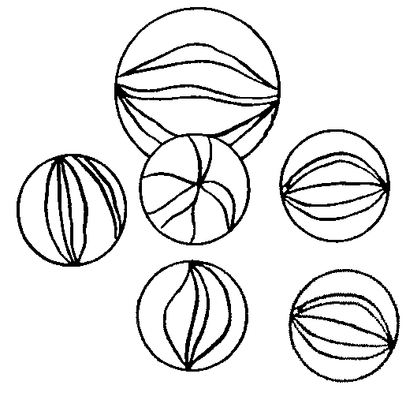  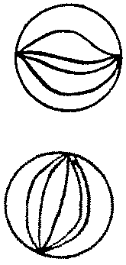  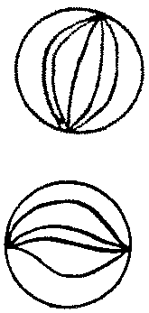  16. Circle  of the marbles.  3  5 |  | 3:14 |  |  | 3:26
7. 256 - 173 = | 3:7 | 17. What is of 25? |  | 3:15 | 24. Is this angle bigger or smaller than a right angle? |  | 3:27
8. Circle the best estimate to 102 - 69:  15 20 25 30 | 3:8 | 18.  ?  3  =  8  12 |  | 3:16 |  |  | 3:27
9. A school has 500 tickets to sell for a play. They sell 289. How many left? | 3:9 | 19. Add the  3  9  3  9  +  fractions. |  | 3:17 | 25. Which pair of lines are parallel?  a. b. |  | 3:28
10. What is the missing number?  25 + - 13 = 30 | 3:9 | 20. Write the  1  5  1  3  1  7  1  2  smallest fraction. |  | 3:18 |  |  | 3:28
Total (A) |  | Total (B) |  |  | Total (C)
Test Total (A+B+C) |  | R (0-9) | Y (10-19) |  |  | G (20-25)

