Maths Key Skills Stage 4: Skill Check 6

Name: ___________________________________ Date: _______________ Class/Group: _______________________________

A: Place Value, Add and Subtract |  | B: Multiply, Divide and Fractions |  |  | C: Measure and Geometry
1. What is the missing number?  18 27 36 54 | 4:1 | 11. 66 ÷ 6 = |  | 4:9 | 21. There are 650 millilitres of liquid in a jug. How much more liquid needs to be added to make 1 litre? |  | 4:19
2. What is the missing number?  49 63 70 77 | 4:1 | 12. Two factors of 32 add up to 33. What are they? |  | 4:10 |  |  | 4:19
3. What is 1,000 more than 2,350? | 4:2 | 13. 314 x 7 = |  | 4:11 | 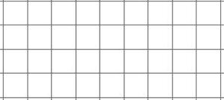  22. What is the perimeter of this rectangle?  1cm |  | 4:20
4. Round this number to the nearest 10: 3,275 | 4:2 | 14. In a class of 18 there are 2 girls for every 1 boy. How many are boys? |  | 4:12 |  |  | 4:20
5. What is 2 – 9? | 4:3 | 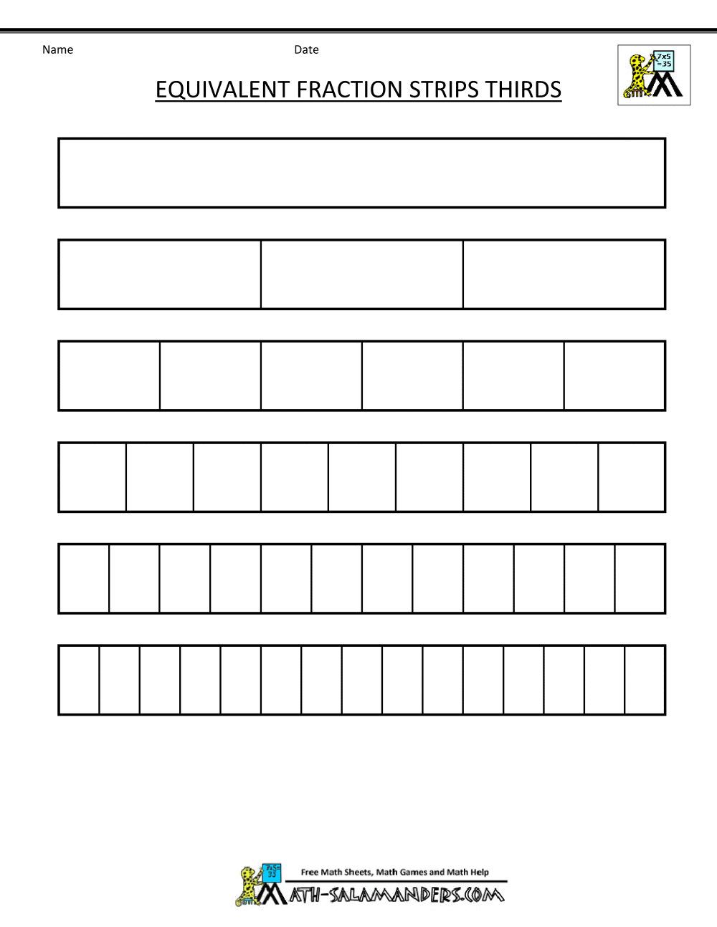  15.  ?  3  5  15  = |  | 4:13 | 23. At lunch, Kirsty has a starter and a main meal. She pays with a £20 note. How much change does she get?  All Starters £4.95 All Mains £9.90 |  | 4:21
6. What is the value of the 3 in this number? 3,296 | 4:4 | 16. What is the missing number?  2.00 2.01 2.02 2.03  5  14  8  14 |  | 4:14 |  |  | 4:21
7. Write the number 67 in Roman numerals. | 4:5 | 17.  + |  | 4:15 | 24. How would 6:15pm be shown on a 24 hour digital clock?  : |  | 4:22
8. 3,912 + 1,129 = | 4:6 | 18. Write 0.25 as a fraction. |  | 4:16 |  |  | 4:22
9. Write the sum to check 492 + 210 = 702: 702 - = | 4:7 | 19. 45 ÷ 10 = |  | 4:17 | 25. What is the special  name for this type  of triangle? |  | 4:23
10. I have £2. I spend £1.15 then 65p. How much do I have left? | 4:8 | 20. Round 5.6 to the nearest whole number. |  | 4:18 |  |  | 4:23
Total (A) |  | Total (B) |  |  | Total (C)
Test Total (A+B+C) |  | R (0-9) | Y (10-19) |  |  | G (20-25)

