Maths Key Skills Stage 3: Skill Check 12

Name: ___________________________________ Date: _______________ Class/Group: _______________________________

A: Place Value, Add and Subtract |  | B: Multiply, Divide and Fractions |  |  | C: Measure, Geometry and Statistics
1. What is the missing number?  0 8 16 24 | 3:1 | 11. 27 ÷ 3 = |  | 3:10 | 23. About how long is a kids’ cartoon show?  a. 15 minutes  b. 50 minutes  c. 1 hour |  | 3:23
2. What is the 7 worth in this number?  712 | 3:2 | 12. 9 x 4 = |  | 3:10 |  |  | 3:23
3. Put these in order, smallest first.  241 412 421 142 | 3:3 | 13. Use 7 x 8 = 56 to solve:  560 ÷ 8 = |  | 3:11 | 22. Tick the shape which is a face of a cylinder. |  | 3:25
4. Draw an arrow to label 70.  0  100 | 3:4 | 14. Eggs come in boxes of 6. I need 27 eggs. How many boxes should I buy?  1  10 |  | 3:12 |  |  | 3:25
5. Circle all the multiples of 4.  6 8 14 16 22 | 3:5 | 15. Shade of  this shape?  3  5 |  | 3:13 | 23. How many right angles are in this shape? |  | 3:26
6. 612 + 100 = | 3:6 | 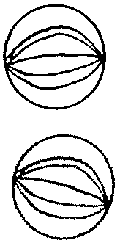  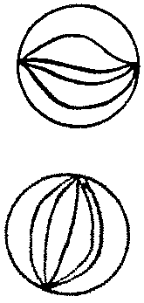  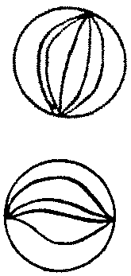  16. Circle  of the marbles. |  | 3:14 |  |  | 3:26
7. 682 + 176 = | 3:7 | 17. What fraction is labelled?  0  1 |  | 3:15 | 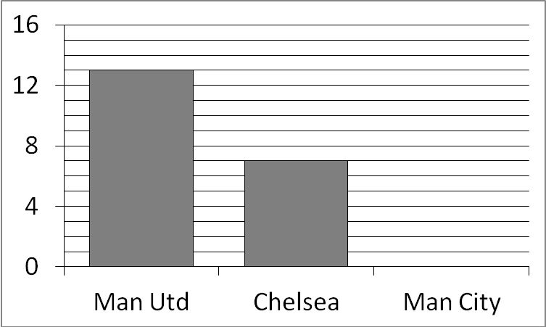  24. Favourite football teams:  9 people said ‘Man City’. Show this.  25. How many more people said ‘Man Utd’ than said ‘Chelsea’? |  | 3:29  3:30
8. Write a sum to check 54 + 18 = 72.  Check: 72 - = | 3:8 | 18.  2  8  ?  4  = |  | 3:16 |  |  | 3:29  3:30
9. To a no. I add 13 then subtract 29. I now have 3. What did I start with? | 3:9 | 19. Subtract the  5  7  2  7  -  fractions. |  | 3:17 |  |  | 3:29  3:30
10. What is the missing number?  212 + = 307 | 3:9 | 20. Write the  1  8  3  8  2  8  5  8  largest fraction. |  | 3:18 |  |  | 3:29  3:30
Total (A) |  | Total (B) |  |  | Total (C)
Test Total (A+B+C) |  | R (0-9) | Y (10-19) |  |  | G (20-25)

