Maths Key Skills Stage 5: Skill Check 1

Name: ___________________________________ Date: _______________ Class/Group: _______________________________

A: Place Value, Add and Subtract |  | B: Multiply, Divide and Fractions |  |  | C: Measure and Problem Solving
1. What is the value of the 4 in this number? 1,348,567 | 5:1 | 11. Which is a common factor of 12 and 20? 3 4 5 6 10 |  | 5:8 | 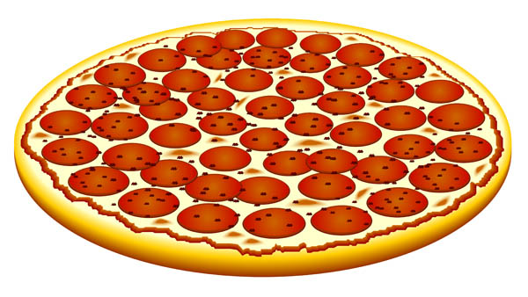  21. Megan and Joe are sharing a pizza. Megan eats 25% of the pizza.  1  2  Joe eats of the pizza.  What fraction of the pizza is left? |  | 5:19
2. Write eight hundred thousand, three hundred and seven in digits. | 5:1 | 12. Give two prime numbers between 1 and 10. |  | 5:9 |  |  | 5:19
3. Round 247,599 to the nearest thousand. | 5:2 | 13. 628 x 12 |  | 5:10 | 22. How many centimetres are there in 3.7 metres? |  | 5:20
4. What is the missing number?  837 937 1,137 | 5:2 | 14. 1,278 ÷ 100 |  | 5:11 |  |  | 5:20
5. What temperature is 15 degrees less than 6 degrees Celsius? | 5:3 | 15. What is 7² ? |  | 5:12 | 23. Calculate the perimeter of this shape.  12cm  9cm  6cm  4cm |  | 5:21
6. What number is represented by these Roman Numerals? DXXX | 5:4 | 16.  3  4  1  8  +  =  1  4 |  | 5:13 |  |  | 5:21
7. 12,498 – 3,149 = | 5:5 | 17. Find an equivalent fraction of .  17  6 |  | 5:14 | 24. Estimate the volume of this shape. Write a, b or c.  a. 6 cm³.  b. 26 cm³.  1cm³  c. 46 cm³. |  | 5:22
8. 24,829 + 83,592 = | 5:5 | 18. Write as a mixed number. |  | 5:15 |  |  | 5:22
9. Complete this sum without written working. 15,200 – 4,150 = | 5:6 | 19.  2  7  x  =  21 |  | 5:16 | 25. Sarah gets on a train at 2.30pm. The train journey lasts 110 minutes. What time does Sarah arrive at her destination? |  | 5:23
10. I buy 2 CDs costing £8.45 each. How much change do I get from £20? | 5:7 | 20. Round 2.37 to 1 decimal place. |  | 5:17 |  |  | 5:23
Total (A) |  | Total (B) |  |  | Total (C)
Test Total (A+B+C) |  | R (0-9) | Y (10-19) |  |  | G (20-25)

