Maths Key Skills Stage 4: Skill Check 7

Name: ___________________________________ Date: _______________ Class/Group: _______________________________

A: Place Value, Add and Subtract |  | B: Multiply, Divide and Fractions |  |  | C: Measure and Geometry
1. What is the missing number?  14 21 28 42 | 4:1 | 11. 9 x 12 = |  | 4:9 | 21. On the back of a film box it says the length of the film is 97 minutes.  How long is this in hours and minutes? |  | 4:19
2. What is the missing number?  36 48 54 60 | 4:1 | 12. Complete the sum that is equal to 36 x 7: 3 x x 7 |  | 4:10 |  |  | 4:19
3. Round this number to the nearest 10: 5,731 | 4:2 | 13. 68 x 4 = |  | 4:11 | 22. What name is given to this type of angle? |  | 4:24
4. Round this number to the nearest 100: 3,275 | 4:2 | 14. One wooden block is 4cm tall. If 14 blocks are piled up, how tall are they? |  | 4:12 |  |  | 4:24
5. What is the next number in this sequence: 4, 2, 0, -2, | 4:3 | 15.  ?  5  4  20  = |  | 4:13 | 23. Draw all the lines of symmetry on this triangle. |  | 4:25
6. Write < or > to make this correct:  3,948 2,817 | 4:4 | 16. When I divide an amount by 100, what fraction of the amount do I have? |  | 4:14 |  |  | 4:25
7. What number does this Roman Numeral represent? XC | 4:5 | 17.  14  13  5  13  7  10  - |  | 4:15 | 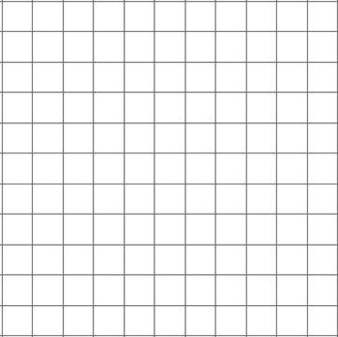  24. Complete this shape:  1 2 3 4 x  y  4  3  2  1  0  Mirror line |  | 4:26
8. 2,725 - 834 = | 4:6 | 18. Write as a decimal number. |  | 4:16 |  |  | 4:26
9. Estimate the answer to:  6,504 + 4,478 | 4:7 | 19. What is the value of the 9 in:  3.91 |  | 4:17 | 25. What are  A  the co-ordinates  of the point  labelled A? |  | 4:27
10. Sarah had £65. She bought a £28 dress and a £17 bag. How much left? | 4:8 | 20. A log is 6 metres long. It is cut into quarters. How long is each piece? |  | 4:18 |  |  | 4:27
Total (A) |  | Total (B) |  |  | Total (C)
Test Total (A+B+C) |  | R (0-9) | Y (10-19) |  |  | G (20-25)

