Maths Key Skills Stage 2: Skill Check 15

Name: ___________________________________ Date: _______________ Class/Group: _______________________________

A: Place Value, Add and Subtract |  | B: Multiply, Divide and Fractions |  |  | C: Measure and Geometry
1. What is the missing number?  104 94 84 74 64 | 2:1 | 11. 40 ÷ 10 = |  | 2:11 | 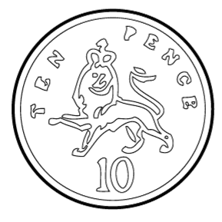  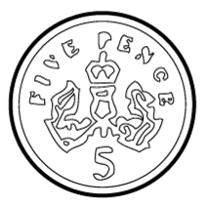  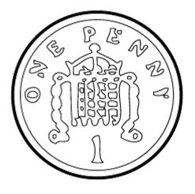  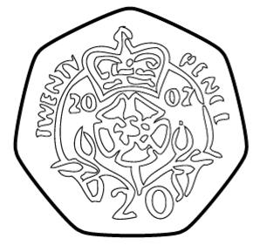  21. Tim has fifty pence (25p). Tick the coins that have the same value. |  | 2:19
2. What is the value of the 5 in this number? 95 | 2:2 | 12. Which are the even numbers?  9 18 27 36 |  | 2:11 |  |  | 2:19
3. Draw an arrow to label 7.  5  10 | 2:3 | 13. What symbol is missing?  56 = 7 8 |  | 2:12 | 22. Sam has seventy five  pence (75p). He buys  a comic for twenty  pence (20p). How much  change does Sam get? |  | 2:20
4. Use <, > or = to make this correct:  3 x 5 10 + 4 | 2:4 | 14. What symbol is missing?  4 = 36 9 |  | 2:12 |  |  | 2:20
5. Write this number in numerals.  sixty eight | 2:5 | 15. Tick (✓) if true:  7 x 3 = 3 x 7 18 ÷ 6 = 6 ÷ 18 |  | 2:13 | 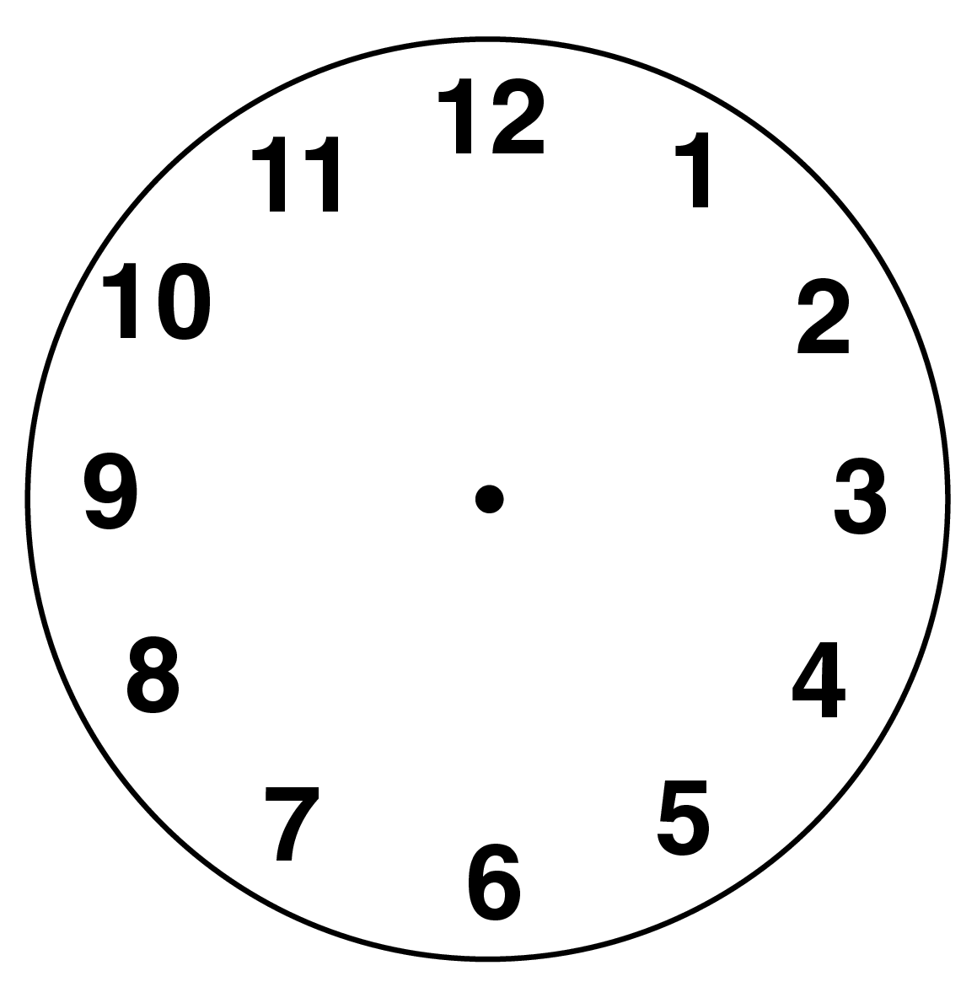  23. What time does  this clock show? |  | 2:22
6. There are 28 people on a train. 12 more get on. How many people now? | 2:6 | 16. 4 boys share 32 chocolates. How many chocolates does each boy get? |  | 2:14 |  |  | 2:22
7. 20 - = 3 | 2:7 | 17. 4 bags each contain 6 apples. How many apples are there in total? |  | 2:14 | 24. The way pupils get to school is shown in this block diagram.  4  3  2  1  Walk Bike Bus  3 pupils travel by bus. Show this on the diagram.  25. How many pupils were asked in total? |  | 2:29  2:30
8. 92 - 10 = | 2:8 | 18. What fraction  is shaded? |  | 2:15 |  |  | 2:29  2:30
9. Is this true? Write ‘yes’ or ‘no’.  23 + 9 = 9 + 23 | 2:9 | 19. How many thirds are in 1 whole? |  | 2:15 |  |  | 2:29  2:30
10. Use 48 = 22 + 26 to help find:  48 - 22 = | 2:10 | 20. How many halves make 2 whole ones? |  | 2:16 |  |  | 2:29  2:30
Total (A) |  | Total (B) |  |  | Total (C)
Test Total (A+B+C) |  | R (0-9) | Y (10-19) |  |  | G (20-25)

