Maths Key Skills Stage 1: Skill Check 12

Name: ___________________________________ Date: _______________ Class/Group: _______________________________

A: Number and Place Value |  | B: Fractions and Measure |  |  | C: Measure and Geometry
1. What is the total score on the dice?  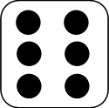  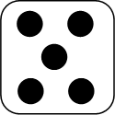  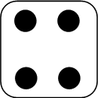 | 1:1 | 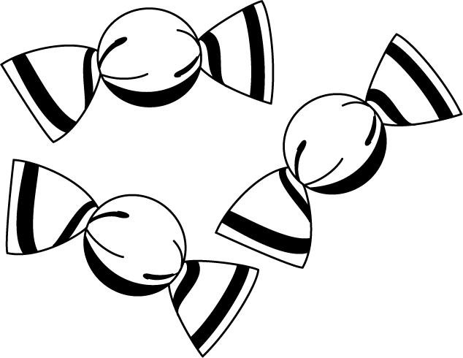  11. Circle ½ of the sweets. |  | 1:11 | 16. If today is Tuesday, then Monday:  a. is today.  b. is tomorrow.  c. was yesterday. |  | 1:16
2. What is the missing number?  20 30 40 50 | 1:2
3. What number is one more than 73? | 1:3 | 12. What fraction of this shape is shaded? |  | 1:12 | 17. How many hours are in a day?  a. 12  b. 24  c. 48 |  | 1:17
4. Circle the right phrase:  8 is less than/equal to/more than 2x4 | 1:4
5. Write this number in numerals:  sixteen | 1:5 |   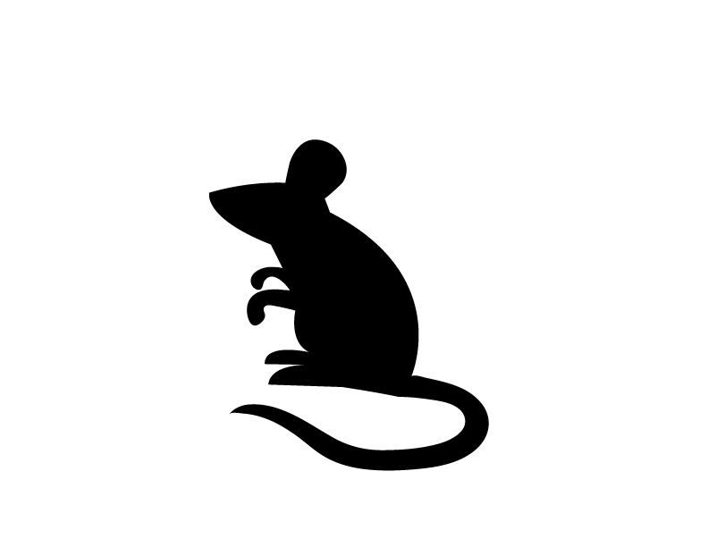  13. Circle the animal that is quicker than the other. |  | 1:13 | 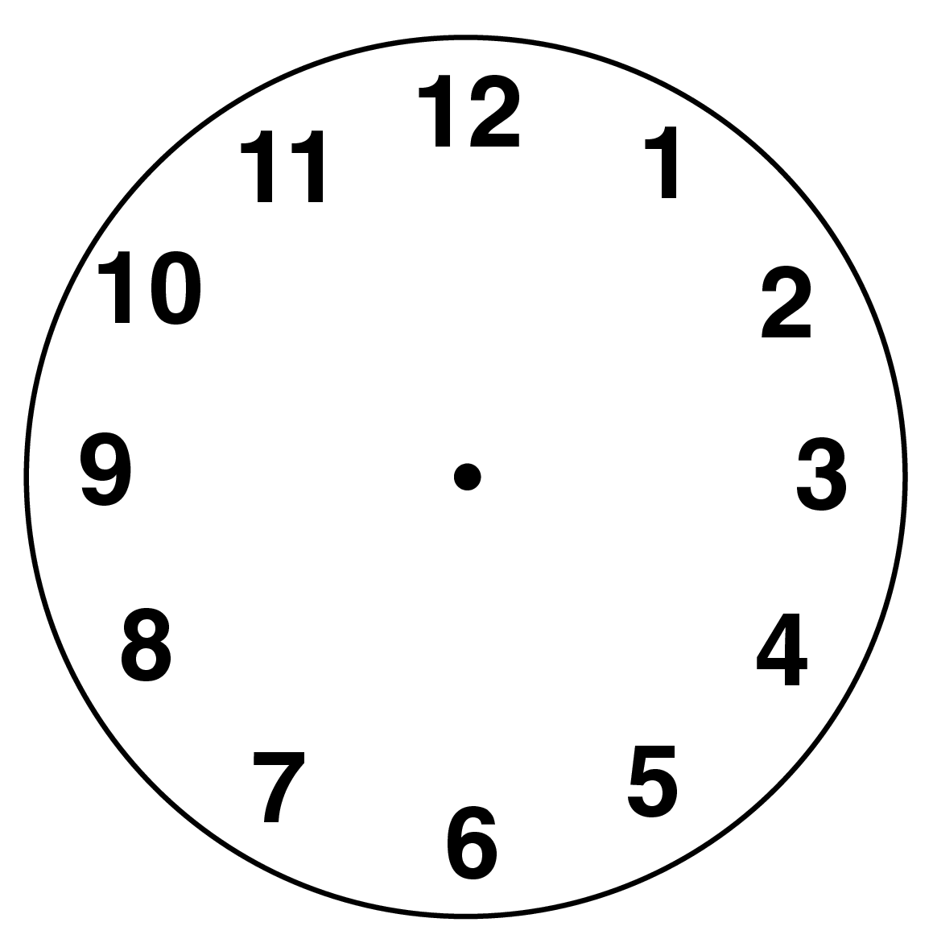  18. What time does  this clock show? |  | 1:18
6. What symbol is missing?  6 1 = 5 | 1:6
7. What is the missing number?  20 - = 7 | 1:7 | 14. A man times himself running a marathon. Which number represents the hours?  04:38:28 |  | 1:14 |   19. Draw a rectangle on the grid. |  | 1:19
8. 9 + 6 = | 1:8
9. Jo has 15 sweets. After eating some she has 4 left. How many did she eat? | 1:9 | 15. How much altogether?  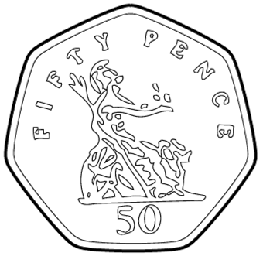  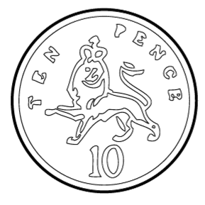  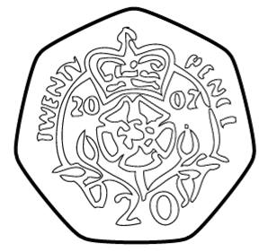 |  | 1:15 | 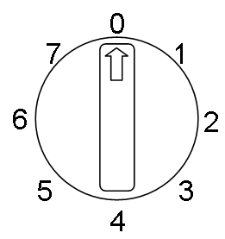  20. What number will the  dial be pointing to  after a half turn? |  | 1:20
10. Eggs come in boxes of 6. If I buy 2 boxes, how many eggs do I have? | 1:10
Total (A) |  | Total (B) |  |  | Total (C)
Test Total (A+B+C) |  | R (0-7) | Y (8-15) |  |  | G (16-20)

