Maths Key Skills Stage 4: Skill Check 2

Name: ___________________________________ Date: _______________ Class/Group: _______________________________

A: Place Value, Add and Subtract |  | B: Multiply, Divide and Fractions |  |  | C: Measure and Geometry
1. What is the missing number?  14 28 35 42 | 4:1 | 11. 7 x 12 = |  | 4:9 | 21. Harry is 9 years and  5 months old.  Zac is 14 months older.  How old is Zac? |  | 4:19
2. What is the missing number?  36 42 48 60 | 4:1 | 12. Complete the sum that is equal to 24 x 11: 2 x x 11 |  | 4:10 |  |  | 4:19
3. Round this number to the nearest 10: 2,167 | 4:2 | 13. 95 x 8 = |  | 4:11 | 22. What name is given to this type of angle? |  | 4:24
4. Round this number to the nearest 100: 1,543 | 4:2 | 14. One wooden block is 6cm tall. If 12 blocks are piled up, how tall are they? |  | 4:12 |  |  | 4:24
5. What is the next number in this sequence: 4, 3, 2, 1, 0, | 4:3 | 15.  1  5  ?  20  = |  | 4:13 | 23. How many lines of symmetry does this rectangle have? |  | 4:25
6. Write < or > to make this correct:  1,782 2,817 | 4:4 | 16. To share a number into hundredths you divide it by . |  | 4:14 |  |  | 4:25
7. What number does this Roman Numeral represent? LX | 4:5 | 17.  12  9  7  9  1  10  - |  | 4:15 | 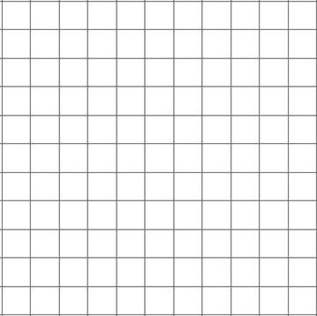  24. Complete this shape:  1 2 3 4 x  y  4  3  2  1  0  Mirror line |  | 4:26
8. 2,725 + 834 = | 4:6 | 18. Write as a decimal number. |  | 4:16 |  |  | 4:26
9. Estimate the answer to:  6,504 – 4,478 | 4:7 | 19. What is the value of the 7 in:  1.72 |  | 4:17 | 25. What are  the co-ordinates  A  of the point  labelled A? |  | 4:27
10. A pet mouse weighed 65g. Its weight doubled. How heavy is it now? | 4:8 | 20. Put these heights in order, smallest first: 1.4m 1.18m 1.22m |  | 4:18 |  |  | 4:27
Total (A) |  | Total (B) |  |  | Total (C)
Test Total (A+B+C) |  | R (0-9) | Y (10-19) |  |  | G (20-25)

