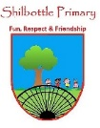

**Geography – Exploring maps through our local area**

**Vocabulary**

**Skills**

**Books**

* Use 8 points on a compass.
* Follow a route on a map.
* Interpret a flat map of the globe.
* Use paper and Digi maps to plan and follow a route.
* Make comparisons between different places.
* Name human and physical geographical features in my local area.

Exact and correct, often with measurements.

**accurate**

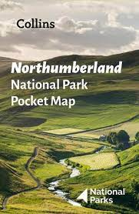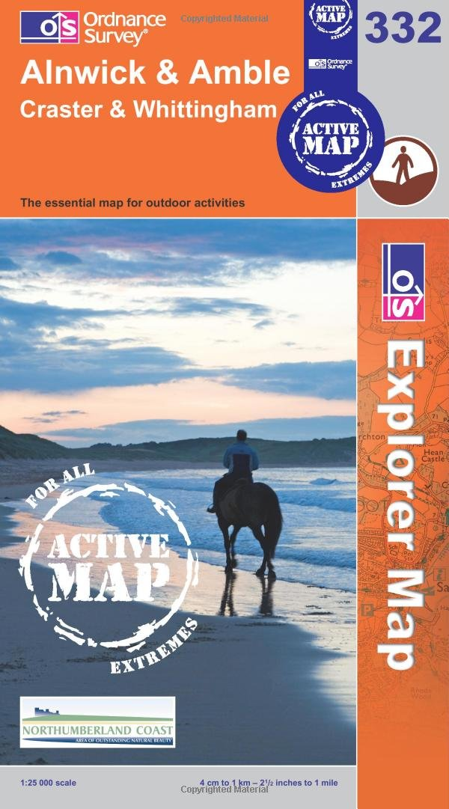

An instrument showing the direction of North, South, East and West.

**compass**

Relating to the whole world or worldwide.

**global**

Geography dealing with how human activity affects or is influenced by the earth's surface.

**human features**

**Knowledge**

To understand or be able to explain.

**interpret**

Places or areas very close to where you are.

**local**

**By the end of this topic you will have increased your local knowledge of the Geography around you and:**

* Be able to follow a simple route on a map for your local area.
* Use 8 points on a compass; North, North east, East, South East, South, South West, West and North West.
* Read and interpret maps of the local area.
* Identify and interpret symbols on a map.
* Compare a region of the UK with a region of a European country.

Relating to the whole of a country or nation rather than to part of it or to other nations.

**national**

Geography dealing with things that occur naturally on earth. e.g. Weather, hills, rivers

**physical features**

An area, especially part of a country or the world having definable characteristics.

**region**

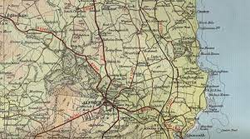

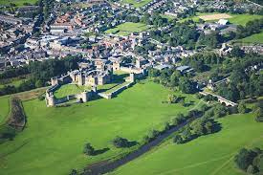

A large natural stream of water flowing in a channel to the sea, a lake, or another river.

**route**

A rule determining the distances between places on a map.

**scale**

Relating to or done by all people or things in the world.

**universal**

**What I should be able to do and know now.**

**What I will know and be able to do at the end of the topic.**

**Key skills in Geography**

**Knowledge:**

* Can you name a local area near where you live?
* What are the 8 points on a compass?
* On a map, describe the location of places using compass directions.
* What does a scaled drawing of a map mean?
* If a map is scaled 5:1 what does this mean?
* What can you use to create an accurate map?

**Skills:**

* Make an accurate map of an area studied.
* Use standard symbols on maps.
* Give directions using 8 points on a compass.
* Follow directions using an 8-point compass.
* Use mathematical knowledge to scale a map.
* To use a compass to support map work.
* To name and use the 8 points on a compass.
* To name and locate towns and villages in our local area (Northumberland).
* To locate where we are on a regional, National and Global map.
* To use symbols and the key when reading maps.

**Knowledge:**

* A map is not the same size as the land, it is smaller.
* The world on a 3D map is a globe
* Natural things occur on Earth.
* Humans make and build some geography.
* Names of local places around me; Alnwick, Alnmouth, Amble, Shilbottle.
* A map will guide me where I need to go.

**Skills:**

* Name some local towns and villages.
* Draw a map from birds-eye view.
* Locate some features on a map using a key.
* Use 4 points on a compass.

**What I will be learning**

Through exploring our local area, we will learn to;

* To use 8 points on a compass.
* To follow routes on a map for my local area.
* To make scale drawings using scales based around powers of 10.
* To use photographs and measurements to create an accurate map of my local area.