Maths Key Skills Stage 1: Skill Check 5

Name: ___________________________________ Date: _______________ Class/Group: _______________________________

A: Number and Place Value |  | B: Fractions and Measure |  |  | C: Measure and Geometry
1. What is the missing number?  0 2 3 4 | 1:1 | 11. Circle half (½) of the sweets.  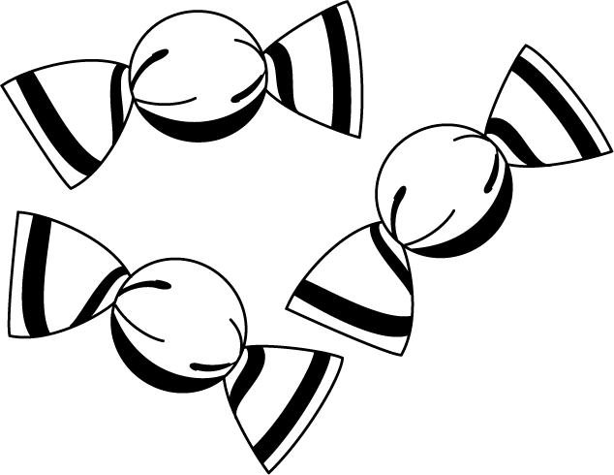 |  | 1:11 | 16. I go to bed in the:  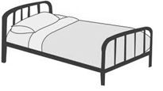  a. morning  b. afternoon  c. evening. |  | 1:16
2. What is the missing number?  2 6 8 10 | 1:2
3. What number is one more than 24? | 1:3 | 12. Colour in ¼ of this shape. |  | 1:12 | 17. What month comes before April?  a. February  b. May  c. March |  | 1:17
4. What number is labelled?  0  5 | 1:4
5. Write this number in words:  4 | 1:5 | 13. Circle the shortest arrow. |  | 1:13 | 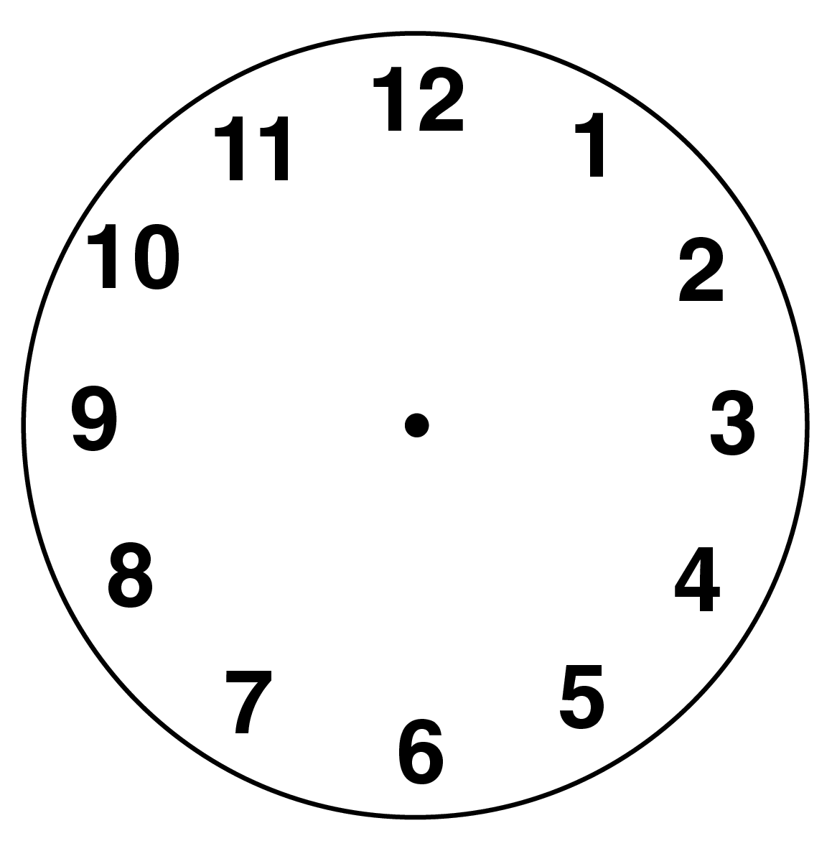  18. What time does  this clock show? |  | 1:18
6. What symbol is missing?  8 5 = 13 | 1:6
7. What is the missing number?  10 - 9 = | 1:7 | 14. How long is the matchstick?  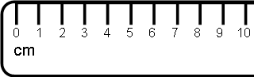 |  | 1:14 | 19. What is this shape?  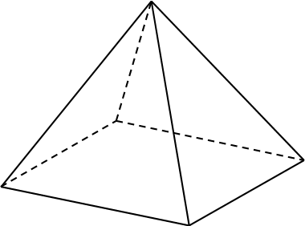  a. cuboid  b. pyramid  c. sphere |  | 1:19
8. 19 + 4 = | 1:8
9. Tom has 5 apples. Kim has 8 apples. How many apples altogether? | 1:9 | 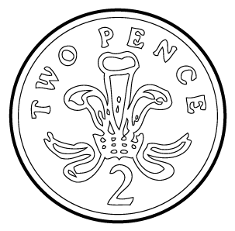  15. How much altogether?  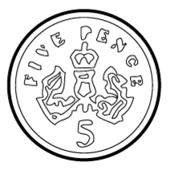  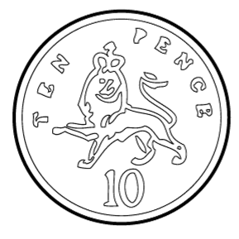 |  | 1:15 | 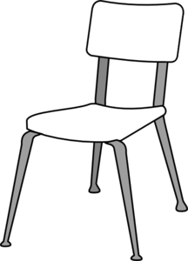  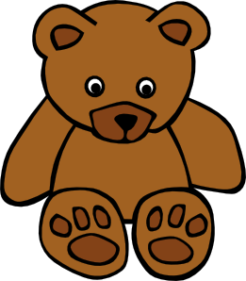  20. The teddy bear is:  a. on the chair.  b. under the chair.  c. next to the chair. |  | 1:20
10. 10 pens are shared by 2 children. How many pens do they get each? | 1:10
Total (A) |  | Total (B) |  |  | Total (C)
Test Total (A+B+C) |  | R (0-7) | Y (8-15) |  |  | G (16-20)

