Maths Key Skills Stage 1: Skill Check 1

Name: ___________________________________ Date: _______________ Class/Group: _______________________________

A: Number and Place Value |  | B: Fractions and Measure |  |  | C: Measure and Geometry
1. What is the missing number?  23 24 25 26 | 1:1 | 11. Circle half (½) of the balls.   |  | 1:11 | 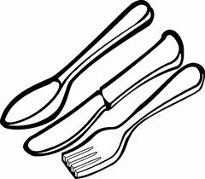  16. Which comes first in the day?  a. tea  b. lunch  c. breakfast |  | 1:16
2. What is the missing number?  5 10 20 25 | 1:2
3. What number is one more than 38? | 1:3 | 12. Circle a quarter (¼) of the sweets.  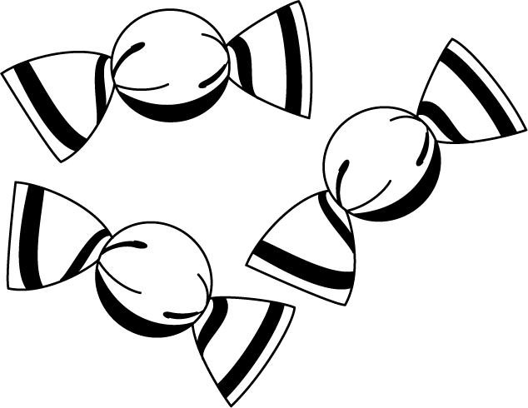 |  | 1:12 | 17. How many days are in a week?  a. 4  b. 7  c. 12 |  | 1:17
4. Pat has 3 sweets. Sam has 5.  Who has the most? | 1:4
5. Write this number in numerals:  twelve | 1:5 | 13. Circle the full glass.  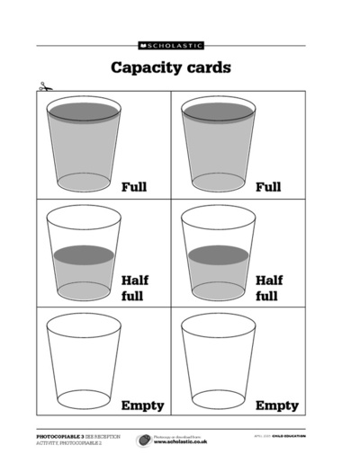 |  | 1:13 | 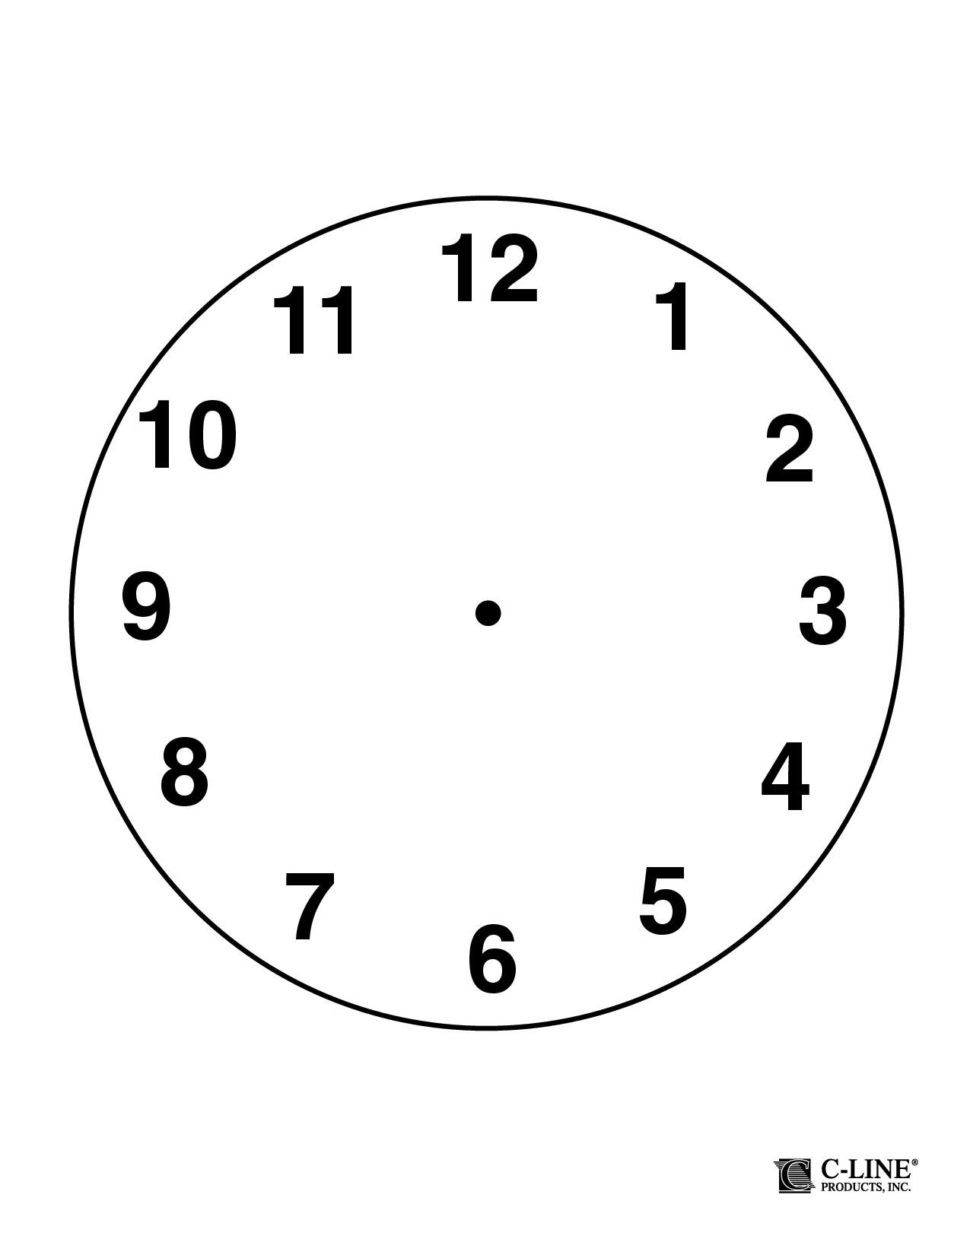  18. Draw the hands  to show:  2 o’ clock |  | 1:18
6. What symbol is missing?  5 4 = 9 | 1:6
7. What is the missing number?  10 = 3 + | 1:7 | 14. How heavy is the feather?  0  5  10  15  20  25  grams |  | 1:14 | 19. What is this shape?  a. square  b. triangle  c. circle |  | 1:19
8. 14 + 5 = | 1:8
9. What is the missing number?  20 = 3 + 9 | 1:9 | 15. How much altogether?  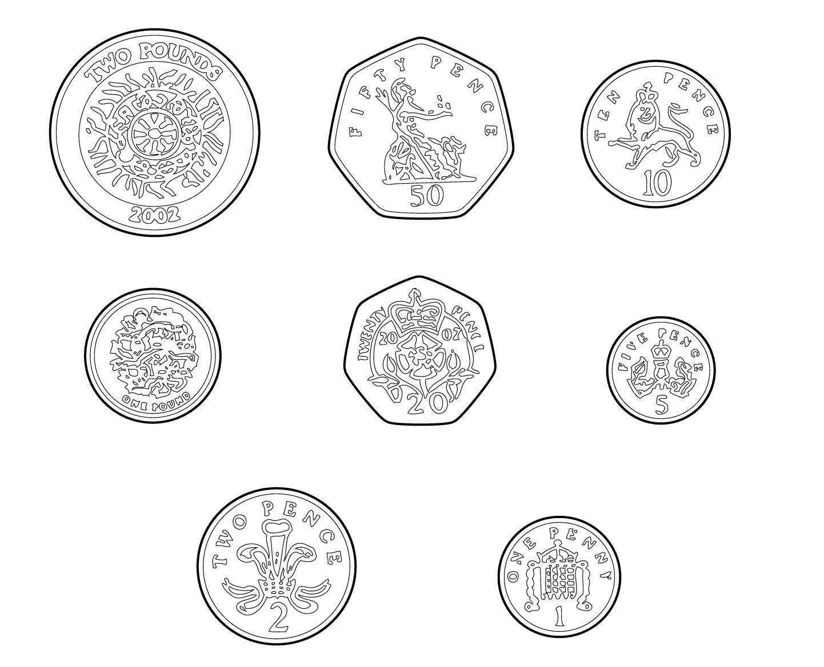 |  | 1:15 | 20. The arrow points:  a. up  b. left  c. right |  | 1:20
10. 4 children each have 2 pens. How many pens do they have altogether? | 1:10
Total (A) |  | Total (B) |  |  | Total (C)
Test Total (A+B+C) |  | R (0-7) | Y (8-15) |  |  | G (16-20)

