

**P.S.H.E. – Changing Me.**

**Skills**

* Can express how they feel
* Can describe emotions.
* Can say who they can talk to if they have any worries.
* Can identify stereotypical family roles and challenge these ideas.
* Can identify changes.
* Can suggest ways to help them manage feelings.

**Knowledge**

In this puzzle we begin with an exploration about babies and what they need to grow and develop including parenting. You will learn that it is usually the female that carries the baby in nature. We will discuss how our bodies change as we get older on the outside and on the inside. You will discuss how you feel about growing up and there will be opportunities for you to seek reassurance if anything is worrying you.

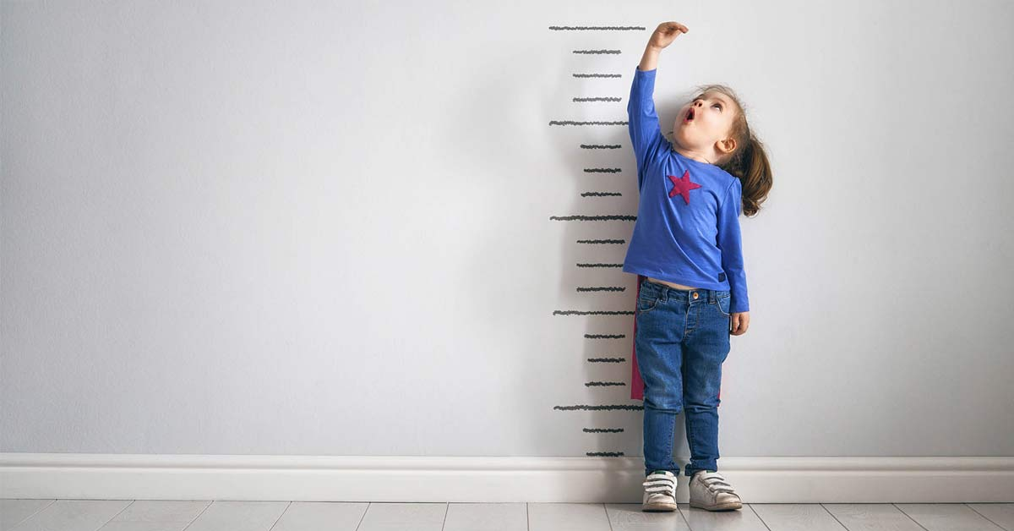

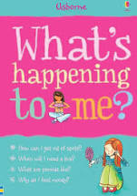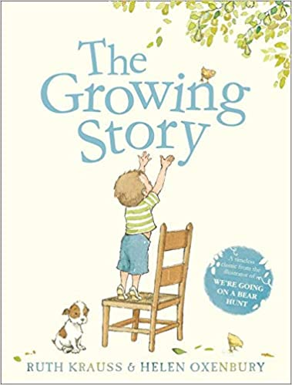

**Books**

|  |  |
| --- | --- |
| Vocabulary | Meaning |
| **affection** | A gentle feeling of fondness or liking something or someone. |
| **anxious** | Feeling or showing worry, nervousness, or unease about something with an uncertain outcome. |
| **birth** | The emergence of a baby or other young from the body of its mother; the start of life as a physically separate being. |
| **body** | The physical structure, including the bones, flesh, and organs, of a person or an animal. |
| **care** | Providing what is necessary for the health, welfare, maintenance, and protection of someone or something. |
| **challenge** | A task or situation that tests someone's abilities |
| **changes** | To become different; be altered or modified. |
| **control** | The power to influence or direct people's behaviour or the course of events. |
| **female** | Word for girls, women or female gender. |
| **grow** | To develop over time, perhaps increasing in size. |
| **male** | Word for boys, men or male gender. |
| **nervous** | Easily alarmed or feeling anxious or worried about something. |

**What I will know and be able to do at the end of the topic.**

**Key skills in PHSE**

**What I should be able to do and know now.**

**Knowledge**

Can you describe the emotions that a new baby

can bring to a family?

Can you describe a change that will happen to you as you get older?

Can you identify stereotypical family roles and why they may not be the same in all families?

Can you suggest ways to help manage your feelings during changes if you are anxious?

**Skills**

I can describe feelings..

I can explain changes as a baby grows..

I can discuss topics with my peers..

I can work in a group.

I can identify changes from baby to child..

I can respect others’ opinions.



**Knowledge**

I know that a baby grows into a child.

I know that as you get older you learn.

I know that things change over time.

I know that an adult is different to a child.

I know that a mum looks after the baby.

Babies cannot look after themselves.

**Skills**

I can sit and listen.

I can give my opinion.

I can describe a change.

I can take my turn.

I can work with a partner.

**What I will be learning**

* Know that in animals and humans lots of changes happen between conception and growing up.
* Know that in nature it is usually the female that carries the baby.
* Know that in humans a mother carries the baby in her uterus (womb) and this is where it develops.
* Know that babies need love and care from their parents/carers.
* Know some of the changes that happen between being a baby and a child.
* Know that the male and female body needs to change at puberty so their bodies can make babies when they are adults.
* • Know some of the outside body changes that
* happen during puberty
* • Know some of the changes on the inside that
* happen during puberty