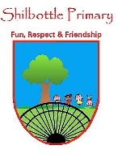
Art - Year 1 and 2 - Paper art
00
Skills
Use a range of materials creatively to design and make products.
Develop art techniques, such as creating a sculpture.
Use sculpture to develop and share their ideas and imagination.
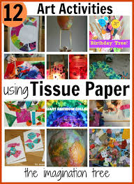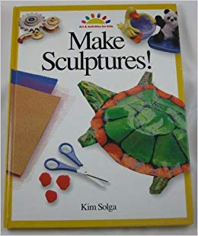
Books

Knowledge
To explore different types of paper used in art.
To be able to use paper to create a collage.
To be able to work with tissue paper to create a piece of artwork.
To be able to use paper to create beads.
To be able to use papier mâché to create a sculpture.
To be able to create sculptures from paper.

Vocabulary | Meaning
collage | Art made by sticking different materials together.
manipulate | To handle something.
papier mâché | A mixture of paper, flour and water that becomes hard when dry.
planet | Like Earth and moves around the sun.
recycling | Making waste into something that can be used again.
sculpture | A 2d or 3d shape made from different things.

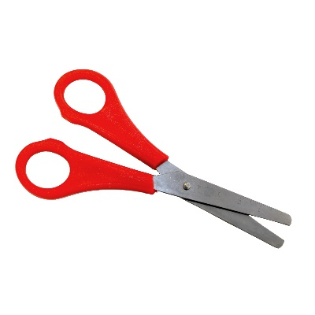
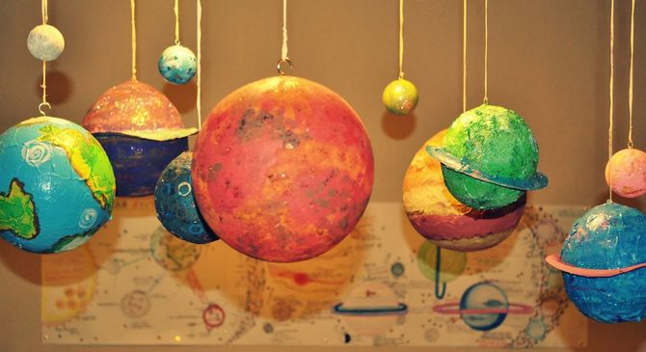
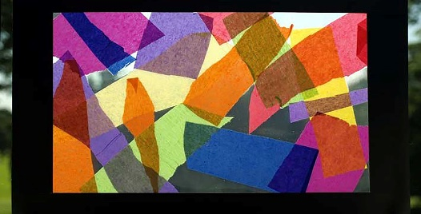
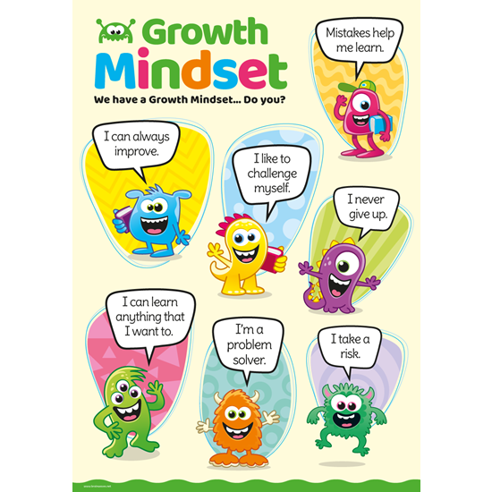
Growth Mindset Strategies

What I will know and be able to do at the end of the topic.
What I should be able to do and know now.
Knowledge and Skills
What are the different types of paper that can be used in art? – Tissue, crêpe, wrapping, greaseproof, newspaper, plain, card.
What is a collage and how can we create one? - Understand that a collage involves pasting paper cut outs on to a surface and looking at how we can cut shapes from different paper to use for our collage.
Why is tissue paper good to work with to create a piece of artwork? - Tissue paper is very thin so this is the best paper to tear and use to make a collage of a stained glass window.
What materials can we use to make beads? - As well as making beads from wood, plastic or glass, they can also be made from paper.
What is papier mâché and how can we use it to create a sculpture? - Understand that papier mâché is a mixture of paper, flour and water that becomes hard when dry. Use recycled materials such as cardboard tubes and egg cartons to create a sculpture that can be covered with papier mâché.
How can we create sculptures from paper? We can use paper to twist, fold, curl and slot together to create a sculpture.
Knowledge
I know that paper is a material
Skills
I can handle equipment and tools effectively, including pencils for writing

I am confident about trying new activities, and say why I like some activities more than others

I can safely use and explore a variety of materials, tools and techniques, experimenting with colour, design, texture, form and function.

I can represent my own ideas, thoughts and feelings through art.

What I will be learning

- Describe and compare different types of
paper.
- How to work with paper to create a collage.
- How to create a stained glass effect and where it is most commonly used.
- To work with paper to create beads and use their beads to create objects.
- How to work with papier mâché to create a model and decorate it appropriately.
- What a sculpture is and how to manipulate paper to create a planet sculpture.

