Maths Key Skills Stage 3: Skill Check 2

Name: ___________________________________ Date: _______________ Class/Group: _______________________________

A: Place Value, Add and Subtract |  | B: Multiply, Divide and Fractions |  |  | C: Measure, Geometry and Statistics
1. What is the missing number?  0 8 24 32 | 3:1 | 11. 36 ÷ 3 = |  | 3:10 | 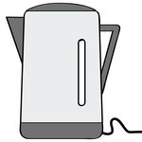  23. About how long does it take for a full kettle to boil?  a. 50 seconds  b. 5 minutes  c. 50 minutes |  | 3:23
2. What is the 2 worth in this number?  257 | 3:2 | 12. 8 x 3 = |  | 3:10 |  |  | 3:23
3. Put these in order, smallest first.  293 329 932 392 | 3:3 | 13. Use 5 x 6 = 30 to solve:  300 ÷ 6 = |  | 3:11 | 22. Which of these is a correct description of a cuboid?  a. I have 6 faces and 6 vertices.  b. I have 6 edges and 8 vertices.  c. I have 6 faces and 12 edges. |  | 3:25
4. Draw an arrow to label 40.  0  100 | 3:4 | 14. Eggs come in boxes of 6. I need 20 eggs. How many boxes should I buy? |  | 3:12 |  |  | 3:25
5. Circle all the multiples of 8.  6 8 14 16 20 | 3:5 | 15. What fraction  is shaded?  3  5 |  | 3:13 | 23. Label two acute angles using the letter ‘A’. |  | 3:26
6. 462 + 100 = | 3:6 | 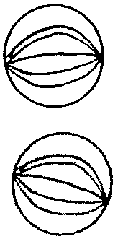  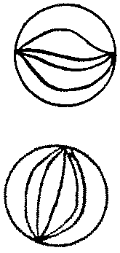  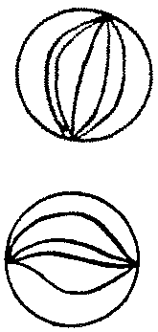  16. Circle  of the marbles. |  | 3:14 |  |  | 3:26
7. 256 + 128 = | 3:7 | 17. What fraction is labelled?  0  1 |  | 3:15 | 24. Favourite colours of students:  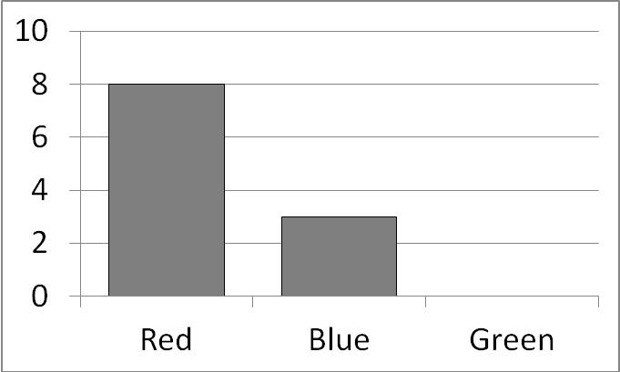  6 people said green. Show this.  25. How many more people said ‘Red’ than said ‘Blue’? |  | 3:29  3:30
8. Write the sum to check 82 - 37 = 45.  Check: 45 + = | 3:8 | 18.  1  4  ?  8  = |  | 3:16 |  |  | 3:29  3:30
9. To a no. I add 27 then subtract 19. I now have 13. What did I start with? | 3:9 | 19. Subtract the  7  8  3  8  -  fractions. |  | 3:17 |  |  | 3:29  3:30
10. What is the missing number?  149 + = 211 | 3:9 | 20. Write the  2  5  1  5  4  5  3  5  largest fraction. |  | 3:18 |  |  | 3:29  3:30
Total (A) |  | Total (B) |  |  | Total (C)
Test Total (A+B+C) |  | R (0-9) | Y (10-19) |  |  | G (20-25)

