Design and Technology– Year 1 – spring 1 and 2 - Houses
Vocabulary  Skills  Name main features of a house.  Identify different ways of combining materials.  Identify a hinge join.  Design a product.  Discuss their design.  Evaluate a finished product.  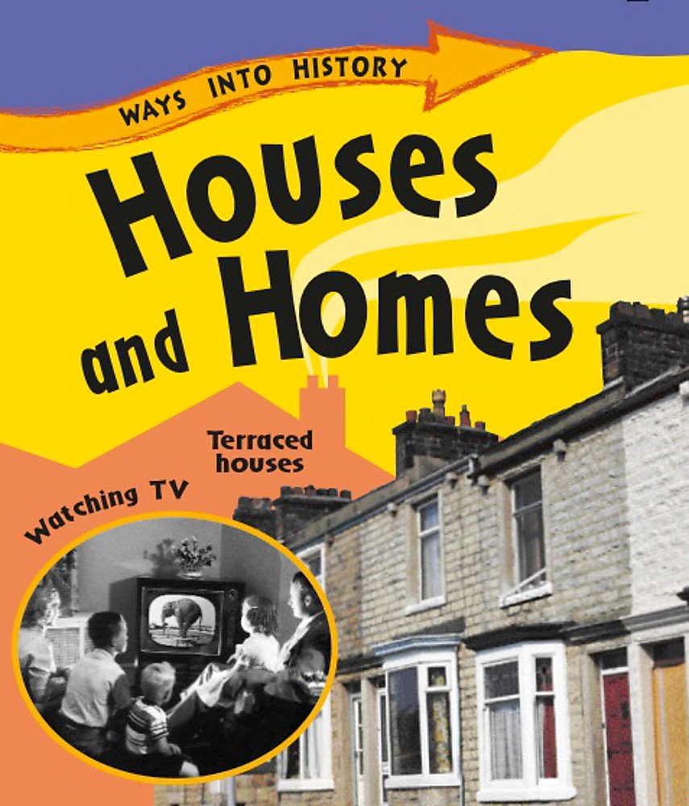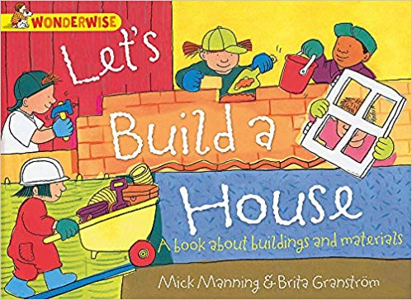  Books  Knowledge  To explore different types of houses and identify shapes and features.  To investigate how to join and combine shapes to make a house.  To investigate ways of creating the interior features of a house.  To be able to design a house.  To be able to follow a design to create a house.  To be able to evaluate a finished product.  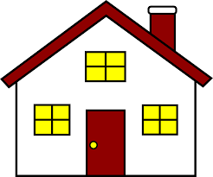 | Meaning
bungalow | A house that only has one storey.
cottage | A small house usually in the country.
detached | A separate house on its own.
design | A plan or drawing produced to show an object before it is made.
designer | A person who plans the look or workings of something before it is made, by preparing drawings or plans.
evaluate | To assess, judge or calculate the quality of something.
materials | The matter from which a thing is or can be made.
stable | Firmly fixed, not likely to overturn.
semi-detached | A house joined to another house on one side.
terraced | A row of houses joined together.
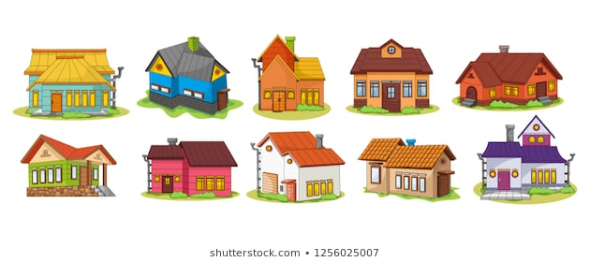

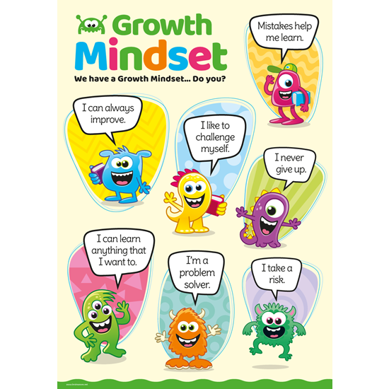
What I will know and be able to do at the end of the topic.
Growth Mindset Strategies

What I should be able to do and know now.
Knowledge
How many different types of houses can you think of? Flat, bungalow, cottage, semi-detached, detached, terraced.
What materials could we use to make a model house and how can we join them together to create a stable structure? – A variety of materials, such as boxes, card, tubes, recycled materials, as well as tools with which to shape and join the materials, such as scissors, glue and masking tape.
Can you recall which characters built houses from different materials in a fairy story? – The 3 little pigs used straw, wood and brick to build houses. The brick house was the strongest.

Skills –
Using your knowledge from science, what properties should the materials have that you use for your house? –
The material should be strong, flexible, hard, easy to cut.

Knowledge
They safely use and explore a variety of materials, tools and techniques, experimenting with colour, design, texture, form and function.
Know what they are making.
Understand simple characteristics of materials.
Skills
How to cut with scissors.
How to draw a picture.
Explain their choices.
Use knowledge of existing products to help come up with ideas.

What I will be learning

- How to recognise some different types of homes and their features.
- How to use materials for a particular purpose.
- To choose materials and joining methods for creating items of furniture.
- How to design a house for a particular purpose.
- How to follow a design to create a model, selecting appropriate tools and materials.
- How to evaluate a finished product.

