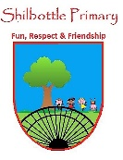

**French - Year 5 – Spring - Getting to know you**

**Books**

**Skills**

**Vocabulary Meaning**

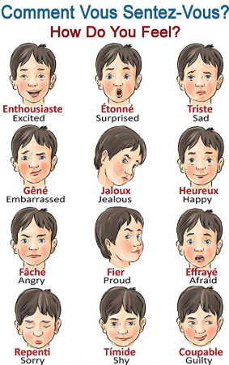

To use the simple future tense when speaking French.

I can follow a simple story.

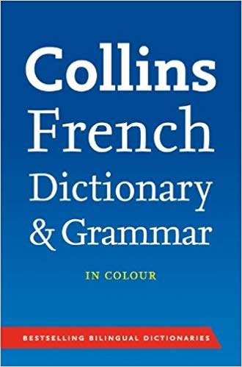



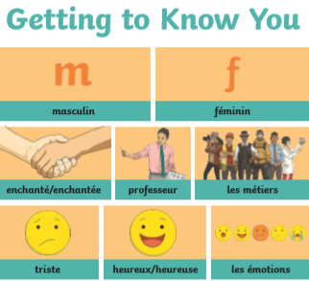

**What I should be able to do and know now.**

**What I will know and be able to do at the end of the topic.**

**Growth Mindset Strategies**

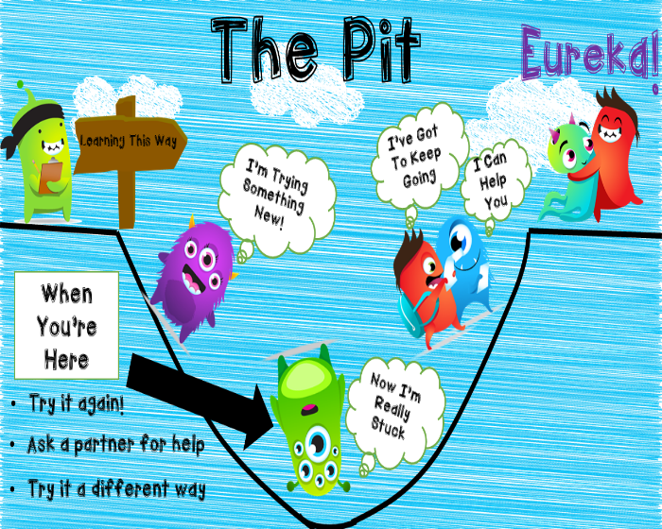

**Knowledge**

I will recognise the difference between future and past tenses in English. As a result be able to see the connection when using French.

I can use abstract French nouns to describe how I am feeling.

I am developing an understanding of the phonetic differences between French and English words when I am reading aloud.

**Skill**

I know where to look to help me spell French words correctly.

I can respond with an appropriate response in a conversation in French. Including, asking to repeat, slow down or indicating that I don`t understand.

**Knowledge**

I will recognise French vocabulary

that is associated with school.

I will use the pronouns `il` and `elle`

to replace a person’s name.

I will use the pronouns `ils` and

`elles` to replace two people`s

names.

**Skills**

I can listen and respond to French

vocabulary that is linked to the topic

of School.

I can respond in writing and speech

using the French language to answer.

**questions related to School.**

**What I will be learning**

Look what I can do

When I grow up …

How do you spell that?

How are you feeling?

How am I going to do?

Je me presente