

**DT– Roman Shields**

**Word Meaning**

**Skills**

**Books**

* To be able to create a product to fit some design criteria.
* To select appropriate materials to build a product.
* To safely use equipment when building a prototype.
* To analyse and evaluate existing products and those I have designed myself.

A plan or idea for how something is made or how it works.

**design**

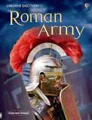 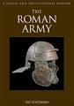

The tools and things that you need to turn your materials into a product.

**equipment**

Testing your product and deciding on ways that it is good but also improvements you could make.

**evaluate**

The things that you make your product from; card, paper, wood, plastic, string, paint.

**materials**

**Knowledge**

To stop something from getting damaged.

**protect**

A person from the Roman empire, who invaded Britain from Rome.

**Roman**

**By the end of this topic you will learn:**

* What a Roman soldier needed their shield for.
* How to design and create my own Roman shield.
* How to choose materials and equipment to successfully create a Roman shield.

A mirror image, one side is the reflection of the other. A line of symmetry.

**reflected**

A part of a Roman soldier’s equipment in battle, a curved board that protected them from weapons.

**shield**

A block of colour, all the same with no other colours or gaps in it.

**solid colour**

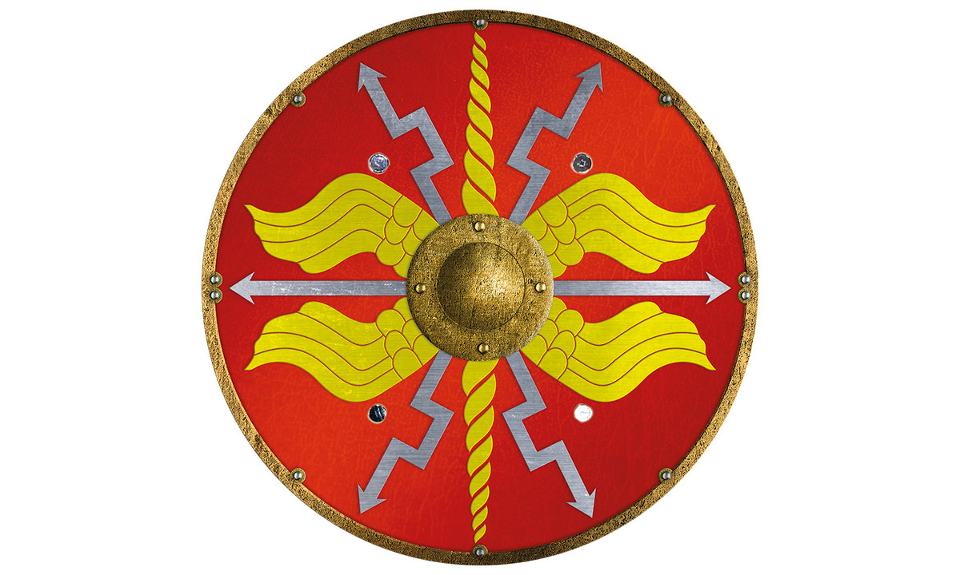

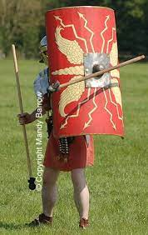

How strong something is.

**strength**

The arrangement of lots of parts to build a product.

**structure**

A stencil to guide you when ci=cutting a shape out.

**template**

**What I should be able to do and know now.**

**What I will know and be able to do at the end of the topic.**

**Key skills in DT**

* To develop their understanding of how to strengthen, stiffen and reinforce structures.
* To select from and use a wider range of tools and equipment to perform practical tasks (cutting, shaping, joining and finishing).
* To generate, develop, and communicate their ideas through discussion, annotated sketches and information and communication technology.
* To be able to create design criteria.

**Knowledge:**

* Can create a shield in the style of the Romans?
* When I cut something, I must use my _________ to measure it before I cut it.
* Can you use a Roman pattern on your shield?
* Explain What the Shield would be used for?
* The main colours of Roman shield were ______ and _______.
* Why were the Romans great soldiers?

**Skills:**

* Accurately measure and cut cardboard to the nearest mm.
* Draw and label a design idea.
* Choose the appropriate equipment for the process I am carrying out.
* Accurately use the equipment to cut straight.
* Use a scissors safely when cutting cardboard.
* Evaluate and improve products to make them better.

**Knowledge:**

* To know that weapons were used in a battle.
* To know that I have to plan something before I can make it.
* I know that I have to test my product to see if it works.
* I know that I can get ideas from existing products that are similar.

**Skills:**

* Use a ruler to measure the length of something.
* Draw and describe a design idea.
* Know which equipment is most appropriate to stick cardboard.
* Suggest improvements for a product.

**What I will be learning**

* To explore what the Romans used shield for.
* To explore the themes and designs on the Shields and what these represent.
* To plan and design a successful Roman shield.
* To use tools and materials accurately to create my shield.
* To test my Shield and suggest improvements for a better product next time.